Web search engine: - A web search engine is a software system that is designed to search for information on the World Wide Web. The search results are generally presented in a line of results often referred to as search engine results pages (SERPs).

Search engines are **answer machines**. When a person performs an online search, the search engine scours its corpus of billions of documents and does two things: first, it returns only those results that are relevant or useful to the searcher's query; second, it ranks those results according to the popularity of the websites serving the information. It is both **relevance** and **popularity** that the process of SEO is meant to influence.

How a search engine works: - There are three basic stages for a search engine: crawling – where content is discovered;

indexing, where it is analyzed and stored in huge databases;

and retrieval, where a user query fetches a list of relevant pages.

## Crawling

Crawling is where it all begins – the acquisition of data about a website. This involves scanning the site and getting a complete list of everything on there – the page title, images, keywords it contains, and any other pages it links to – at a bare minimum. Modern crawlers may cache a copy of the whole page, as well as look for some additional information such as the page layout, where the advertising units are, where the links are on the page (featured prominently in the article text, or hidden in the footer?).

How is a website crawled exactly? An automated bot – a spider – visits each page, just like you or I would, only very quickly. Even in the earliest days, Google reported that they were reading a few hundred pages a second.

Indexing

You’d be forgiven for thinking this is an easy step – indexing is the process of taking all of that data you have from a crawl, and placing it in a big database. Imagine trying to a make a list of all the books you own, their author and the number of pages. Going through each book is the crawl and writing the list is the index. But now imagine it’s not just a room full of books, but every library in the world. That’s pretty much a small-scale version of what Google does.

## Ranking & Retrieval

The last step is what you see – you type in a search query, and the search engine attempts to display the most relevant documents it finds that match your query. This is the most complicated step, but also the most relevant to users.

SERP: - SERP means search engine result page.

SERP is useful analysis tool to help selecting keywords & Traffic estimation on a website.

Why are SERPs important?

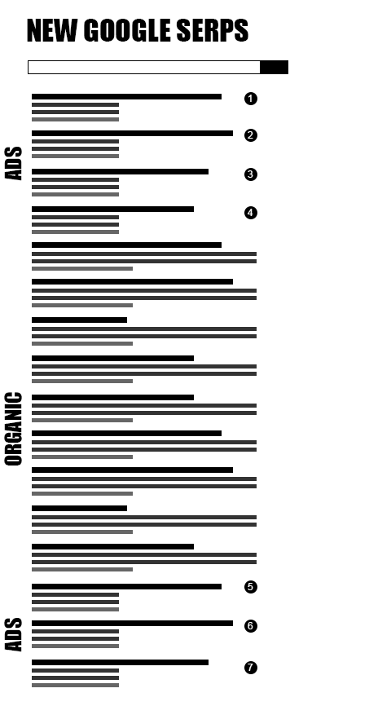

Studies show the higher up you appear in the search results, the more likely someone searching will click over to YOUR site. Most SERPs consist of multiple pages. A search for a popular term will return dozens, - hundreds or thousands of search result pages. In the example pictured above, over 700 million results were returned.

Imagine being a searcher faced with all of those SERP pages. Who has the patience and time to click through them all? No one.

Therefore, the Web pages that appear highest in the search engine results pages are more likely to get clicked and get the traffic. That usually means that if you want to get meaningful traffic, your business needs to appear on the first page of the SERPs or possibly the second or third page.

Who uses the acronym SERP?

SERP is a technical acronym. Most of the time the people using a term like SERP are search engine optimization professionals or marketing professionals. If you hire a professional to help you with your search engine placement — or even just read up on the topic yourself — sooner or later you will encounter this term.

Either way, as a small business owner or manager who realizes the importance of your business being found online you will want to know what a SERP is. The more you know, the better informed the business decisions you make. And you’ll be better able to hold your own with the people or firms you hire.

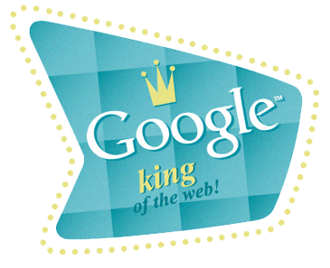

SEO INFORMATION FROM GOOGLE WEBMASTER GUIDELINES

Google recommends the following to get better rankings in their search engine:

* Make pages primarily for users, not for search engines. Don't deceive your users or present different content to search engines than you display to users, a practice commonly referred to as "cloaking."
* Make a site with a clear hierarchy and text links. Every page should be reachable from at least one static text link.
* Create a useful, information-rich site, and write pages that clearly and accurately describe your content. Make sure that your <title> elements and ALT attributes are descriptive and accurate.
* Use keywords to create descriptive, human-friendly URLs. Provide one version of a URL to reach a document, using 301 redirects or the rel="canonical" attribute to address duplicate content.

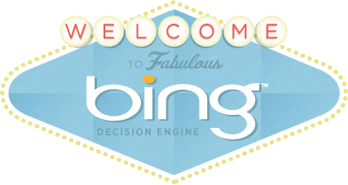

### SEO INFORMATION FROM BING WEBMASTER GUIDELINES

Bing engineers at Microsoft recommend the following to get better rankings in their search engine:

* Ensure a clean, keyword rich URL structure is in place.
* Make sure content is not buried inside rich media (Adobe Flash Player, JavaScript, Ajax) and verify that rich media doesn't hide links from crawlers.
* Create keyword-rich content and match keywords to what users are searching for. Produce fresh content regularly.
* Don’t put the text that you want indexed inside images. For example, if you want your company name or address to be indexed, make sure it is not displayed inside a company logo.

-----------------------------------------------------------------------------------------------

SEO (Search Engine Optimization )

Search engine optimization is the process of improving the quality and quantity of website traffic to a website or a web page from search engines. SEO targets unpaid traffic rather than direct traffic or paid traffic.

There are two types of SEOs

* 1. On Page
  2. Off Page

On Page optimization: -

On-page SEO is the practice of optimizing individual web pages in order to rank higher and earn more relevant traffic in search engines. On-page refers to both the content and HTML source code of a page that can be optimized, as opposed to off-page SEO which refers to links and other external signals.

It all begins with words typed into a search box.

Keyword research is one of the most important, valuable, and high return activities in the search marketing field. Ranking for the right keywords can make or break your website. By researching your market's keyword demand, you can not only learn which terms and phrases to target with SEO, but also learn more about your customers as a whole

Google Keyword Planner

To use this tool, you do need a Google AdWords account. Once you have that set up log into Google AdWords, and this will be your Google AdWords home page. Once you're here, click on the tools and analysis button at the top. Then, click Keyword Planner.

Keyword optimization: -

Keyword optimization (also known as keyword research) is the act of researching, analyzing and selecting the best keywords to target to drive qualified traffic from search engines to your website.

Keyword search optimization is a critical step in initial stages of search engine marketing, for both paid and organic search. If you do a bad job at selecting your target keywords, all your subsequent efforts will be in vain. So, it’s vital to get keyword optimization right.

We must practice search engine keyword optimization to:

* Drive qualified traffic to your website: To drive searchers to your site, you must optimize for the keywords they're searching for
* Measure traffic potential: Analyzing the popularity of keywords helps you gauge the size of a potential online market.
* Write effective content: By incorporating optimized keywords into your website content, you can connect instantly with potential customers and address their needs.
* Understand user behavior: By analyzing the words that your customers use, you get an idea of their needs and how to service those needs.

Keyword optimization plays a major role in every aspect of Internet marketing from content strategy, to link building, to how you group your keywords in your AdWords ad groups, to how your site content is organized.

1. SEO Keyword Optimization.
2. PPC Keyword Optimization.
3. Social Media Keyword Optimization.

SEO Keyword Optimization

When it comes to SEO, the success of your organic search efforts rests largely on how effective you are at discovering, researching, analyzing and selecting the right search engine keywords for your website. All other aspects of SEO rely on successful keyword optimization. What's more, optimizing keywords touches every aspect of your SEO marketing efforts.

Title Tag: Your target keywords must be included in the title tag (and front loaded). This is the most important piece of content on your website, both on and off-page.

Links: Keyword optimization should be integrated into your link building strategy. Internal links, inbound links, breadcrumb links, navigational links should all have your top optimized keywords. It's also important to track and manage your link text efforts

Content strategy: If you want to rank well and connect with searchers, you need to use your target keywords in your content. WordStream for SEO helps combine keyword research with content authoring.

Images: Don't forget to optimize keywords in the pictures on your website. Target keywords should be used in your image alt attribute and file names, to name a few.

Meta Description: There's some debate over whether or not including target keywords in your text snippets helps rankings. But there's little doubt that having your optimized keywords here produces more clicks in searches, which is optimal.

URL: **Uniform Resource Locator**

The address of a World Wide Web page.  
Be sure to include keywords for SEO in file name slugs, like I've done with this page's URL. The page is about keyword optimization, so the slug name is /keyword-optimization.

Site Structure: Keyword optimization is also critical to how you structure and organize your site content. Not only do you need to select the right keywords, but you need to group them hierarchically and order the corresponding pages on your website accordingly.

Types of Keyword: -

What is Major Difference between Primary, Secondary and Tertiary Keywords?

A primary keyword, as the name suggests, is a keyword that is used before any other keywords on a web page or in an article. Therefore, the primary keyword is the most important keyword on a web page. In turn, then, the primary keyword should be included in a site’s title and domain as well as in its content. It should be added to the first sentence on the page too. The primary keyword is essential for purposes of SEO as it is used to describe the web page as well as help people locate the site.

A secondary keyword is used after the primary keyword and is not required with respect to SEO. However, when a secondary keyword is used, the chances of attracting additional visitors to your site are increased.

A tertiary keyword ( Long Tail Keyword) falls third in line of importance and is used behind secondary keywords in keyword Meta tags.

Using these keywords as an example, the subject of your first SEO article would be about jogging. Its primary keyword would be: "jogging", the secondary keyword would be: "jogging running," and the tertiary keywords would be: "jogging tip, benefit jogging, complete guide idiot jogging running, jogging woman, burned calorie jogging, jogging lose weight, jogging loss weight, begin jogging, beginner jogging, calorie jogging."

The primary keyword of a second article about the subject would focus on “jogging running." Its secondary keyword would be "jogging tip," and its tertiary keywords would be "benefit jogging, complete guide idiot jogging running, jogging woman, burned calorie jogging, jogging lose weight, jogging loss weight, begin jogging, beginner jogging, calorie jogging, jogging program."

The position of these keywords in articles changes (shifts) as you move down the list of available search terms. And maintaining this order in your articles is extremely important so that you attract the attention of the people who use these keywords.

_______

Domain

Domain names are the human-readable Internet addresses of websites. Root domains, which are identified by their domain names, have extensions such as .com, .org, .net, etc. (Ex. http://www.example.com) Subdomains are a lower-level component of a root domain and precede the domain name. (Ex. http://subdomain.domain.com)

Top Tips

Word Separators: -

Avoid hyphens. Hyphens detract from credibility and can act as a spam indicator.

Top-Level Domain (TLD): -

Top-level domains (like “.com”) are the extensions associated with domain names. For best ranking results, avoid uncommon top-level domains (TLDs). Like hyphens, TLDs such as .info, .cc, .ws and .name are spam indicators.

Length: -

Avoid domain names longer than 15 characters. Short domain names are easier to remember, easier to share, and have a smaller chance of resulting in typos.

What are Domains?

Root Domains: -

A root domain is the top-level hierarchy of a domain. Root domains are purchased from registrars. The following are examples of root domains:

*.example.org

*.moz.com

*.blogspot.com

Subdomains: -

A subdomain is a "third level" domain name that is part of a larger, top-level domain. For example, "blog.example.com" and "english.example.com" are both subdomains of the “. example.com" root domain. Subdomains are free to create under any root domain that a webmaster controls.

The two most common subdomain choices are:

http://www.example.com (www is the subdomain)

http://example.com (has no subdomain)

These are also the subdomains that commonly result in canonicalization errors.

SEO Best Practice:

To maximize search engine-referred traffic, it is important to keep each of the following elements in mind:

1. Domain Name Memorability: -

There are a number of considerations when selecting a domain name. Among them are making the name short, easy to remember, and easy to type. It is also important that the name be easy to type into a browser. This is especially true for websites that rely on word-of-mouth advertising, which forces people to type domain names they might not be familiar with into their web browser.

2. Keyword-rich domains: -

Ideally, webmasters should strike a balance between finding a catchy, unique, brand-friendly domain name and having a domain that contains keywords they are trying to target. The benefit of a keyword-rich domain is two-fold. First, the domain name itself is a ranking factor that the engines consider when calculating ranking order. Second, having relevant keywords in a domain name is beneficial because the domain name is the text that other Internet users will use as anchor text when linking. Since keywords in anchor text are an important ranking factor, having these keywords in a domain name can have a positive impact on ranking.

3. Hyphens: -

If your domain name is two words (like www.examplesite.com), you may want to separate the words with a hyphen for readability: www.example-site.com. That said, use of hyphens also correlates highly with spammy behavior—and more than one hyphen should not be used in a domain name. For this reason, it's generally better to stick to domain names containing only one or two words.

4. Non-.com Top-Level Domains (TLDs): -

When a webmaster registers a domain name, they will be given the option to buy additional TLDs. In order to maximize the direct traffic to a domain, it is advised that webmasters should only buy a domain if the .com version is available. Additionally, it is not recommended that SEO-conscious webmasters purchase low quality TLDs such as .biz, .info, .ws, .name, etc. as a means of increasing traffic.

5. Subdomains or Sub-folders: -

Since search engines keep different metrics for domains than they do subdomains, it is recommended that webmasters place link-worthy content like blogs in subfolders rather than subdomains. (i.e. www.example.com/blog/ rather than blog.example.com) The notable exceptions to this are language-specific websites. (i.e., en.example.com for the English version of the website).

6. Buying & Redirecting Domains: -

Buying web pages for their links and redirecting them to another site has long been a practice employed by SEOs. Though this has been effective in the past, industry leaders such as Search Engine Land's Danny Sullivan have posted about buying domains. They suggest that Google largely devalues links from sites once they are expired or when ownership changes.

7. Domain Registration Length

The notion that domain registration length matters as an SEO factor is a myth. When asked about domain registration length, Google's Matt Cutts said, "To the best of my knowledge, no search engine has ever confirmed that they use length of registration as a factor in scoring. If a company is asserting that as a fact, that would be troubling. The primary reason to renew a domain would be if it's your main domain, you plan to keep it for a while, or you'd prefer the convenience of renewing so that you don't need to stress about your domain expiring."

8. Moving Domains: -

If a webmaster needs to move one domain to another, there are several critical factors to consider. It's also important to set up the redirects on a page-to-page basis such that sub-folders and deep content pages are redirected to corresponding sub-folders and deep content pages on the new domain. SEOs should avoid redirecting all pages from one domain to the homepage of another domain.

URL: -

URL, or Uniform Resource Locator, is a subset of the Uniform Resource Identifier (URI) that specifies where an identified resource is available and the mechanism for retrieving it.

URLs describe a site or page to visitors and search engines. Keeping them relevant, compelling, and accurate is the key to ranking well.

The URL of a web document should ideally be as descriptive and brief as possible. If, for example, a site's structure has several levels of files and navigation, the URL should reflect this with folders and subfolders. Individual pages' URLs should also be descriptive without being overly lengthy, so that a visitor who sees only the URL could have a good idea of what to expect on the page.

Code Sample:-

http://www.example.com

Imposed Limits:-

URLs must be shorter than 2083 characters to render in Internet Explorer (4-8).

Optimal Format:-

http://www.example.com/category-keyword/subcategory-keyword/primary-keyword.html

What is a URL?

A URL is human-readable text that was designed to replace the numbers (IP addresses) that computers use to communicate with servers. They also identify the file structure on the given website.

URLs should:

Use hyphens to separate words when necessary for readability. They should not use underscores, spaces, or any other characters to separate words. Overuse of hyphens in URLs can be seen as spammy, so it’s best to use caution and limit hyphen use in URLs when possible.

Never be longer than 2,048 characters; otherwise Internet Explorer won't be able to load the page.

Avoid the use of parameters, if possible. If parameters need to be used, they should be limited to two or less.

Three Main Benefits of URLs

1. Semantics

A well-crafted URL should semantically make sense. The DPReview URL above is a good example of a semantically accurate URL. (This of course assumes that the page actually is about what is described) It is easy to tell the subject of the URL just by examining its URL. This is helpful to both humans and search engines.

2. Relevancy

The other benefit of having a semantically correct URL, is that webmasters are more likely to get search engine-referred traffic due to the keywords in the URL. These, like title tags, are used for determining relevancy and computing rankings.

3. Links:-

Well-written URLs have the additional benefit of serving as their own anchor text when copied and pasted as links in forums, blogs, or other online venues.

In the DPReview example, a search engine might see the URL http://www.dpreview.com/reviews/canonsd400/ and give ranking credit to the page for terms in the URL like dpreview, reviews, canon, SD, and 400. If you're interested in running a high level anchor text analysis of your site, use the linked tool, but remember that some of your anchor text likely links to external sites, as well.

Image Optimization: - Image Naming-Alt tag

We include images in our articles to get people to read your text. Well-chosen images also strengthen your message. You shouldn’t forget to give those images good alt attributes: alt tags and title tags strengthen the message towards search engine spiders and improve the accessibility of your website.

Let’s explain all about alt tags and title tags and why you should optimize those.

Note: the term “alt tag” is a commonly used abbreviation of what’s actually an alt attribute on an img tag. For any image on your site, the alt tag should describe what’s on it. Screen readers for the blind and visually impaired will read out this text and thus make your image accessible.

Following 10 "must-know" image optimization tips:

1. Name Your Images Descriptively and in Plain English: -

It's really easy to blast through hundreds of product shots and keep the default file name your camera gives them. But before you keep that habit, let's discuss why that's not a good idea.

When it comes to SEO, it's important to use acceptable keywords to help your webpage rank on search engines. Creating descriptive, keyword-rich file names is absolutely crucial for image optimization. Search engines not only crawl the text on your webpage, but they also search for keywords within your image file names.

Let's use this image as an example:



You could use the generic name that your camera gave to the image such as DCMIMAGE10.jpg. However, it would be much better to name the file: 2012-Ford-Mustang-LX-Red.jpg

Also think about how your customers search for products on your website. What naming patterns do they use when they search? In the example above, car shoppers may search using the terms:

* 2012 Red Ford Mustang LX
* Ford Mustang LX Red 2012
* Red Ford Mustang LX 2012

A good habit to get into is to look at your website analytics, and see what phrasing patterns your customers use to perform searches. Determine the most common naming patterns they use, and apply that formula to your image naming process.

If you are not going to get that detailed, just be sure to use good keywords when naming your images (and try to be descriptive!).

2. Optimize Your Alt Tags Intelligently

Alt tags are a text alternative to images when a browser can't properly render them. Even when the image is rendered, if you hover over it with your mouse pointer, you can see the alt tag text created for that image (depending on your browser settings).

The alt attribute also adds SEO value to your website. Adding appropriate alt tags to the images on your website can help your website achieve better rankings in the search engines by associating keywords with images. As a matter of fact, using alt tags is probably the best way for your ecommerce products to show up in Google image and web search.

Let's take a look at the source code of an alt tag:

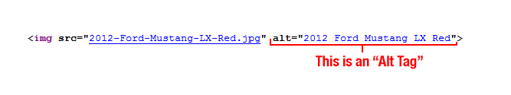

The #1 priority when it comes to image optimization is to fill out each alt tag for every product image on your site.

What are alt tags and title tags?

This is a complete HTML image tag:

&lt;img src=&quot;image.jpg&quot; alt=&quot; image description&quot; title=&quot;image tooltip&quot;/&gt;

The alt and title attributes of an image are commonly referred to as alt tag or alt text and title tag even though they’re not technically tags. The alt text describes what’s on the image and the function of the image on the page. So if you have an image that’s used as a button to buy product X, the alt text would say: “button to buy product X”.

The alt tag is used by screen readers, the browsers used by blind and visually impaired people, to tell them what is on the image. The title attribute is shown as a tooltip when you hover over the element, so in case of an image button, the button could contain an extra call-to-action, like “Buy product X now for $19!”

Each image should have an alt text. Not just for SEO purposes but also because blind and visually impaired people otherwise won’t know what the image is for. A title attribute is not required. It can be useful but in most cases, leaving it out shouldn’t be much of an issue.

But what if an image doesn’t have a purpose?

If you have images in your design that are purely there for design reasons, you’re doing it wrong, as those images should be in your CSS and not in your HTML. If you really can’t change it, give it an empty alt attribute, like so:

&lt;img src=&quot;image.png&quot; alt=&quot;&quot;/&gt;

The empty alt attribute makes sure that screen readers skip over the image.

______________

Meta tags:-

Meta Description

Meta descriptions are HTML attributes that provide concise explanations of the contents of web pages. Meta descriptions are commonly used on search engine result pages (SERPs) to display preview snippets for a given page.

Code Sample

<head>

<meta name="description" content="This is an example of a meta description. This will often show up in search results.">

</head>

Optimal Length for Search Engines Roughly 320 Characters.

Meta description tags, while not important to search engine rankings, are extremely important in gaining user click-through from SERPs. These short paragraphs are a webmaster’s opportunity to advertise content to searchers and to let them know exactly whether the given page contains the information they're looking for.

The Meta description should employ the keywords intelligently, but also create a compelling description that a searcher will want to click. Direct relevance to the page and uniqueness between each page’s Meta descriptions is key. The description should optimally be between 150-160 characters.

<head>

<meta name="description" content="Here is a description of the applicable page">

</head>

### SEO Best Practices

The Meta description tag serves the function of advertising copy. It draws readers to a website from the SERP and thus, is an extremely important part of search marketing. Crafting a readable, compelling description using important keywords can improve the click-through rate for a given webpage. To maximize click-through rates on search engine result pages, it's important to note that Google and other search engines bold keywords in the description when they match search queries.

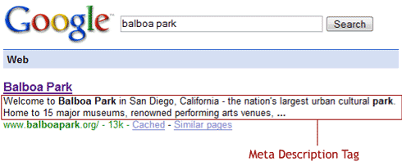

Recommended Length

Meta descriptions can be any length, but search engines generally truncate snippets longer than 160 characters. It is best to keep meta descriptions between 150 and 160 characters.

Avoid Duplicate Meta Description Tags

As with title tags, it is important that meta descriptions on each page be unique. One way to combat duplicate meta descriptions is to create a dynamic and programmatic way to make unique meta descriptions for automated pages.

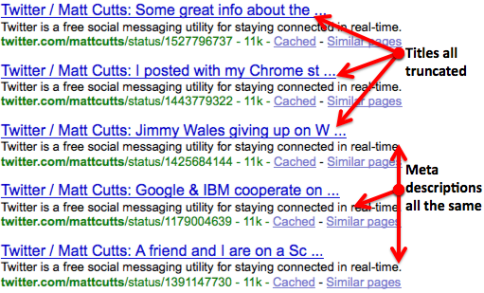

________________

Redirection: -

Redirection is the process of forwarding one URL to a different URL. There are three main kinds of redirects: 301, 302, and meta refresh.

Types of Redirects: -

1. 301, "Moved Permanently"—recommended for SEO
2. 302, "Found" or "Moved Temporarily"
3. Meta Refresh

What is a Redirect?

A redirect is a way to send both users and search engines to a different URL from the one they originally requested. Below are descriptions of some of the commonly used types of redirects.

301 Moved Permanently:-

A 301 redirect is a permanent redirect which passes between 90-99% of link juice (ranking power) to the redirected page. 301 refers to the HTTP status code for this type of redirect. In most instances, the 301 redirect is the best method for implementing redirects on a website.

302 Found (HTTP 1.1) / Moved Temporarily (HTTP 1.0):-

Some of Google's employees have indicated that there are cases where 301s and 302s may be treated similarly, but our evidence suggests that the safest way to ensure search engines and browsers of all kinds give full credit is to use a 301 when permanently redirecting URLs. The Internet runs on a protocol called Hypertext Transfer Protocol (HTTP) which dictates how URLs work. It has two major versions, 1.0 and 1.1. In the first version, 302 referred to the status code "Moved Temporarily." This was changed in version 1.1 to mean "Found."

Meta Refresh:-

Meta refreshes are a type of redirect executed on the page level rather than the server level. They are usually slower, and not a recommended SEO technique. They are most commonly associated with a five-second countdown with the text "If you are not redirected in five seconds, click here." Meta refreshes do pass some link juice, but are not recommended as an SEO tactic due to poor usability and the loss of link juice passed.

_____________________

Link building:-

Link building (alternative spellings include linkbuilding and link-building) refers to the process of getting external pages to link to a page on your website. It is one of the many tactics used in search engine optimization (SEO).

Link building is (specialized) marketing: -

The principles that apply to good marketing are the same principles that apply to good link building. The process to secure links might be unique, but the guiding philosophy should be grounded in traditional marketing.

Some think that link building is a magic bullet for SEO, or some sort of “traffic faucet” they can turn on and off as needed. In reality, link building is the manual promotion of an asset to a targeted audience — also known as marketing.

The same fundamental philosophies that drive effective marketing drive effective link building:

* Audience development: Research which sites, communities and online platforms are popular with your audience in order to know where to secure links.
* Niche research: Analyze linking environment and current market position to strategically pursue links.
* Competitive analysis: Evaluate competitor backlinks and strategies to set expectations and achieve results.
* Targeted promotion: Find relevant and valuable opportunities to effectively secure links.
* Compelling messaging: Communicate the value of linking via outreach.
* Consistent effort: Create a sustained campaign that achieves lasting results.

Thorough research, strategic promotion, carefully crafted messaging and sustained effort are the foundations for success — in marketing and link building alike.

Link building isn’t some mystical SEO hack. It’s just fundamentally good marketing with a unique twist: instead of converting a customer, you’re trying to earn a link

Lq: Link Quality:

If you were sick, which would you trust more? The advice from five doctors or from fifty random people who offered their advice as you walked down the street?

Unless you’ve had a really bad experience with doctors, you’d probably trust the advice from the doctors. Even though you’re getting fewer opinions, you’re getting those opinions from experts. The quality of their opinions carries more weight.

It works the same way with search engines. They’ll count all the links pointing at websites (except those blocked using nofollow or other methods), but they don’t count them all equally. They give more weight to the links that are considered to be of better quality.

What’s a quality link?

It’s one of those “you’ll know it when you see it” types of things in many cases. But a link from any large, respectable site is going to be higher on the quality scale than a link you might get from commenting on a blog. In addition, links from those in your “neighborhood”, sites that are topically relevant to your site, may also count more.

Lt: Link Text / Anchor Text: -

Amazon has millions of links pointing at it. Yet, it doesn’t rank for “boats.” It does rank for “books.” Why? Many of those links pointing at Amazon say the word “books” within the links while relatively few say “boats,” since Amazon doesn’t sell boats.

The words within a link — the link text or “anchor text” — are seen by search engines as the way one website is describing another. It’s as if someone’s pointing at you in real life and saying “books” and declaring you an expert on that topic.

You often can’t control the words people use to link to you, so capitalize on your opportunities to influence anchor text, within reason.

Ln: Number Of Links:-

Plenty of sites have found that getting a whole lot of links can add up to SEO success. Even more so if you’re getting a lot of links from many different sites. All things being equal, 1000 links from one site will mean far less than 1000 links from 1000 sites.

Long ago, the sheer number of links used to be a far more important, but has decreased steadily as search engines learn how to better evaluate the quality of links.

Internal Links:-

Internal Links are hyperlinks that point at (target) the same domain as the domain that the link exists on (source). In layman's terms, an internal link is one that points to another page on the same website.

Code Sample:-

<a href="http://www.same-domain.com/" title="Keyword Text">Keyword Text</a>

Optimal Format

Use descriptive keywords in anchor text that give a sense of the topic or keywords the source page is trying to target.

Internal Linking and External Linking

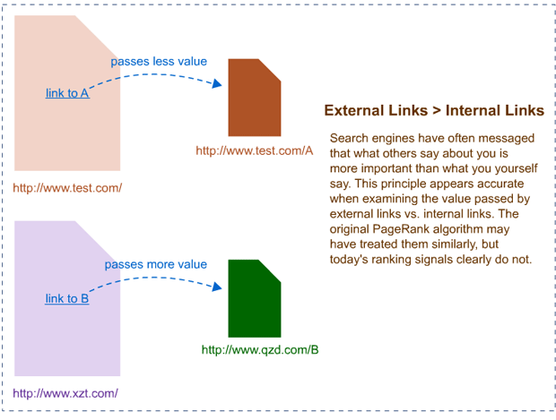

What is an Internal Link?

Internal links are links that go from one page on a domain to a different page on the same domain. They are commonly used in main navigation.

These types of links are useful for three reasons:

1. They allow users to navigate a website.
2. They help establish information hierarchy for the given website.
3. They help spread link juice (ranking power) around websites.

External Links

External Links are hyperlinks that point at (target) any domain other than the domain the link exists on (source).

In layman's terms, if another website links to you, this is considered an external link to your site. Similarly, if you link out to another website, this is also considered an external link.

Code Sample

<a href="http://www.external-domain-example.com/" title="link anchor text">Link Anchor Text</a>

Optimal Format

Use descriptive keywords in anchor text that reflect the same topic or keywords the target page is trying to target. It's not necessary to use the same keyword text every time—in fact, doing so can trigger spam detectors. Instead, strive for a variety of anchor text that enhances context and usability for your users—and for search engines, as well.

An external link is a link that points at an external domain.

Top SEOs believe that external links are the most important source of ranking power.

External links pass "link juice" (ranking power) differently than internal links because the search engines consider them as third-party votes.

Top SEOs don't believe that the "title" link attribute is used for rankings purposes.

________________________

Schema.org -Structured Data:

Schema.org (often called Schema) is a specific vocabulary of tags (or micro data) that you can add to your HTML to improve the way your page is represented in SERPs.

Without schema markup, search engines can only tell what your data says, and they have to work harder to determine why it’s there.

Code Sample

<div itemscope itemtype="https://schema.org/Book">  
<span itemprop="name"> Inbound Marketing and SEO: Insights from the Moz Blog</span>  
<span itemprop="author">Rand Fishkin</span>   
</div>

What is Schema.org Structured Data?

Schema.org is the result of collaboration between Google, Bing, Yandex, and Yahoo! to help you provide the information their search engines need to understand your content and provide the best search results possible at this time.

Adding Schema markup to your HTML improves the way your page displays in SERPs by enhancing the rich snippets that are displayed beneath the page title.

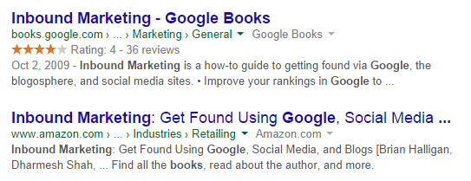

For example, the first search result above contains both a star rating and a publication date. Both of these can be added using Schema. The second example does not have rich snippets and instead displays either the Meta description or other information chosen by Google. To get the review rich snippet, you would use the following code:

<div itemprop="aggregateRating" itemscope itemtype="https://schema.org/AggregateRating">  
<span itemprop="ratingValue"> [Aggregate rating given] </span></span> stars – <span itemprop="reviewCount">[Number of reviews] </span></span> reviews   
</div>

To generate your own code, you can use Google's Structured Data Markup Helper.

The difference between Schema, Microdata, and Structured data

Structured data is a system of pairing a name with a value that helps search engines categorize and index your content.

Microdata is one form of structured data that works with HTML5.

Schema.org is a project that provides a particular set of agreed-upon definitions for microdata tags.

SEO Best Practices:

Types of items described by Schema

Structured data can be used to mark up all kinds of items from products to events to recipes. It is most often used to provide additional information about the following:

* Creative work
* Event
* Organization
* Person
* Place
* Product

A full list of items you can mark up with Schema is available [here](https://schema.org/docs/full.html).

Each type of information has properties that can be used to describe items in more detail. For example, a "book," which falls under the category "creative work," can have the properties "name" (title), "author," "illustrator," "isbn," and more, depending on how fully you want to describe it.

Similarly, an "event" can be classified as anything from a "businessevent" to a "theaterevent."

Search engines that use Schema

Schema is recognized (and in fact the vocabulary is maintained) by Google, Bing, Yahoo!, and Yandex. It's unclear whether other search engines are using this markup to change how they display search results.

Structured data's effect on rankings

Whether structured data affects rankings has been the subject of much discussion and many experiments. As of yet, there is no conclusive evidence that this markup improves rankings. But there are some indications that search results with more extensive rich snippets (like those created using Schema) will have a better click-through rate. For best results, experiment with Schema markup to see how your audience responds to the resulting rich snippets.

#### Using Schema with other structured data

Schema can be used with RDFa and JSON-LD, but it is not supported by microformats.

___________________________

Content writing is a form of online writing which is closely linked to web marketing campaigns. This means creating the writing which appears on websites that are designed to sell or promote a specific product. Content writers work according to the brief provided by a client.

Types of content writing

* Technical writing – This writing caters to verticals like consumer electronics, computer hardware and software, aeronautics, robotics, engineering, chemistry and biotechnology. The type of content involves user manuals, user documents, help files, technical modules, admin manuals and other types of technical reports and literature. This field demands a very strong technological blend of mind. Though, often these vacancies are open to everyone but it is preferable that the candidate has technology degree or technology area of specialization. It is a win-win story if the candidate is a technology enthusiast and has a broad understanding of this genre. Otherwise, this section of writing is very bland and does not have ‘too exciting’ to offer. As a matter of fact, this vertical is pretty tough for a non-technical person to crack, proceed and progress. HR teams and candidates both should proceed very cautiously and make sure that the right selection takes place. A feature writer in this section will turn out to be a complete flop show.

* SEO content writing – Content writing is a part of the entire process of SEO marketing. India is the most blooming market for SEO outsourcing. Almost every second company in Noida belt seems to be one SEO company. Courtesy hard hitting marketing or whatever, the companies manage to earn a good number of projects from US, UK and Australia. Once projects are bagged, there begins a major ‘run for your life’ content writing work. Usually, if there are less projects say 20, the enterprises prefer one writer to take care of them. If the project number is pretty huge like 50 or something, often there is a content team to handle it. The content items are mostly blogs, articles, press releases, classified ads and descriptions.

These are keywords-based content writing jobs. The topics can be anything like insurance services, tangible products or even teas and Baklava pastries. For example, you could be given keywords like leather bags Ontario, Canada bags etc. SEO executives churn out these keywords and render them to the writers for further content development. Ethically speaking, is it possible to create a proper sentence with a ‘must have’ keyword like ‘Canada bags’? Not really but content writers are struggling every day to not only commit a grammar sin but also letting their creativity die a slow death. The pain is added by an unreasonable deadline. For instance, you could be asked to deliver 10 blogs with similar keywords on daily basis and failing to do so might put you at a job risk. A content writer turns into a live typewriter. The pressure is so high that often it takes a toll on the writer’s physical and mental health. It is not possible to write 10 blogs (at least 250 words) every day.

* Editorial and Publication based writing – This sector caters to publishing of school, college and higher education-based books. The vertical has K12 curriculum to take care of and more. With the coming up of technology, writers are required to do editing and writing work for the online version also. For instance, if your work is available for the windows version 7 then after coming up of version 8, you are required to develop the same content for the latest version within a very chronic deadline.

* Marketing and communication writing – One of the most interesting and challenging sectors in the entire content writing league. You have massive opportunities to write about. The writing items include website content, blogs, articles, PPT, social media content, E-books, press releases, newsletter, email campaign content, internal & external communications, marketing collateral like brochures and flyers and audio and video content. Entire writing job requires a much-targeted strategy. Here, the blog and article writing is different from that of SEO. This sector involves lot of research and communication with team leads. For example, the topic given could be ‘maintenance strategies for IoT in 2016 and beyond.’ This department strongly focuses on taking content marketing to another level. Content writers in this genre should have a marketing blend of mind, an eye for detail both in writing and design, and an ability to create catchy content. The challenges mostly are creative difference of opinions and also in terms of contradictory perspectives towards content strategies.

* CSR writing – Another potential section in writing is ‘Corporate Social Responsibility’. Content writing is merely a part of it but still a significant one. Industry giants have CSR departments which invest in social causes and involve employees to be a part of it. The communication that goes in engaging the employee or the literature required for CSR related activities are done by a writer. The content writing may involve blogs, reports, and different types of communications. Since, I do not have experience in CSR, I would request a subject expert to elaborate on the challenges in comments.

* Research and report writing – There are a lot of agencies that offer research-based reports on industries. The topic can be around latest trends, if the trends will work out, probable outcomes etc. These reports are rich in content and big in quantity too. The writers have their own share of challenges which mostly go around deadlines, content challenges, subjects etc. I will appreciate if someone from this genre of writing can come up and brief on what kind of challenges are faced by the writers in comments. I do not carry any experience in this field.

* Feature writing – This section calls for all the creativity you have packed in you. The writing activities involve columns in digital and print space, poems, short stories, satires, features based on lifestyle, food etc. This section doesn’t really demand someone to be particularly a journalism graduate but it calls for mind that can weave words like magic, observe people, and create stories that will engage the readers at one go and exceptional vocabulary. In the current landscape, a lot of people are satisfying their creative needs through blogging. If you couldn’t make it to live MINT, HT or anything like that do not lose heart, start your blog today. Begin with a topic like “12 things you would love to write about.’ The same content writing type may have travel writing as a broad section in the field. All those who have a travel bug in them should go ahead without losing a second. And if destiny is not letting you meet, you know what to do – Blog it and Brag it!

* Instructional design – If technical writing and publications had a child, it would be instructional design. E-learning or E-education paves a vast path for writers to build an outstanding career in this vertical. This section involves not only writing but also creating story boards. The writer is again expected to have a technical understanding, ability to create characters and also patience to create massive content. Writers work hard to meet with challenges like change in school curriculum & technology, confront low quality developers and also they have a pressure to meet the international standards of curriculum.

* Business writing – It is like a younger brother to marketing based writing. The writing activities involve emails, memos, sales proposals, RFPs, concept paper, summaries, manual writing, etc. This genre has huge growth potential and the writer is able to develop a strong understanding in business development and analysis section and he or she may graduate to a higher position in future too.

* Copywriting – All the jingles on radio that you hear or the catchy punch lines you read on banners, these are nothing but magic created by these copywriters. Very competitive and demanding, this section calls for creativity in abundance almost that is ‘out-of-the-box’. Ideas do not come easy and not in a routine manner so these copywriters are often different personalities with strong vocabulary. The environment at these offices is different from the above mundane corporate culture.
* Ghost writing – Contrary to what the name suggests, this kind of writing pertains to writing on behalf of someone else. Usually, such writers work for C level officers in organizations like CEO, CTO etc. The officers do not have time to write themselves but rather they let the same job get done by writers. Here, the point to be noticed is that the writers do not get credited; instead their name is not published. The content is published under the name of the officer. The challenge of this profile is the writer has to think like a CEO or any officer of the same grade. If you are 20 something working hard to make a career in this, you have to put an extra brain work and think about the business like someone 40s, 50s etc. The key to such writing is that such officers never think ground things but rather breaking the stereo type and bringing innovation to the market.

The following Points are designed to answer three questions:

1. What is “SEO content”?
2. What types of SEO content are there?
3. What is my SEO content strategy?

What Is SEO Content?

To understand what marketers, mean by SEO content, it’s helpful to break down the phrase into its component parts:

* “SEO” refers to search engine optimization, or the process of optimizing a website so that people can easily find it via search engines like Google.
* By “content,” we mean any information that lives on the web and can be consumed on the web ([more on the various types of content below](http://www.wordstream.com/#types-of-seo-content)).

So, putting these two concepts together: SEO content is any content created with the goal of attracting [search engine traffic](http://marketing.wordstream.com/WSContentDL25WaysIncreaseTraffic.html?camplink=InContentCTA).

you’ll need to do in order to SEO your web content:

* Keyword Research: If you want to [generate traffic through search](http://marketing.wordstream.com/WSContentDL25WaysIncreaseTraffic.html?camplink=InContentCTA), it’s best to do keyword research before you start writing. This way, you can focus on keywords for which a certain amount of search volume already exists – in other words, write toward topics that people are already searching for information about.
* Keyword Optimization: Know where and how to use keywords in your content for maximum search ability.
* Content Organization: The content on your site should be organized in a logical way. This is not only good for SEO, it also helps visitors on your site find other related content easily. (The longer they stay on your site, the better.)
* [Content Promotion](http://www.wordstream.com/blog/ws/2014/03/26/content-promotion): Increase visibility to new content you create by sharing it on social networks and building links to your content (both internally and from external sites).

Types of SEO Content

SEO content can include any of the following:

* Product Pages – These are the bread and butter of any retail e-commerce site. A good product page can serve as both SEO content and a PPC landing page.
* Blog Posts – A blog is one of the easiest ways to create a regular stream of SEO content. In general, blog posts are more engaging and more likely to attract links than product pages, so they can be a great way to build some authority for your site. (Keep in mind that blogs are very flexible, and you can use them to host any of the below types of content in this list.)
* Articles – Think news article, interview, or feature piece. This is the main kind of content you’ll find on most newspaper- or magazine-style websites.
* Lists – A list is really just a kind of article but framing it as a list (such as “10 Ways to Lower Your Energy Bill” or “101 Things I Hate About Google”) makes it easier to scan. These types of titles also seem to be more clickable when found in search results or in social media feeds.
* Guides – A guide is a longer piece of content that explains in detail how to do something. (Guides are often broken up onto multiple web pages, though it’s a best practice to allow users to [view long content as a single page](http://www.wordstream.com/blog/ws/2011/09/16/google-tests-infinite-scroll-devalues-pagination) if they wish.) You can post a full guide on your website, or you can post a summary or excerpt, requiring visitors to fill out a registration form to read the full guide. This can be a good way to generate leads, but keep in mind that putting up a registration wall will likely reduce the amount of SEO traffic you can drive to that guide.

Videos – In general there are fewer videos on the web than pages of text; consequently, it can be easier to rank on the first page for a competitive keyword by creating a video instead of an article. Depending on what type of site or business you run, videos can be a great way to attract and reach an audience. Consider creating video tutorials of how to use your products. Or illustrate a process that is related to your business – for example, a plumber could make a video showing how to unclog a sink.

Infographics – Info graphics, or large-format images that contain a lot of data (often in the form of graphs or charts) on a single subject, can rack up a lot of page views and links. However, because so much of the content is embedded in the image and therefore not readable as text by search engines, it’s important to carefully optimize the rest of the page. You can use one of these five free infographic templates to get started.

Slideshows – A slideshow is a way to display a series of related images. Sometimes pictures are more important than text – say you’re trying to show what all the stars wore to the Oscars. Here again, SEO of your title, captions, image file names and so on is important because there is less for the search engines to “read.”

Glossaries – Most people use Google to look up terms than they use a dictionary. (Do you even know where your dictionary is?) If you work in a specialized industry, a well-built-out glossary can be a good way to capture some search traffic. Think cooking terms, medical terms, fashion terms, architectural terms …

Directories – A directory is a useful taxonomy of links to sites or resources around a given topic. For example, a perfume blog might create a directory of places to buy perfume, from major department stores to independent shops around the country.

## How to Develop an SEO Content Strategy

If you’ve been producing content in a haphazard manner, hoping and praying that some of it eventually ranks, it’s time to buckle down and commit to a more methodical SEO content strategy for the web.

Here are four steps to defining and refining your SEO content strategy:

### 1. Define your goals

First, determine your goals as a website or business. Are you looking to drive sales through your website? Do you monetize your site via ads and therefore just want to increase traffic and return readership?

Your goals will determine what types of content you should focus on.

If you’re primarily trying to drive product sales, your primary focus should be attractive, informative product pages that are optimized for both search and conversions.

Your secondary focus could be helpful blog content that illustrates when and how to use your products, linking to those pages where relevant (it’s best if your blog is not entirely self-promotional, though).

If your site operates on an advertising model and the goal is to attract new readers through search, you’ll want to focus on rich content (such as long-form articles or video resources that are informative, entertaining or both) with “stickiness” (“sticky” content keeps visitors on your site longer or encourages them to return).

2. Consider your audience

Know your audience – surveys and your analytics software can help you get a better picture of your typical visitor or client. Consider developing marketing personas, or characters that represent your ideal site visitors and customers. Then think about what kinds of content those personas would be looking for.

For example, if you operate a B2B website that targets C-level executives, you might want to create high-level white papers that can be downloaded and saved to read later.

If your business targets teens and tweens, you might want to focus on frequent updates with less text and more images and video. You’ll also want to be sure your site is optimized for mobile usage.

3. Create an editorial calendar: -

Once you have an idea of who you are targeting and why, you can start to build out an editorial calendar.

An editorial calendar is a schedule that dictates when you will publish new content and what type of content it will be. This will help you stick to a regular schedule (it’s especially important to create new content on a regular basis if you have a blog), as well as prevent you from scrambling to come up with a topic for new content at the last minute.

A few tips for creating and adhering to an editorial calendar:

Use Outlook (or Google Calendar) – Share the editorial calendar with your whole marketing team. Set up reminders for authors so they get a notification when a deadline is coming up.

Consider creating ongoing features – For example, a food blog might do a meatless recipe every Monday. Many blogs do link roundups once per week (including this one). Create a category page for each ongoing feature, so visitors can find all of your Meatless Monday recipes or link roundups in one place.

Give yourself plenty of lead time when producing more complicated types of content, such as videos and infographics. These often need multiple rounds of edits to perfect and can be more complicated to optimize for search.

Don’t plan too far out in advance – Calendars often get derailed after a month or two, due to changes in marketing goals, budgets, or staff, so don’t try to plan out a schedule for the next year and risk wasting a lot of time and effort.

### 4. Analyze and re-assess

Finally, stay on top of your site’s analytics. Regularly analyze your SEO content to see what’s working and what isn’t. Good measures of success and engagement include page views, links, comments (on blog posts and some other types of content), social shares (Facebook likes, tweets, etc.), and conversion rates. Your analysis should have two goals:

* **Study your successes so you can repeat those strategies** – Look for patterns. Does your audience love videos? Then make more videos! Adjust your editorial calendar going forward so you can focus more time and effort on the content types that really resonate.
* **Carve out time for updating and improving older SEO content** – If you tried to optimize an article for a certain keyword, but it’s getting more traffic for a different variation of that keyword, then go back in and re-optimize it for the new keyword. You might be able to significantly increase traffic by putting that keyword in the title, for example.

_____________________________________________

9 Best WordPress SEO Plugins and Tools That You Should Use



Search engines are a major source of traffic for most websites. That’s why our users often ask us for SEO tips and plugins that can help improve SEO of their WordPress sites. In this article, we will share 9 best WordPress SEO plugins and tools that will improve SEO of your website.

1. WordPress SEO by Yoast

[](https://wordpress.org/plugins/wordpress-seo/)

It is one of the most downloaded WordPress plugin of all times. Yoast’s WordPress SEO is a comprehensive solution for all your on-site SEO needs.

It allows you to add SEO title, Meta description, and Meta keywords to each post and page of your site.

You can also write custom title for your main site, archives, and category and tag pages. It also adds Open Graph Meta data, Twitter Cards, Sitemaps and ping search engines whenever you update your site.

The list of features for WordPress SEO is extremely long. Check out why we use WordPress SEO on WPBeginner and all our websites.

2. SEMrush

[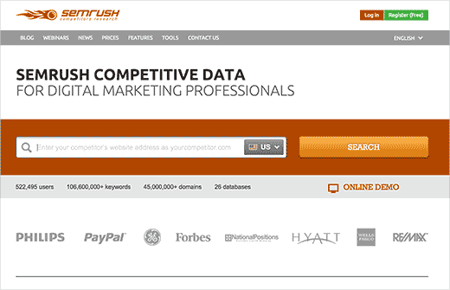](http://www.wpbeginner.com/refer/semrush/)

SEMRush is a tool that Pros use to gather analytics and insights from their competitor’s to help improve their own SEO.

You can learn about organic keywords to rank for, places where you can get backlinks from, insights into your competitor’s advertising strategies, and so much more.

SEMrush is a paid subscription and is used by thousands of SEO professionals all over the world. It can provide you an enormous wealth of data.

3. Google Keyword Planner

[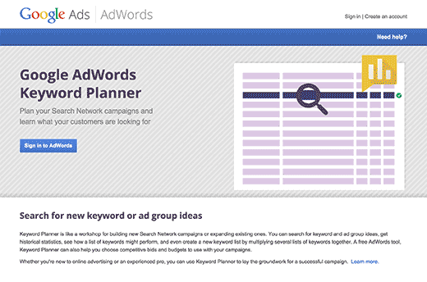](https://adwords.google.com/KeywordPlanner)

No one on the planet has more insights into what people are searching for than the search giant Google.

Did you know that you can get your own keyword ideas from Google itself by using the Google Keyword Planner tool?

This free tool is offered to Google’s advertisers for free and anyone can use it. Its main purpose is to show advertisers the keywords they can bid on for their advertising campaigns. It also helps advertisers choose right keywords by showing them an estimate of search volume, number of results, and difficulty level.

As a content marketer or blogger, you can use this data to find keywords with high search volume, high advertiser interest, and more importantly keywords where you can easily outrank all other sites.

4. KeywordTool.io

[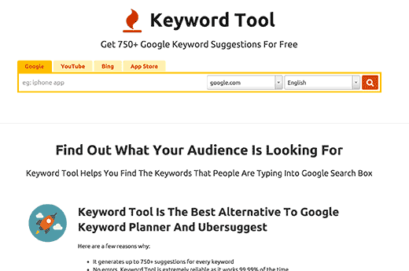](http://keywordtool.io/)

Keyword Tool is one of the best free keyword research tool available right now. It allows you to simply generate keyword ideas by typing in a keyword. These keyword suggestions are gathered from Google’s auto suggest feature.

These keyword suggestions are a treasure of information. Google autocomplete suggest keywords based on how often a keyword is used for the search. This means that the top most results are the most frequently searched terms on Google for that particular keyword.

Keyword Tool is amazingly fast, and most importantly it is completely free for anyone to use. You can use it to optimize content on your WordPress site. It also allows you to get keyword suggestions from YouTube, Bing, and App Store as well.

5. Open Site Explorer

[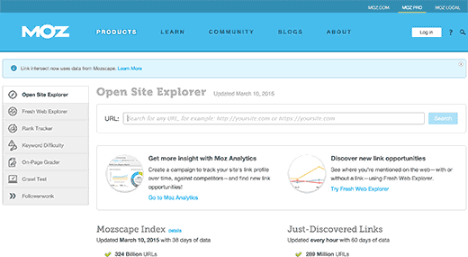](https://moz.com/researchtools/ose/)

Developed by Moz, this free tool allows you to check data for any domain name. You can see who is linking to that domain and what anchor texts they are using. Apart from that, Open Site Explorer offers a wealth of information like top pages, linking domains, which pages are linked on your site, etc.

This tool is free, but has daily search limits for each person.

To unlock the full power, you would need a Moz Pro Subscription which also gets you access to their other tools as well.

6. LinkPatrol

[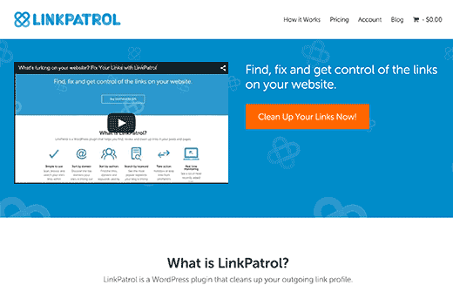](https://linkpatrolwp.com/)

LinkPatrol is a premium WordPress plugin which allows you to control all the links on your website.

You can monitor all the outgoing links on your site, find out which links are giving away link juice, and more.

LinkPatrol is less resource intensive than other free plugins that do the same job. It provides a quicker and efficient way to clean up all your anchor text, spammy links, and link juice problems with a very intuitive and super-fast user interface.

7. Broken Link Checker

Broken links can not only create bad experience for your users, but they can also affect your site’s SEO. If you have been running a blog for some time, then you should check your site from time to time for broken links and fix them.

Broken Link Checker is a free WordPress plugin that allows you to find broken links on your WordPress site. You can then fix those links without even editing your posts. See our tutorial on how to fix broken links in WordPress with Broken Link Checker.

It is a highly useful plugin, and it’s totally free. The only downside is that it can become resource intensive and may slow down your server. Some hosting providers like WPEngine has already blocked this plugin on their servers.

8. Rel NoFollow Checkbox

[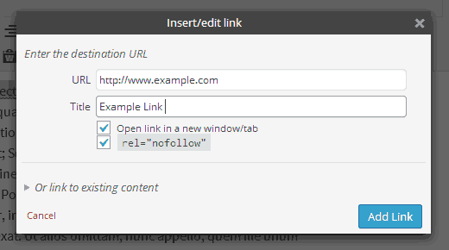](http://wordpress.org/plugins/rel-nofollow-checkbox/)

When you link to an external site, you are giving away some of your site’s authority to that link. If you don’t want do that, then you can add a nofollow attribute to that link.

In fact, you can even make all external links nofollow in WordPress. But this might not be a great idea. Sometime you may want to give a dofollow link to truly helpful sites.

Rel NoFollow Checkbox is a simple WordPress plugin which adds a checkbox in the insert link popup of WordPress post editor. This popup already has a check box which allows you to open links in new tab. Now whenever you are adding an external link you can easily make it nofollow by simply checking a box.

See our tutorial how to add a nofollow checkbox to insert link section in WordPress for detailed instructions.

9. SEOquake

[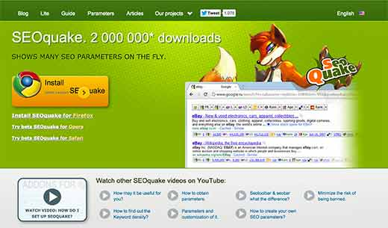](http://www.seoquake.com/)

SEOquake is a SEO tool available as browser addon for Google Chrome, Mozilla Firefox, Opera, and Safari web browsers. It provides SEO related information for any website. These information parameters include page rank, age, last updated, alexa rank, and many other parameters. It is one of the most downloaded browser addon by SEO professionals.

Apart from that, SEOquake toolbar can show you all these parameters for all the search results. This information can be extremely useful if you are gauging competition for different keywords. You can even download search results in CSV format and prepare your own excel sheets of search data.

Bonus SEO Tips for WordPress Site Owners

Site speed is one of the many important factors in search rankings. Fast loading sites can easily outrank slower websites. While you are spending a lot of time improving your content strategy, give some of that time to improve your site speed.

Make sure your WordPress site loads fast. You can check your site speed on tools like Google Page Speed and Pingdom.

Always install and setup a caching plugin on your WordPress site. We recommend using W3 Total Cache or WP Super Cache. To give your site speed even more boost, you can set up a CDN service to work with your caching plugin. At WPBeginner and on all our websites, we use MaxCDN. It greatly improves our page load times.

You should also upload optimized images only. Images can affect your site’s speed and by optimizing them you can significantly improve your sites performance.

Lastly, if none of these tips are improving your page speed, then its most likely your web host’s fault. You need to move to a better WordPress hosting provider. We recommend using Siteground because they have fully optimized servers to run WordPress sites. If you want managed WordPress hosting, then we recommend either Pagely or WPEngine.

_______________________________

About /robots.txt

Web site owners use the /robots.txt file to give instructions about their site to web robots; this is called *The Robots Exclusion Protocol*.

It works like this: a robot wants to visits a Web site URL, say http://www.example.com/welcome.html. Before it does so, it firsts checks for http://www.example.com/robots.txt, and finds:

User-agent: *

Disallow: /

The "User-agent: *" means this section applies to all robots. The "Disallow: /" tells the robot that it should not visit any pages on the site.

There are two important considerations when using /robots.txt:

* robots can ignore your /robots.txt. Especially malware robots that scan the web for security vulnerabilities, and email address harvesters used by spammers will pay no attention.
* the /robots.txt file is a publicly available file. Anyone can see what sections of your server you don't want robots to use.

So don't try to use /robots.txt to hide information.

**How to create a /robots.txt file**

**Where to put it**

The short answer: in the top-level directory of your web server.

The longer answer:

When a robot looks for the "/robots.txt" file for URL, it strips the path component from the URL (everything from the first single slash) and puts "/robots.txt" in its place.

For example, for "http://www.example.com/shop/index.html, it will remove the "/shop/index.html", and replace it with "/robots.txt", and will end up with "http://www.example.com/robots.txt".

So, as a web site owner you need to put it in the right place on your web server for that resulting URL to work. Usually that is the same place where you put your web site's main "index.html" welcome page. Where exactly that is, and how to put the file there, depends on your web server software.

Remember to use all lower case for the filename: "robots.txt", not "Robots.TXT.

See also:

* [What program should I use to create /robots.txt?](http://www.robotstxt.org/faq/editor.html)
* [How do I use /robots.txt on a virtual host?](http://www.robotstxt.org/faq/virtual.html)
* [How do I use /robots.txt on a shared host?](http://www.robotstxt.org/faq/shared.html)

**What to put in it**

The "/robots.txt" file is a text file, with one or more records. Usually contains a single record looking like this:

User-agent: *

Disallow: /cgi-bin/

Disallow: /tmp/

Disallow: /~joe/

In this example, three directories are excluded.

Note that you need a separate "Disallow" line for every URL prefix you want to exclude -- you cannot say "Disallow: /cgi-bin/ /tmp/" on a single line. Also, you may not have blank lines in a record, as they are used to delimit multiple records.

Note also that globbing and regular expression are **not** supported in either the User-agent or Disallow lines. The '*' in the User-agent field is a special value meaning "any robot". Specifically, you cannot have lines like "User-agent: *bot*", "Disallow: /tmp/*" or "Disallow: *.gif".

What you want to exclude depends on your server. Everything not explicitly disallowed is considered fair game to retrieve. Here follow some examples:

**To exclude all robots from the entire server**

User-agent: *

Disallow: /

**To allow all robots complete access**

User-agent: *

Disallow:

(or just create an empty "/robots.txt" file, or don't use one at all)

**To exclude all robots from part of the server**

User-agent: *

Disallow: /cgi-bin/

Disallow: /tmp/

Disallow: /junk/

**To exclude a single robot**

User-agent: BadBot

Disallow: /

**To allow a single robot**

User-agent: Google

Disallow:

User-agent: *

Disallow: /

**To exclude all files except one**

This is currently a bit awkward, as there is no "Allow" field. The easy way is to put all files to be disallowed into a separate directory, say "stuff", and leave the one file in the level above this directory:

User-agent: *

Disallow: /~joe/stuff/

Alternatively you can explicitly disallow all disallowed pages:

User-agent: *

Disallow: /~joe/junk.html

Disallow: /~joe/foo.html

Disallow: /~joe/bar.html

________________________

Verify your site ownership

What is verification?

Verification is the process of proving that you own the site or app that you claim to own. We need to confirm ownership because once you are verified for a site or app you have access to its private Google Search data, and can affect how Google Search crawls it.

What is a property?

A property in Search Console represents a site or app that you own. You can request actions on your property such as requesting a recrawl, or view Google Search data for your property, such as Google Search statistics or crawling errors.

Verification associates a specific user with a specific property. Every Search Console property requires at least one verified owner, though it can have more.

Note that you could add any site or app as a property to Search Console, but until you verify ownership of it (or an owner grants you rights on it) you can't use it in Search Console. For example, you could add www.wikipedia.org as a property to your Search Console account, but you couldn't access it until a Wikipedia developer helped you prove ownership (or a Wikipedia Search Console property owner added you as a user to the Search Console property).

Verify a website

1.Either add a new site or click Manage Property > Verify this property on the Search Console home page next to the existing property that you want to verify.

2. Choose one of the verification methods listed below and follow the instructions. Not all verification methods are available for all properties; the verification page will list which methods are available and recommended for your site.

Multiple people can add and verify a site separately, using the same or different methods. If you use the same method, just be sure that you don't overwrite any verification tokens of any other owners.

## How long does verification last?

Google periodically checks if your verification is valid in a way appropriate to your verification method (for example, by checking for the presence of an HTML tag on your site). If verification can no longer be confirmed, your permissions on that property will expire after a certain grace period.

If all verified owners expire for a property, all delegated owners (owners added by a verified owner), users, and associates for the property will lose access to the Search Console property.

Common verification errors

In addition to any method-specific verification errors, the following verification errors are possible in most verification methods:

The connection to your server timed out.

We were unable to verify your file because we received a server timeout. This could be because your server is down or is busy and responding slowly. Make sure that your server is responding and try again.

We encountered an error looking up your site's domain name.

We tried to access your verification file, but were unable to access your domain due to a DNS error. This could be because your server is down, or there is an issue with the DNS routing to your domain. Make sure that your domain is resolving correctly and try again.

The download request was redirected too many times.

Check the URL for potential issues, such as an infinite loop.

Your server returned an invalid response.

This can happen if your site is requires password authentication, or if we cannot access it for other reasons.

We were unable to connect to your server.

Make sure that your server is not down, and that your domain is resolving correctly, and try again.

An internal error occurred.

If this problem persists, check the Webmaster Central Help Forum for updates.

_________________________________

What is a sitemap?

A *sitemap* is a file where you can list the web pages of your site to tell Google and other search engines about the organization of your site content. Search engine web crawlers like Googlebot read this file to more intelligently crawl your site.

Also, your sitemap can provide valuable *metadata*associated with the pages you list in that sitemap: Metadata is information about a webpage, such as when the page was last updated, how often the page is changed, and the importance of the page relative to other URLs in the site.

You can use a sitemap to provide Google with metadata about specific types of content on your pages, including video and image content. For example, you can give Google the information about video and image content:

* A sitemap *video entry* can specify the video running time, category, and age appropriateness rating.
* A sitemap image entry can include the image subject matter, type, and license.

What is a site map in SEO?

* In simple terms, a **Sitemap** is an XML file that is full of your individual webpage's URLs. It's like an archive of every webpage in your website. This file should be easily discoverable in your site in order for search engine crawlers to stumble upon it.

## Build and submit a sitemap:

1. Decide which pages on your site should be crawled by Google, and determine the canonical version of each page.
2. Decide which sitemap format you want to use. You can create your sitemap manually or choose from a number of third-party tools to generate your sitemap for you.
3. Test your sitemap using the Search Console Sitemaps testing tool.
4. Make your sitemap available to Google by adding it to your robots.txt file and submitting it to Search Console.

How do I submit a sitemap to Google?

To submit your sitemap:

* Select your site on your Google Search Console home page.
* Click Crawl.
* Click Sitemaps.
* Click ADD/TEST SITEMAP.
* Type sitemap.xml.

Sitemap formats:-

Google supports several sitemap formats, described here.

All formats limit a single sitemap to 10MB (uncompressed) and 50,000 URLs. If you have a larger file or more URLs, you will have to break your list into multiple sitemaps. You can optionally create a sitemap index file (a file that points to a list of sitemaps) and submit that single index file to Google. You can submit multiple sitemaps and/or sitemap index files to Google.

XML:-

Google supports the standard sitemap protocol. Google also supports XML extensions for video, images, mobile, and news resources; use these extensions to describe video files, images, and other hard-to-parse content on your site to improve how we index these resources.

Here is a very basic XML sitemap that includes the location of a single URL:

<?xml version="1.0" encoding="UTF-8"?>

<urlset xmlns="http://www.sitemaps.org/schemas/sitemap/0.9">

<url>

<loc>http://www.example.com/foo.html</loc>

</url>

</urlset>

RSS, mRSS, and Atom 1.0:-

If you have a blog with an RSS or Atom feed, you can submit the feed's URL as a sitemap. Most blog software is able to create a feed for you, but recognize that this feed only provides information on recent URLs.

* Google accepts RSS (Real Simple Syndication) 2.0 and Atom 1.0 feeds.
* You can use an mRSS (media RSS) feed to provide Google details about video content on your site.

Text:-

If your sitemap includes only web page URLs, you can provide Google with a simple text file that contains one URL per line. For example:

http://www.example.com/file1.html

http://www.example.com/file2.html

Guidelines for text file sitemaps:

* Encode your file using UTF-8 encoding.
* Your text file should contain nothing but the list of URLs.
* You can name the text file anything you wish, provided it has a .txt extension (for instance, sitemap.txt).

Google sites:-

If you've created and verified a site using Google Sites, Sites will automatically generate a sitemap for you. You cannot modify the sitemap, but you can submit it to Google if you want to read the sitemap report data. Note that your sitemap might not be displayed properly if you have more than 1,000 pages in a single sub-directory.

* If your site is hosted at Google Sites, your sitemap URL is http://sites.google.com/site/yoursitename/system/feeds/sitemap
* If you created your site using Google Apps, your sitemap URL is http://sites.google.com/yourdomain/yoursitename/system/feeds/sitemap

What is a video site map?

A video sitemap is a text file packed with useful data about the content of your video. By submitting a sitemap to Google, you are informing the search engine of your video's title, subject matter, run time, who the intended audience is, and many more details that will influence how and when it gets indexed.

You can use the Google Video extension to the Sitemap protocol to give Google information about video content on your site. You can create a new video Sitemap or add video information to an existing Sitemap.

Adding video content to a Sitemap:-

The entries in a video Sitemap must include a link to a landing page for a video and some required information. Many of the elements in a video Sitemap are optional, but they provide useful metadata that can enhance your video results and improve Google's ability to include your video in search results.

Once you have created your Sitemap, you can submit it to Google using Search Console.

Guidelines for video content in Sitemaps:-

Video content includes web pages which embed video, URLs to players for video, or the URLs of raw video content hosted on your site. If Google cannot discover video content at the URLs you provide, those entries will be ignored by Googlebot.

Each URL entry must contain the following information:

* Title
* Description
* Play page URL
* Thumbnail URL
* Raw video file URL and/or the video player URL
* Each Sitemap file that you provide must have no more than 50,000 entries. If you have more than 50,000 videos, you can submit multiple Sitemaps and a Sitemap index file. Sitemaps does not support nesting of Sitemaps index files. Keep in mind that if you are adding optional tags, you may hit the 50MB uncompressed limit before you hit the 50,000 video limit.
* Google can crawl the following video file types: mpg, .mpeg, .mp4, .m4v, .mov, .wmv, .asf, .avi, .ra, .ram, .rm, .flv, .swf. All files must be accessible via HTTP. Metafiles that require a download of the source via streaming protocols are not supported.
* Make sure that your robots.txt file isn't blocking any of the items (including the play page URL, the video URL, and the thumbnail URL) included in each Sitemap entry. More information about robots.txt.
* Google will verify that the information you include for each video matches what is on your site. To see how your site will appear to Google, you should view your play pages in a text-only browser such as Lynx, or a more conventional browser with Flash and JavaScript disabled.
* You can specify pages from different sites in one Sitemap. All sites, including the one containing your Sitemap, must be verified in Search Console.

Image sitemaps:-

Follow Webmaster Guidelines and best practices for publishing images to increase the likelihood that your images can be found in Image Search results. Additionally, you can use Google image extensions for sitemaps to give Google more information about the images available on your pages. Image sitemap information helps Google discover images that we might not otherwise find (such as images your site reaches with JavaScript code), and allows you to indicate images on your site that you want Google to crawl and index.

You can use a separate sitemap to list images, or you can add image information to an existing sitemap. The following example shows a sitemap entry for the page http://example.com/sample.html, which contains two images.

<?xml version="1.0" encoding="UTF-8"?>

<urlset xmlns="http://www.sitemaps.org/schemas/sitemap/0.9"

xmlns:image="http://www.google.com/schemas/sitemap-image/1.1">

<url>

<loc>http://example.com/sample.html</loc>

<image:image>

<image:loc>http://example.com/image.jpg</image:loc>

</image:image>

<image:image>

<image:loc>http://example.com/photo.jpg</image:loc>

</image:image>

</url>

</urlset>

You can list up to 1,000 images for each page, using the syntax outline in the example above!

___________________________________

What is a Webmaster Tool?

Google Search Console (previously Google Webmaster Tools) is a no-charge web service by Google for webmasters. It allows webmasters to check indexing status and optimize visibility of their websites. As of May 20, 2015, Google rebranded Google Webmaster Tools as Google Search Console.

What is Google Search Console?

Google Search Console is a collection of tools and resources to help website owners, webmasters, web marketers and SEO professionals monitor website performance in the Google search index.

Features include information about search appearance, search traffic, technical status updates, crawl data and additional educational resources.

Google Webmaster Tool becomes now Google Search Console. Actually search console is very useful to monitor a site performance. This article covers all beginners’ steps, it might be useful for those who are not aware of this search console. Here it is another step in short.

Search Traffic:

* Search Analytic - Analyze your performance on Google Search Console by (clicks, impression, CTR, position). You can compare your results for better understand.
* Links to Your Site - It will show you who links the most. You can download XL sheet by clicking on your website URL for better understand.
* Internal Links - It will show you how many internal links in your website. If you can't see any of your internal link then you can find on search box.
* Manual Action - The manual action in search console shows information about actions taken by the manual webspam team that directly affect that site’s ranking in Google’s web search results. You’ll probably see a message that says, “No manual webspam actions found.” So, keep checking those notification.
* International Targeting - In this section you can target your audience based on location and language settings. For language setting "hreflang" tags are necessary in your website.
* Mobile Usability - Fix mobile usability issues affecting your site. If your website is mobile friendly then it will show you "No mobile usability errors detected."

Here you will learn: -

1. Adding and verifying a site in Google Search Console

## 2. Adding an HTML tag

## 3. Uploading an HTML file

## 4. Verifying via domain name provider

## 5. Adding Google Analytics code

## 6. Using Google Tag Manager

## 7. How to link Google Analytics with Google Search Console

## 8. Adding a sitemap

## 9. Checking a robots.txt file

## 10. Fetch as Google and submit to index

## 11. Site errors in Google Search Console

## __________________________________________________________

What is the meaning of web analytics?

Web analytics is the measurement, collection, analysis and reporting of web data for purposes of understanding and optimizing web usage. Web analytics is not just a tool for measuring web traffic but can be used as a tool for business and market research, and to assess and improve the effectiveness of a website.

What is the Google Analytics?

Google Analytics is a free Web analytics service that provides statistics and basic analytical tools for search engine optimization (SEO) and marketing purposes. The service is available to anyone with a Google account.

A Brief History of Analytics

Google Analytics was originally developed from the Urchin on Demand software that Google acquired in the spring of 2005 (Urchin is still developed and available through value-added resellers, and is currently at version 7). The first Google-branded version was released in November 2005. In 2006, further ideas from Measure Map (developed by Adaptive Path) were integrated into Analytics when Google acquired them.

Early on, Analytics was available by invitation only, as demand for the product was very high. It wasn’t fully available to all users until nearly a year after its initial release (August 2006)

What is a tracking code for Google Analytics?

Tracking code. The tracking code (1) is a snippet of JavaScript that collects and sends data to Google Analytics from a website. It's automatically generated for every web property. You need to copy and paste it from your account on to your web pages for Google Analytics to work.

How do I get my Google Analytics code?

To find the tracking code, tracking ID, or property number in your Google Analytics account:

Sign in to your Analytics account.

Select the Admin tab.

Select an account from the dropdown in the ACCOUNT column.

Select a property from the dropdown in the PROPERTY column.

Under PROPERTY, click Tracking Info > Tracking Code.

Why every website owner needs Google Analytics

Do you have a blog? Do you have a static website? If the answer is yes, whether they are for personal or business use, then you need Google Analytics.

Here are just a few of the many questions about your website that you can answer using Google Analytics.

* How many people visit my website?
* Where do my visitors live?
* Do I need a mobile-friendly website?
* What websites send traffic to my website?
* What marketing tactics drive the most traffic to my website?
* Which pages on my website are the most popular?
* How many visitors have I converted into leads or customers?
* Where did my converting visitors come from and go on my website?
* How can I improve my website's speed?
* What blog content do my visitors like the most?

There are many, many additional questions that Google Analytics can answer, but these are the ones that are most important for most website owners. Now let's look at how you can get Google Analytics on your website.

Here what you learn about Google Analytics

How to install Google Analytics

First, you need a Google Analytics account. If you have a primary Google account that you use for other services like Gmail, Google Drive, Google Calendar, Google+, or YouTube, then you should set up your Google Analytics using that Google account. Or you will need to create a new one.

This should be a Google account you plan to keep forever and that only you have access to. You can always grant access to your Google Analytics to other people down the road, but you don't want someone else to have full control over it.

Big tip: don't let your anyone (your web designer, web developer, web host, SEO person, etc.) create your website's Google Analytics account under their own Google account so they can "manage" it for you. If you and this person part ways, they will take your Google Analytics data with them, and you will have to start all over.

Set up your account and property

Once you have a Google account, you can go to Google Analytics and click the Sign into Google Analytics button. You will then be greeted with the three steps you must take to set up Google Analytics.

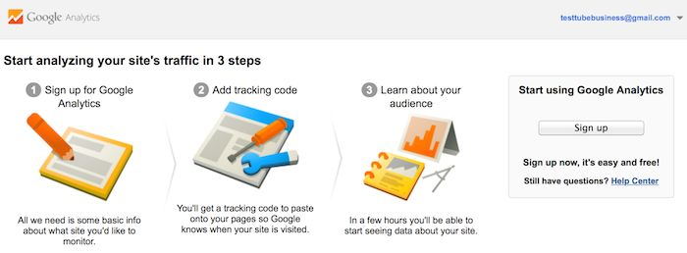

After you click the Sign Up button, you will fill out information for your website.

Install your tracking code

Once you are finished, you will click the Get Tracking ID button. You will get a popup of the Google Analytics terms and conditions, which you have to agree to. Then you will get your Google Analytics code.

This must be installed on every page on your website. The installation will depend on what type of website you have. For example, I have a WordPress website on my own domain using the Genesis Framework. This framework has a specific area to add header and footer scripts to my website.

* if you have a WordPress on your own domain, you can use the Google Analytics by Yoast plugin to install your code easily no matter what theme or framework you are using.
* If you have a website built with HTML files, you will add the tracking code before the </head> tag on each of your pages. You can do this by using a text editor program (such as TextEdit for Mac or Notepad for Windows) and then uploading the file to your web host using an FTP program (such as FileZilla).
* If you have a Shopify e-commerce store, you will go to your Online Store settings and paste in your tracking code where specified.
* If you have a blog on Tumblr, you will go to your blog, click the Edit Theme button at the top right of your blog, and then enter just the Google Analytics ID in your settings.

The installation of Google Analytics varies based on the platform you use (content management system, website builder, e-commerce software, etc.), the theme you use, and the plugins you use. You should be able to find easy instructions to install Google Analytics on any website by doing a web search for your platform + how to install Google Analytics.

Set up goals:

After you install your tracking code on your website, you will want to configure a small (but very useful) setting in your website's profile on Google Analytics. This is your Goals setting. You can find it by clicking on the Admin link at the top of your Google Analytics and then clicking on Goals under your website's View column.

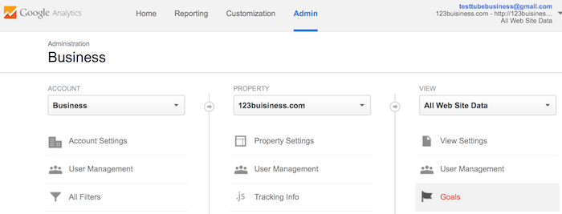

Goals will tell Google Analytics when something important has happened on your website. For example, if you have a website where you generate leads through a contact form, you will want to find (or create) a thank you page that visitors end upon once they have submitted their contact information. Or, if you have a website where you sell products, you will want to find (or create) a final thank you or confirmation page for visitors to land upon once they have completed a purchase.

Set up site search

Another thing you can set up really quickly that will give you valuable data down the road is Site Search. This is for any website with a search box on it

**Add additional accounts and properties**

If you want to add a new Google Analytics account, you can do so by going to your Admin menu, clicking on the drop-down under the Account column, and clicking the Create New Account link.

How to view Google Analytics data

Once you start getting in Google Analytics data, you can start learning about your website traffic. Each time you log in to Google Analytics, you will be taken to your Audience Overview report. Alternatively, if you have more than one website, you will be taken to your list of websites to choose from, and then taken to the Audience Overview report for that website. This is the first of over 50 reports that are available to you in Google Analytics. You can also access these reports by clicking on the Reporting link at the top.

Standard report features

Most of the standard reports within Google Analytics will look similar to this. At the top right, you can click on the drop-down arrow next to your website to switch to different websites within all of your Google Analytics accounts. Or you can click the Home link at the top.

Types of Google Analytics reports

Speaking of reports, here is quick summary of what you will find in each of the standard Google Analytics reporting sections, accessible in the left sidebar.

Everything in (parenthesis) is a specific report or set of reports within the following sections that you can refer to.

**1. Audience reports**

These reports tell you everything you want to know about your visitors. In them, you will find detailed reports for your visitors' age and gender (Demographics), what their general interests are (Interests), where they come from (Geo > Location) and what language they speak (Geo > Language), how often they visit your website (Behavior), and the technology they use to view your website (Technology and Mobile).

**2. Acquisition reports**

These reports will tell you everything you want to know about what drove visitors to your website (All Traffic). You will see your traffic broken down by main categories (All Traffic > Channels) and specific sources (All Traffic > Source/Medium).

You can learn everything about traffic from social networks (Social). You can also connect Google Analytics to AdWords to learn more about PPC campaigns and to Google Webmaster Tools / Search Console to learn more about search traffic (Search Engine Optimization)

**3.Behavior reports**

These reports will tell you everything you want to know about your content. Particularly, the top pages on your website (Site Content > All Pages), the top entry pages on your website (Site Content > Landing Pages), and the top exit pages on your website (Site Content > Exit Pages).

If you set up Site Search, you will be able to see what terms are searched for (Site Search > Search Terms) and the pages they are searched upon (Site Search > Pages).

You can also learn how fast your website loads (Site Speed) as well as find specific suggestions from Google on how to make your website faster (Site Speed > Speed Suggestions).

Conversions:

If you set up Goals within your Google Analytics, you can see how many conversions your website has received (Goals > Overview) and what URLs they happened upon (Goals > Goal URLs). You can also see the path that visitors took to complete the conversion (Goals > Reverse Goal Path).

Speaking of goals and conversions, most of the tables within Google Analytics standard reports will tie specific data to your conversions. For example, you can see the number of conversions made by visitors from California in the Audience > Geo > Location report. You can see the number of conversions made by visitors from Facebook in the Acquisitions > All Traffic > Source/Medium report. You can see the number of conversions made by visitors who landed on specific pages in the Behavior > Site Content > Landing Pages report.

Shortcuts and emails

While you won't need every report within Google Analytics, you should explore them all to see what they have to offer. When you find some that you want to visit again and again, use the Shortcut link at the top of the report to add them to the Shortcuts in your left sidebar for faster access.

____________________________

Alexa rank is very important for SEO purpose, your website's value and impression depends on your Alexa ranking. ... The Alexa rank  probably contributes nothing to search engine ranking. The Alexa rank is a crude measure of traffic. And the traffic to a site has an increasing impact on its ranking.

Off page SEO

What is Domain Authority (DA)?

Domain Authority is a score (on a 100-point scale) developed by Moz that predicts how well a website will rank on search engines. Use Domain Authority when comparing one site to another or tracking the “strength” of your website over time. We calculate this metric by combining all of our other link metrics—linking root domains, number of total links, MozRank, MozTrust, etc.—into a single score.

To determine Domain Authority, we employ machine learning against Google's algorithm to best model how search engine results are generated. Over 40 signals are included in this calculation. This means your website's Domain Authority score will often fluctuate. For this reason, it's best to use Domain Authority as a competitive metric against other sites as opposed to a historic measure of your internal SEO efforts.

**How is Domain Authority Scored?**

We score Domain Authority on a 100-point, logarithmic scale. Thus, it's easier to grow your score from 20 to 30 than it would be to grow from 70 to 80.

**Domain Authority vs. Page Authority**

Whereas Domain Authority measures the predictive ranking strength of entire domains or subdomains, Page Authority measures the strength of individual page. The same is true for metrics such as MozRank and MozTrust.

**Where can you Find Domain Authority?**

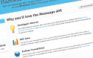 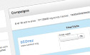 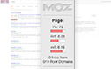 

Domain Authority metrics are incorporated into dozens of SEO and online marketing platforms across the web.

You can measure Domain Authority using Open Site Explorer or the MozBar, Moz's free SEO toolbar. Moz incorporates Authority metrics into all Moz Analytics campaigns, as well as the Mozscape API.

**Technical Definition of Domain Authority**

Domain Authority is Moz's calculated metric for how well a given domain is likely to rank in Google's search results. It is based off data from the Mozscape web index and includes link counts, MozRank and MozTrust scores, and dozens of other factors. It uses a machine learning model to predictively find an algorithm that best correlates with rankings across thousands of search results that we predict against.

It's best to use Page Authority (PA) and Domain Authority (DA) as comparative metrics when doing research in the search results and determining which sites/pages may have more powerful/important link profiles than others. While specific metrics like MozRank can answer questions of raw link popularity—and link counts can show the raw quantities of pages/sites linking—the authority numbers are high-level metrics that attempt to answer the question, "How strong are this page's links in terms of helping them rank for queries in Google.com?"

SEO Best Practice

How do I influence this metric?

Unlike other SEO metrics, Domain Authority is difficult to influence directly. It is made up of an aggregate of metrics (MozRank, MozTrust, link profile, and more) that each have an impact on this score. This was done intentionally; this metric is meant to approximate how competitive a given site is in Google.com. Since Google takes a lot of factors into account, a metric that tries to calculate it must incorporate a lot of factors, as well.

The best way to influence this metric is to improve your overall SEO. In particular, you should focus on your link profile—which influences MozRank and MozTrust—by getting more links from other well-linked-to pages.

BackLinks: -

Backlinks are incoming links to a webpage. When a webpage links to any other page, it's called a backlink. In the past, backlinks were the major metric for the ranking of a webpage. A page with a lot of backlinks tended to rank higher on all major search engines, including Google.

Backlinks are the references to Google search.

If you have 8 backlinks to a website that means:-

1. There are 8 different web pages which are referring to your site.

2. It means there are 8 webpages that are trusting your content/web page, as the result they are referring your page to their visitors.

Google takes references as suggestions and for Google suggestions are the “Back Links”

What is do-follow links:-

This kind of link will pass PR and it’s highly recommended by search engines (Google, Bing, and Yahoo).

Example of do-follow link

<a herf="http://www.example.com/">LinkText</a>

What are No-follow links?

This link will not pass PR.

Example of NO-Follow link

<a herf="http://www.example.com" rel="nofollow">Link text</a>

What is an incoming link?

Backlinks, also known as incoming links, inbound links, inlinks, and inward links, are incoming links to a website or web page. In basic link terminology, a backlink is any link received by a web node (web page, directory, website, or top level domain) from another web node.

Link building (alternative spellings include linkbuilding and link-building) refers to the process of getting external pages to link to a page on your website. It is one of the many tactics used in search engine optimization (SEO).

Building links is a difficult, time-consuming process as not all links are created equal. A link from an authoritative website like the Wall Street Journal will make a greater impact on a SERP than a link from a newly built website, but high quality links are hard to come by. This guide will teach you how to build quality links.

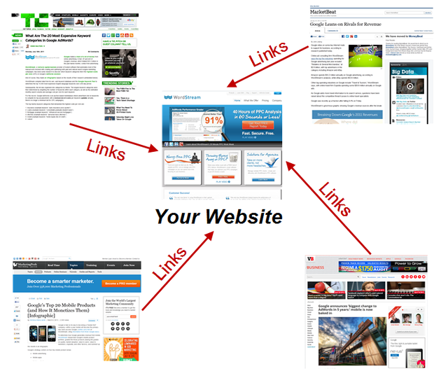

Remember, link building is imperative in achieving high [organic search rankings](http://www.wordstream.com/search-engine-optimization).

Link Building Basics: -

Link building is an art. It's almost always the most challenging part of an SEO's job, but also the one most critical to success. Link building requires creativity, hustle, and often, a budget. No two link building campaigns are the same, and the way you choose to build links depends as much upon your website as it does your personality.

Below are three basic types of link acquisition.

1. "Natural" Editorial Links: -

Links that are given naturally by sites and pages that want to link to your content or company. These links require no specific action from the SEO, other than the creation of worthy material (great content) and the ability to create awareness about it.

1. Manual "Outreach" Link Building: -

The SEO creates these links by emailing bloggers for links, submitting sites to directories, or paying for listings of any kind. The SEO often creates a value proposition by explaining to the link target why creating the link is in their best interest. Examples include filling out forms for submissions to a website award program or convincing a professor that your resource is worthy of inclusion on the public syllabus.

1. Self-Created, Non-Editorial:-

Hundreds of thousands of websites offer any visitor the opportunity to create links through guest book signings, forum signatures, blog comments, or user profiles. These links offer the lowest value, but can, in the aggregate, still have an impact for some sites. In general, search engines continue to devalue most of these types of links, and have been known to penalize sites that pursue these links aggressively. Today, these types of links are often considered spammy and should be pursued with caution.

Why is link building important for SEO?

The anatomy of a hyperlink

In order to understand the importance of link building, it's important to first understand the basics of how a link is created, how the search engines see links, and what they can interpret from them.

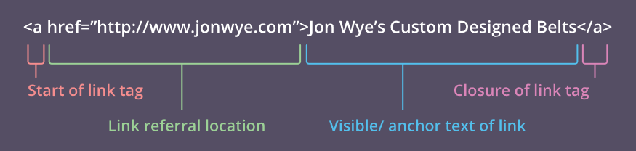

1. Start of link tag**:** Called an anchor tag (hence the "a"), this opens the link tag and tells search engines that a link to something else is about to follow.
2. Link referral location**:** The "href" stands for "hyperlink referral," and the text inside the quotation marks indicates the URL to which the link is pointing. This doesn't always have to be a web page; it could be the address of an image or a file to download. Occasionally, you'll see something other than a URL, beginning with a # sign. These are local links, which take you to a different section of the page you're already on.
3. Visible/anchor text of link**:** This is the little bit of text that users see on the page, and on which they need to click if they want to open the link. The text is usually formatted in some way to make it stand out from the text that surrounds it, often with blue color and/or underlining, signaling to users that it is a clickable link.
4. Closure of link tag**:** This signals the end of the link tag to the search engines

What links mean for search engines: -

There are two fundamental ways that the search engines use links:

1. To discover new web pages
2. To help determine how well a page should rank in their results

Once search engines have crawled pages on the web, they can extract the content of those pages and add it to their indexes. In this way, they can decide if they feel a page is of sufficient quality to be ranked well for relevant keywords (Google created a short video to explain that process). When they are deciding this, the search engines do not just look at the content of the page; they also look at the number of links pointing to that page from external websites and the quality of those external websites. Generally speaking, the more high-quality websites that link to you, the more likely you are to rank well in search results.

Links as a ranking factor are what allowed Google to start to dominate the search engine market back in the late 1990s. One of Google's founders, Larry Page, invented PageRank, which Google used to measure the quality of a page based in part on the number of links pointing to it. This metric was then used as part of the overall ranking algorithm and became a strong signal because it was a very good way of determining the quality of a page.

--------------------------------

What is PageRank?

(PR) is a calculation, famously invented by Google founders Larry Page and Sergey Brin, which evaluates the quality and quantity of links to a webpage to determine a relative score of that page's importance and authority on a 0 to 10 scale. PageRank is a way of measuring the importance of website pages.

Google PageRank shows how important web pages are to the world. It include content richness, page authority, keyword density, back links, images.

But From March 2016 Google has confirmed that it is removing Toolbar PageRank. That means that if you are using a tool or a browser that shows you PageRank data from Google, within the next couple weeks it will begin not to show any data at all.

Google explained that the company still uses PageRank data internally within the ranking algorithm, but the external PageRank values shown in the Toolbar are going away completely.

For years and years, Google has stripped away PageRank from their Toolbars and browsers and hasn’t updated the PageRank score in it in years.

Search engine submission: -

 Search engine submission is an effective tool of web promotion. It refers to the direct submission of a website to a search engine. It is a form of internet marketing that helps webmasters increase the rankings of a web pages or pages.

Search engine submission is an effective tool of web promotion. It refers to the direct submission of a website to a search engine.

It is a form of internet marketing that helps a webmasters increase the rankings of a web pages or pages.

The search engine submission process is done through two methods primarily.

1. The first method is submitting one page at a time by using various webmaster tools such as Google Webmaster Central or Bing Webmaster Tools and by generating an up to date sitemap file along with a robots text file.

2. The second one requires submission of the entire site by submitting the home page and home page only to as many search engines as possible which is a mass submission process.

This type of search engine submission requires that the webmaster submits the website’s home page and then the rest will occur automatically after your site has been listed in multiple search engine databases and indexed by these search engines.

We have to manually submit our site on Google and yahoo. For another top 50 top submission sites we can use 2 websites to do it at once.

1. freewebsubmission.com

2. entireweb.com

# Why Search Engine Submission Is Necessary?

The simple answer is yes – search engine submission is necessary. The majority of search engines nowadays (most especially Google) crawl and index pages by following links. Using that logic, a single inbound link from any already-indexed page will identify your page to the engine. Subsequently, if that page links to other pages within your site, they will also be indexed… and so on.

The main reason people submit their sites to search engines is because they want their site to be discovered quickly by spiders and don’t want to wait for the search engines to find them organically. Brand-new sites especially want to be discovered quickly and submitting to search engines is a general SEO tool used in the beginning of a website’s life.

Another reason people choose to submit their sites to search engines is if they have a webpage or part of their site that has just been updated. Submitting your site after updates helps them get recognized more quickly.

There are two methods to submitting a site to a search engine. You can either submit one page at a time or submit the entire site. Generally webmasters submit the home page of the website because search engine spiders are sophisticated enough to crawl an entire site after they’ve been directed to the homepage.

For mature sites it’s generally not necessary to submit to search engines because the major ones like Google, Bing and Yahoo have already used their spiders, bots and crawlers to navigate the already established sites and rank them accordingly. However, as mentioned above, if you make major renovations on your site and want the search engines to recognize them quickly there’s no harm in resubmitting. In fact, there’s no harm at all in submitting your site to search engines on a regular basis.

When submitting your site focus on the top three search engines. If you are having your website design or redesign, this will often be included as part of your package. But you can also manually submit your site to the major search engines whenever you wish.

Directory submission: -

Directory submission in SEO is process of submitting our website URL on various business directories or web directories to create backlinks. Backlinks are used by search engines to improve ranking. If you have more backlinks to your website from relevant websites, ranking of your website will improve.

Directory submission is a sort of site submission where you submit your site to other online web index. You should do that submission to lead the site to be found by the search spiders.

How to do directory submission?

Following are the basic steps to submit your website in Directories:-

1. Find the list of directories

2. Choose the directories based on your requirement, consider the following facts in mind like number of blog associated, PR of the site, Alexa rank, domain authority, number of indexed pages in search engines (Google, Yahoo, Bing).

3. Choose a relevant category for your submission

4. Choose a relevant sub-category

5. Write down your website, click on Submit your site

6. Fill the details in the given fields to add your website.

Article Writing and submissions: -

SEO writing is a form of writing that helps websites become more visible to major search engines like Google and Bing. A highly visible website with good content appears on the first few pages of results when someone searches for that topic.

That makes writing for SEO very worthwhile for websites seeking an audience.

Here are the 7 secrets of professional SEO article writers:

1. **[](http://contentfac.com/wp-content/uploads/2011/01/seo-article-writing-services.jpg)**
2. **Get your keyword research on.**If you're going to post content on your site anyway, you might as well take the time to make sure Google takes notice of your effort. Find out which keywords and phrases people are searching for (as well as what you can be competitive in), and make yourself a spreadsheet. Keep track of how many times you work the keywords into your web content writing, and use the right tools to track where you rank for the keywords you target.
3. **Put the keywords to work.**It's not enough to just use the keywords in 2-3% of the copy. You need to put the primary keyword in the title of the blog/article, as well as in the first and last sentence. By doing this, the keywords stand out to the search engine crawlers, as well as the eyes of the readers. Remember, the people using search engines are searching for that particular phrase because they want to know more about it/buy it, so it makes sense to give them what they're looking for. You'll get more clicks if you do — it's one of the tricks of the trade for professional SEO article writers.
4. **Write about something people care about.**Nobody knows your business like you do — so what kind of expert advice or tips do you have that you can share? If not, you can at least discuss news relating to your business. When in doubt, look at your list of SEO keywords and see what kind of list, link bait or in-depth posts you can work those keywords into. Don't be afraid to interview some experts, either (if you quote them and feature their expertise in your post, they'll be likely to share your content via their social channels — this way, you can leverage larger networks to increase the size of your own).
5. **Make it long enough to count.**Sure, 100 words of fresh content is better than no new content at all. Still, search engines tend to give preference to longer blogs and articles. Try to shoot for at least 300 words, but if you can get to 500 or more, go for it. There has been a lot of research that shows that search engines tend to favor "in-depth" content of at least 2,000 words.
6. **Optimize the optimization of your web content writing.**If you use WordPress as your blogging platform, there are lots of free online PR tools (in the form of plugins) you can take advantage of. At The Content Factory, Use Yoast and Shareaholic, along with several others. Free and easy web PR is as simple as hitting the "install now" link.
7. **Edit your work.**The only difference between professional SEO article writers and regular people is an eye for self-editing. Programs like OpenOffice, Google Docs and Microsoft Word make it easy — the red and green squiggleys give most of it away. Having an eye for aesthetically pleasing formatting is also important. Stay away from super long paragraphs and sentences that go on for miles.
8. **Become your own online PR agency.**Once you've written and posted the fresh content, the work is only half complete. The final step of all web content writing is acting as your own online PR agency — link to your content all over the place. Comment on blogs and link back to your site. Submit your content to Digg, Reddit and StumbleUpon. Social media management and web content writing go hand-in-hand, and as soon as you hit the "Publish" button on your fresh article or blog, you should tweet your heart out.

What Is a Press Release / News Release?

Whether we call it a "press release," a "press statement," a "news release," or a "media release," we're always talking about the same basic thing: an official announcement (written or recorded) that an organization issues to the news media and beyond.

Most press releases are succinct at just a page long. Two pages tops. Ultimately, companies want to provide enough information so that news outlets have sufficient material for publishing their own stories about whatever the company is announcing in the release.

When Should I Distribute a Press Release?

While there's no cut-and-dried formula for when a press release should be written (and distributed), here's a few reasons when it's a good idea:

* New product launches
* Updates to existing products
* Opening a new office
* Introducing a new partnership
* Rebranding
* Promoting/hiring a new executive
* Receiving an award

A regular cadence of (meaningful) news can help a company stand out and build mindshare with journalists over time, so that's where the press release (or news announcement) comes in.

## How to Write a Press Release:-

## You've got your announcement in mind, and now it's time to get it down in words to share with your community, industry, and followers.

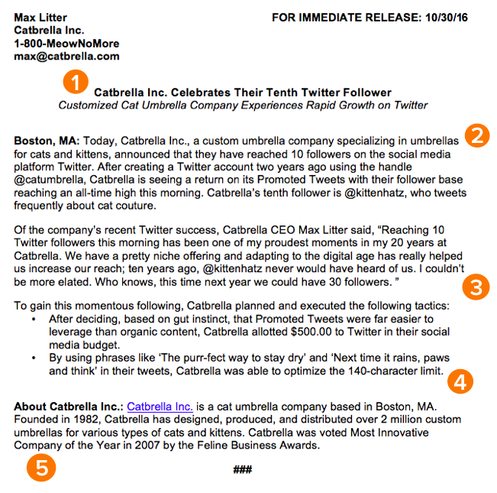

1: Make Your Headline Irresistible:-

After keyword research, Article tittle is the most important thing

Setting up your press release for success starts with your headline. You only have one line to work with, which can seem scary, but consider diction carefully to make your headline captivating. Each day, so invest the time to write a compelling headline. It's worth the time and effort on your part.

Use action verbs, clear, understandable language, and keep your headline simple and short -- fortune (and search engines) reward the brief, so keep your title to one line to clearly focus people's attention on your topline message.

Most importantly, make it interesting: Keep in mind that reporters get dozens, if not hundreds, of releases each day, so invest the time to write a compelling headline. It's worth the time and effort on your part.

2: Don't Play Hard to Get:-

For reporters, analysts, influencers, or followers to be inclined to share your announcement, you have to tell them upfront why they should care.

The first paragraph of your release should cover the, who, what, why, where, and how of your new launch, update, or development. Reporters don't have a ton of time to sift through details and fluffy background information -- they just need the facts that'll help them tell your story to someone else from a position of authority.

There shouldn't be any new, crucial information covered after this section that the reader could potentially miss.

3: Offer a Tempting Quotable: -

Once you've set the scene, it's time to bring your details to life with a quote that reporters can use for context around your announcement and help paint a picture of how your news affects the given industry, customer base, and landscape.

Ideally, quotes will be from key stakeholders in your company including your executive team, project leads, or those directly impacted by your announcement. Quoting key figures and authorities underlines the importance of your development. The chosen quote should shape your narrative and emphasize the core of the announcement. Don't ask everyone in your office for a comment or feel compelled to quote all 25 people included in the acquisition -- pick one or two critical spokespeople and focus the quotes around their unique perspective.

4: Provide Valuable Background Information: -

In this last paragraph, keep in mind that the reader already has all of the vital details and information they need to file a story or spread the word.

It can be tempting to provide superfluous facts and tidbits about your company or the development of your announcement -- we sometimes think a piece of writing is lacking if it isn't drawn-out and just shy of being a novella. However, a press release needs to be helpful and concise.

Offer details here that strengthen your narrative, like creative or noteworthy ways your company developed the project or announcement at hand. Or, when applicable, comment on future implications of your announcement.

5: Make the "Who" and "What" Obvious: -

Twitter is chock-full of reporters lamenting press releases or pitches that don't clearly explain what the company does or what the announcement is actually about, so instead of being the butt of a joke, make your release incredibly easy to reference.

Describe what your company does in clear, plain English, include a link to your company's homepage early on, and make your boilerplate succinct and straightforward. If you cite data, include a reference link for the data source, and make sure every name in the release has an associated title and company as well.

Tips for Publishing Press Releases: -

Writing a press release is really only half the battle. Once you're finished with production, it'll be time to focus on distribution.

Of course, we're all familiar with the traditional distribution levers we can pull, which include publishing the press release on our website/blog, as well as sharing the press release with our followers/subscribers via social media and email. But for ensuring a press release gets the maximum amount of distribution possible, here are some tips you can follow.

1) Reach out to specific journalists.

Instead of blasting a press release out to every journalist you can find an email address for, focus on a few journalists who have experience covering your industry (and company, hopefully) and send them personalized messages. Connect the dots. Show why what *you* wrote connects to what *they* write.

2) Don't be afraid to go offline.

Most journalists have mountains of emails (and press releases) to sort through. Try sending your release through snail mail or another offline channel to differentiate yourself.

3) Send the release to top journalists the day before.

Give journalists some time to craft a story around your press release by sending it to them -- under embargo -- the day before it officially goes live. (FYI "under embargo" just means they aren't allowed to share the information in the press release until the time you specify.)

4) To avoid competition, don't publish your release on the hour.

If you're publishing your press release on a distribution service like PR Newswire or Business Wire, avoid publishing it on the hour (e.g., 1 p.m., or 3 p.m., or 5 p.m.). The reason? Most companies schedule their releases to go out on the hour, which means if your release goes out on the hour too, it's more likely to get lost in the shuffle. Instead, try going with a more distinct time (e.g., 1:12 p.m., or 3:18 p.m., or 5:22 p.m.).

5) Share your media coverage.

If all goes according to plan, and your press release gets picked up by the media, your job still isn't finished. To keep the buzz going, you can release a "second wave" of distribution by sharing the specific stories that news outlets write based on your press release.

How to Write a Blog Post:

You've probably heard how blogging is to the success of your marketing. Without it, your SEO will tank, you'll have nothing to promote in social media, you'll have no clout with your leads and customers, and you'll have fewer pages to put those valuable calls-to-action that generate inbound leads.

Step 1: Understand your audience.

Before you start to write, have a clear understanding of your target audience. What do they want to know about? What will resonate with them? This is where creating your buyer personas comes in handy. Consider what you know about your buyer personas and their interests while you're coming up with a topic for your blog post.

For instance, if your readers are millennial looking to start their own business, you probably don't need to provide them with information about getting started in social media -- most of them already have that down. You might, however, want to give them information about how to adjust their approach to social media from a more casual, personal one to a more business-savvy, networking-focused approach. That kind of tweak is what separates you from blogging about generic stuff to the stuff your audience *really*wants (and needs) to hear.

2. Start with a topic and working title

Before you even write anything, you need to pick a topic for your blog post. The topic can be pretty general to start with. For example, if you're a plumber, you might start out thinking you want to write about leaky faucets. Then you might come up with a few different working titles -- in other words, iterations or different ways of approaching that topic to help you focus your writing.  For example, you might decide to narrow your topic to "Tools for Fixing Leaky Faucets" or "Common Causes of Leaky Faucets." A working title is specific and will guide your post so you can start writing.

 3. Write an intro (and make it captivating)

First, grab the reader's attention. If you lose the reader in the first few paragraphs -- or even sentences -- of the introduction, they will stop reading even before they've given your post a fair shake. You can do this in a number of ways: tell a story or a joke, be empathetic, or grip the reader with an interesting fact or statistic.

Then describe the purpose of the post and explain how it will address a problem the reader may be having. This will give the reader a reason to keep reading and give them a connection to how it will help them improve their work/lives. Here's an example of a post that we think does a good job of attracting a reader's attention right away:

4. Organize your content:

Sometimes, blog posts can have an overwhelming amount of information -- for the reader *and*the writer. The trick is to organize the info so readers are not intimidated by the length or amount of content. The organization can take multiple forms -- sections, lists, tips, whatever's most appropriate. But it *must* be organized!

5. Write a Blog:

Now that you have your outline/template, you're ready to fill in the blanks. Use your outline as a guide and be sure to expand on all of your points as needed. Write about what you already know, and if necessary, do additional research to gather more information, examples, and data to back up your points, providing proper attribution when incorporating external sources. Need help finding accurate and compelling data to use in your post? Check out this roundup of sources -- from Pew Research to Google Trends.

If you find you're having trouble stringing sentences together, you're not alone. Finding your "flow" can be really challenging for a lot of folks. Luckily, there are a ton of tools you can lean on to help you improve your writing. Here are a few to get you started:

* Power Thesaurus: Stuck on a word? Power Thesaurus is a crowd sourced tool that provides users with a ton of alternative word choices from a community of writers.
* ZenPen: If you're having trouble staying focused, check out this distraction-free writing tool. ZenPen creates a minimalist "writing zone" that's designed to help you get words down without having to fuss with formatting right away.
* Cliché Finder: Feeling like your writing might be coming off a little cheesy? Identify instances where you can be more specific using this handy cliché tool.

 6. Edit/proofread your post, and fix your formatting:

You're not quite done yet, but you're close! The editing process is an important part of blogging -- don't overlook it. Ask a grammar-conscious co-worker to copyedit and proofread your post.

When you're ready to check your formatting, keep the following advice in mind…

* Featured Image:-

Make sure you choose a visually appealing and relevant image for your post. As social networks treat content with images more prominently, visuals are now more responsible than ever for the success of your blog content in social media. In fact, it's been shown that content with relevant images receives 94% more views than content without relevant images.

* Visual Appearance

It’s not just pictures that make a post visually appealing -- it's the formatting and organization of the post, too. In a properly formatted and visually appealing blog post, you'll notice that header and sub-headers are used to break up large blocks of text -- and those headers are styled consistently. Here's an example of what that looks like:

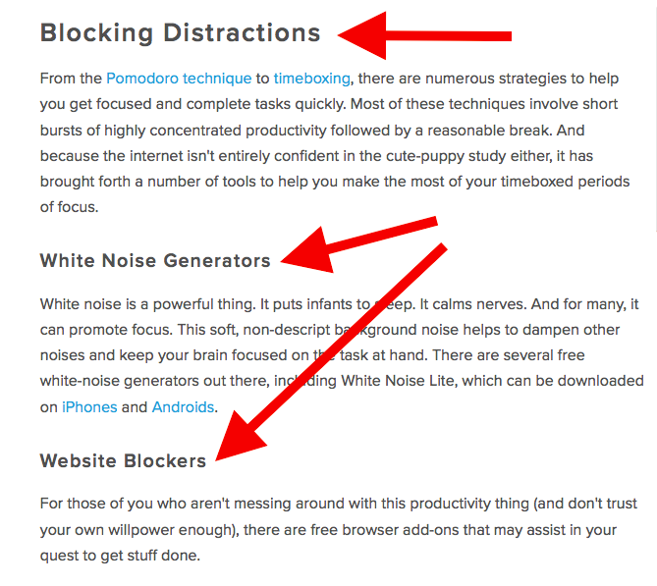

Also, screenshots should always have a similar, defined border (see screenshot above for example) so they don't appear as if they're floating in space. And that style should stay consistent from post to post.

Maintaining this consistency makes your content (and your brand) look more professional, and makes it easier on the eyes.

* Topics/Tags

Tags are specific, public-facing keywords that describe a post. They also allow readers to browse for more content in the same category on your blog. Refrain from adding a laundry list of tags to each post. Instead, put some thought into a tagging strategy. Think of tags as "topics" or "categories," and choose 10-20 tags that represent all the main topics you want to cover on your blog. Then stick to those.

7. Insert a call-to-action (CTA) at the end

At the end of every blog post, you should have a CTA that indicates what you want the reader to do next -- subscribe to your blog, download an eBook, register for a webinar or event, read a related article, etc. Typically, you think about the CTA being beneficial for the marketer. Your visitors read your blog post, they click on the CTA, and eventually you generate a lead. But the CTA is also a valuable resource for the person reading your content -- use your CTAs to offer more content similar to the subject of the post they just finished reading.

Readers who want to learn more have the opportunity to do so, and the business receives a lead they can nurture ... who may even become a customer!

8. Optimize for on-page SEO

After you finish writing, go back and optimize your post for search.

Don't obsess over how many keywords to include. If there are opportunities to incorporate keywords you're targeting, and it won't impact reader experience, do it. If you can make your URL shorter and more keyword-friendly, go for it. But don't cram keywords or shoot for some arbitrary keyword density -- Google's smarter than that!

1. Meta Description:

Meta descriptions are the descriptions below the post's page title on Google's search results pages. They provide searchers with a short summary of the post before clicking into it. They are ideally between 150-160 characters and start with a verb, such as "Learn," "Read," or "Discover." While meta descriptions no longer factor into Google's keyword ranking algorithm, they do give searchers a snapshot of what they will get by reading the post and can help improve your click through rate from search.

1. Page Title and Headers:

Most blogging software uses your post title as your page title, which is the most important on-page SEO element at your disposal. But if you've followed our formula so far, you should already have a working title that will naturally include keywords/phrases your target audience is interested in. Don't over-complicate your title by trying to fit keywords where they don't naturally belong. That said, if there are clear opportunities to add keywords you're targeting to your post title and headers, feel free to take them. Also, try to keep your headlines short -- ideally, under 65 characters -- so they don't get truncated in search engine results.

1. Anchor Text:

Anchor text is the word or words that link to another page -- either on your website or on another website. Carefully select which keywords you want to link to other pages on your site, because search engines take that into consideration when ranking your page for certain keywords.

It's also important to consider which pages you link to. Consider linking to pages that you want to rank well for that keyword. You could end up getting it to rank on Google's first page of results instead of its second page, and that ain't small potatoes.

1. Mobile Optimization:

With mobile devices now accounting for nearly 2 out of every 3 minutes spent online, having a website that is responsive or designed for mobile has become more and more critical. In addition to making sure your website's visitors (including your blog's visitors) have the best experience possible, optimizing for mobile will score your website some SEO points.

Back in 2015, Google made a change to its algorithm that now penalizes sites that aren't mobile optimized. This month (May 2016), Google rolled out their second version of the mobile-friendly algorithm update -- creating a sense of urgency for the folks that have yet to update their websites.

Comment Marketing:

There are clever, intentional ways to market yourself and your brand in the comments sections of sites, and there's less competition now than ever before. Now you will learn what you can do to get noticed in the comments and the benefits you'll reap from high-quality contributions.

## How do comments help me/my site?

## Why do comments help so much, and how do they help? Well, it turns out that if you leave great comments on other folks' sites, they may lead to visits to your website through your profile, through links that you leave, through people clicking on your profile and then following that link, which can lead to links in future posts by the authors of the site where you commented or in future content pieces created by people who read that site.

## If they see that your comment is particularly insightful, it brings up a great example, shows off a resource that is sorely lacking, especially when you are either leaving links or commenting about things, if you do so in a very respectful, diplomatic way. For example, one of the best strategies, best tactics I've seen for leaving a comment with a link in it is to say, "Hey, I want to make sure that this blog accepts links in the comments, but I figured I should point to X. Editor, feel free to remove if links are not appropriate." So that way you're saying, "Hey, I recognize that dropping a link in a comment could be a little sketchy."

What makes a comment great?

Basically, every single one of these start with you must leave consistent, high-quality, great comments. Greatness in a comment means a few things.

* It's should be on-topic:

Meaning that while you may have lots of very interesting things to share, if you go off topic, you will, even if you provide great value, tick off the moderators of the community. You will often turn off a lot of folks who are reading those comments. It's just not what people are there for. So you've got to keep it on-topic.

* Respectful to the author and other commenters:

I say respectful because what I don't mean is you can't disagree. In fact, I think it is great to say, "Hey, I really love this post. I think you made some great points, but point number three and four that you made here or this one and that one, I disagree with and here's why. This is my experience or I have this data or I conducted this survey or I want to show you this information, go check it out over here." That is just fine. As long as you are respectful and kind, I think you're in a great position to disagree and to add value. Disagreement actually does add a lot of value.

* Provides unique value:

Speaking of value, we are trying to provide unique value here. We want to provide unique value through our comments. When I say unique value, what I mean is you can't just say things that were already in the post itself, things that have already been mentioned in other comments, or things that are sort of common knowledge, anyone could find them out or they're instantly recognizable, they're sort of already known.   
  
We want insight or tactics, help, context, examples, data, whatever it is that is not found in the original piece or through common knowledge. That's what makes a comment truly stand out. That's what makes people vote up a comment, click on the profile, and go check this person out. They seem really smart and intelligent and helpful.

* It should be Well-written:

There are a few other items. We want to be well-written — so grammar, spelling, or language issues.

* Well-formatted:

So you should use spacing and paragraphs, bullet points if they're available in the markup effectively to try and convey your point so that it doesn't just look like a bunch of jammed together words and sentences. If you have a very long run-on paragraph in a comment, it can turn people off from even starting to read that.

* Transparent:

Finally — this is important — transparent. So you should not try and pull the wool over people's eyes in a comment. We want to not hide our intent or our associations. Even if you are doing comment marketing specifically as a commenting strategy to try and attract people, you can be totally up front about that.

You can say, "Hey, full disclosure, I work for company X, and I wrote this piece, but I think it's relevant and helpful enough that I want to bring it up here. So, with permission, hopefully I'm linking to it. Editor, feel free to remove this link if it's not appropriate.

Here's why I'm linking to it and here's what the value is that it provides." Now you've been transparent about your intentions and motivations, your associations, what you're doing. You will get a lot more both forgiveness and leeway to leave comments that are valuable if you do that.

----------------------------

### **What Is Classified Advertising?**

In simple terms, the ads that you see on newspapers which can also be found on online magazines, news portals etc. classified ads can help you boost your products or blog’s exposure at a cheaper cost, they usually cost you really cheaper when compared to other marketing strategies.

So basically, classified SEO ads are usually free to use and used to increase your products or blog’s exposure.

**How classified ads are helpful?**

Majority of the marketers and SEO enthusiasts use classified ads for traffic optimization. Yet, you must remember that using free classifieds for SEO has to be done carefully.

It is a revolving door when it comes to website traffic. You must promote yourself aggressively if you wish to see any sales and subsequent profits. Paid classifieds do bring traffic but what if your funds have dried up and you cannot pay for your advertising?

Free classified ads are a very important tool in the online marketing business. They do not cost anything and can start providing results from the very moment that they get posted online.

A classified ad has **three** parts:

* **Headline:**The art of crafting an effective free classified ad involves the creation of a cleverly crafted; effective Headline. An attractive headline makes expert use of keywords that generate interest and bring in the much-desired readers and buyers.
* **Details:** It then goes on to provide details of the product or services and tries to meet the customer’s needs as honestly as it can. Most free classifieds use attractive offers to rope in the customer – e.g. ‘Limited Offer’; ‘Special Discount for the first five’ or ‘Limited Stock’ etc.
* **Contact details:**The finishing touch is given by the closing which must lead the buyer to the ‘Contact now’ or ‘Buy now’ button.

How Classified Ads Help With SEO?

Classified ads are usually used to generate leads and increase click through rates. They are an excellent method of getting relevant back links to your blog or website. Some websites allow you to post the content with back links and such classified ads can immediately generate sales inquiry within hours of being posted.

This is why using free classified ads to promote and market your online business is one of the most popular and effective SEO strategies, employed by most online marketers.

Classified ads are filled with SEO potential as they use very specific strategies. If you are using paid or free classified ads on your website then your ad and content get automatically indexed on search engines.

5 Benefits of Classified SEO Ads: -

* 1. Classified SEO ads are easy to use:

Whether you know it or not, classified SEO ads are usually both mobile and search friendly. They are easier to navigate and gives your users what they want. They are so concise and yet give your audience what they expect. This is what makes classified ads usage effortless.

* 1. They open up a global market for your products:

Do you have any products or services to sell from your websites? Don’t know how to get more exposure for your products? Do you want to increase your product sales? Then, classified advertising is the way to go. It can create a global market for your business and there’s usually a HUGE potential online to increase your product sales.

* 1. Most classified SEO ads are free:

There are a lot of websites out there which help you post classified ads for FREE. Sites like OLX, Click.in, and Myadmonster etc. can help you easily post free classified SEO ads to boost your products visibility. You don’t have to invest even a penny on advertising so when you get everything for almost free, why not make the most out of them?

* 1. Create ads within minutes not weeks:

If you observe it closely, most offline newspaper classified ads take a lot of time to get published. For instance, you have to speak to the newspaper ad agencies to get your ad posted and you also need to give all the details. All these process usually takes a lot of time and moreover these offline classified ads don’t last long unlike online classified SEO ads. Which are also easier to create and take a few minutes of your time not weeks unlike offline.

* 1. SEO for classified websites can increase your traffic:

If you have a product based selling website, you can immensely increase your traffic by posting your blog’s or website address in the form of classified SEO ads. Or you can simply put a link back to your sites, so if someone gets curious about your products or services while browsing online classified ads can land on your sites.

--------------------------------------------

Form Posting

# Forum Posting for SEO:-

The topic of forum posting for SEO purposes is one that causes extreme responses from those in the know and those that use them regularly. The benefits are widely debated, but as a business, it is important to find out if forum posting needs to be included as part of your digital marketing strategy.

## **Google and Forum Posting** **for SEO**

Google does not give as much weight to links in forums as it does to links in content rich articles. Because of this, forum posting should not be the primary SEO tool for your business. However, it should also not be ignored. **When done correctly, forum posting can:**

* Increase website traffic
* Introduce your business to new customers
* Expose you to new opportunities for your business

### **What You Need to Know About Forum Posting**

In the past, linking in forums was a valuable tool for SEO, but because there was no skill involved, it was quickly taken advantage of by spammers. Because of this, reputable forums have banned promotional links in their forums and brought an end to simple forum linking as an SEO tool.

Forums can still be valuable for your business if used in the correct way. It is not a quick and easy option, but it can pay off with patience and dedication. You will need to make a commitment to contribute to the forum consistently, provide value for the others, openly discuss topics and share your knowledge.

To get started search on the Internet for forums that relate to topics you are knowledgeable in and relate to your business. Submit your request to join. For example, if you own a health food store, get involved in nutrition forums.

## **How to Integrate Yourself into a Forum**

* Be honest about who you are and what you do. Be upfront about your business or industry and make your posts helpful to others in the forum. The old adage is true, you have to give to get.
* If you are on a forum related to your business or industry and you have solutions to problems being mentioned, give the solution. This will begin to show others on the forum that you are an expert in that field, which can mean you will be the person, or company they go to when it is time for them to spend money.
* If you are in an educational focused forum be sure to ask honest questions. If you are the one asking the good questions, people will start watching your posts to learn what they are either afraid to ask or not sure how to ask.

### **To Link or Not to Link in a Forum**

Once you have earned the trust of the forum members, you can then begin adding links to your own website inside the forum. However, do so sparingly and be sure the link is relevant to the thread. For example, if someone is having trouble finding an organic cherry juice, you could link to your website and let them know that you stock a range of organic fruit juices that may be of interest.

Do not link back to your website on topics that are not relevant because it will likely be removed by an administrator, you will lose respect amongst other forum members and it could get your banned.

Business Listing:

A local business listing is an online entry that contains your business Name, Address and phone number (NAP) along with other details. There are a lot of websites like Yelp, Foursquare and Yellow Pages where local businesses can create free local business listings.

There are thousands of websites and directories on which local business owners are allowed to create free business listings. Some you may already have heard about include Google+ Local, Yelp, Bing Places, Internet Yellow Pages, and Yahoo! Local.

The purpose of creating local listings is to make your business visible on the Internet. Each new listing you create increases your chances of being found by customers. At the same time, many of the local business indexes share data with each other. Thus, the more places you are listed and the more visible you are, the more these indexes trust the accuracy of your business data—increasing your chances of ranking well in local searches.

In order to qualify for a local business listing in any index, your business must meet **all four** of the following criteria:

1. Have a business name or DBA
2. Have a local phone number that matches your city of location (not a shared phone number, toll-free number, or call tracking number)
3. Have a dedicated physical street address (not a shared address, PO box, or virtual office)
4. Make face-to-face contact with your customers (business is not conducted virtually)

If you meet all four of the above criteria, you are ready to move forward to the following topics:

Most indexes require you to verify each listing you create. Know what to expect during the claiming process.

#### [Important Attributes](https://moz.com/learn/local/important-business-listing-attributes)

For your listing to be successful, pay close attention to these listing attributes; NAP (Name, Address, Phone Number), Categories, Photos, Social Profiles, Reviews, etc.

#### Category Importance

Adding categories to your business listings may seem like a trivial step, but it's actually one of the most important business listing attributes.

#### [Claiming Your Listings](https://moz.com/learn/local/guide-to-claiming)

Know what to expect and how to best claim your business listing online. Business Verification can take the form of a phone call (quickest), postcard (slowest), or an email.

#### [Local Search Citations](https://moz.com/learn/local/citations)

Local citations are mentions of your business name, website, and location on other sites. These listings send qualified signals to Google that you are an indeed a real business and will help you to rank better.

#### [Where to Get Citations](https://moz.com/learn/local/how-to-get-citations)

Solidify Top Data Aggregators: Business Listing Platforms that fuel Search Engines (Factual, Infogroup, Neustar Localeze, and Acxiom).

#### [Top Citations by City](https://moz.com/learn/local/citations-by-city)

What are the top Business Citations in your City? Discover which business listings reign king in your area to help increase your Local SEO.

#### [Top Citations by Category](https://moz.com/learn/local/citations-by-category)

We've compiled a list of the best places a local business can get citations, based on your industry or vertical.

#### [Duplicate Listing Issues](https://moz.com/learn/local/why-duplicates-matter)

A variety of negative outcomes can arise from the presence of duplicate listings, detracting from your local business' ability to rank well and win customers.

#### [Cleaning Up Duplicates](https://moz.com/learn/local/moving-locations)

There's a lot to do when your business changes locations - but if you forget about local search, your customers may never find your new address.

#### [Local Search Ecosystem](https://moz.com/learn/local/local-search-data-providers)

Is your business information wrong in Google Business Listings or Bing Local? Learn where they get their data so you can make sure it's right.

If you have an existent business and want to go through the steps of changing its name, you can register a new DBA ("doing business as"). You will then need to edit all existing mentions of the old business name so that all listings include you under the new DBA name. While this may have some benefits, be advised that a change in business name will likely cause you to lose rankings and reviews. Consider this decision carefully.

Links and Citations

Google, Yahoo!, Bing, Best of the Web, and other search engines find out about your business in two primary ways:

Visiting links that point to your website, and tracking sites where those links appear.

Tracking citations of your business, and on which sites these citations appear.

The search engines use these two factors in determining how to rank a particular business. All other things being equal, the business with the most links from high-quality websites in your area—like a chamber of commerce or a city government—and the most citations from high-quality websites in your area, will rank the highest. So you will want to make sure to get your business name, address, phone number, and website listed as many places as you can.

What Are Citations?

Citations are defined as "mentions" of your business name on webpages other than your own, accompanied by your address, phone number, or both—even if there is no link to your website. An example of a citation might be an online yellow pages directory where your business is listed, but not linked to. It can also be on the website for a local chamber of commerce or local business association where your business information can be found even if their website does not link to yours. You may also see the term "web references" used on other websites—a synonym for "citations".

Categories

Many local search engines allow you to place your business into a number of categories—usually between two and five—that help describe the nature of your business.

This is an important step in creating your local business listing. The search engines use category data when deciding which businesses to show for particular searches. The search engines will not display a business that is uncategorized—or even worse, miscategorized—for particular sets of keywords. This usually happens among keywords and phrases that are the most competitive—where there are already a number of businesses associated with a particular category that might satisfy what the searcher is looking for.

In choosing your categories, you may find Moz Local Category Research Tool helpful for learning which categories Google and the other search engines offer for your business.

Reviews and Ratings

Reviews and ratings can persuade prospective customers who are looking for the goods and services you offer. While a bad review can encourage someone to hit their "back" button and perform another search, a good review can encourage someone to pick up the phone and call you! Because reviews and ratings are displayed in so many different ways across different search engines, there is some debate about how much reviews or ratings of a business influence its rank in search engine results—but reviews can definitely influence a potential customer's decision to choose your business.

It's important to engage all of your customers—and especially to get your best customers to leave a review of your business on their preferred search engine or portal. Likewise, it's important to recognize when someone has left a negative review of your business. Reach out to that customer and find out why they had a bad experience with your company, and see if there is anything you can do to change their opinion of you.

Each review platform has its own rules. Some platforms do not have strict or very clear rules, but the two review giants in the industry, Google and Yelp, do have specific review policies to which you must adhere. Yelp, for instance, does not allow businesses to solicit reviews from customers beyond a simple "check us out on Yelp" sticker in their window or icon on their website. Google does not allow suggestions for review content.

If you're thinking about asking customers for reviews, know the rules of the sites on which you're hoping those reviews will appear before you ask.

Photos and Videos

Attractive photos and videos have been shown to increase the number of clicks that a particular listing gets. They generally offer a great way to show off your business—projects that your company has worked on, products you offer, your team, or your office itself. A compelling image can help you stand out in an otherwise flat playing field.

In terms of rankings, photos and videos don't seem to affect results. A Google+ Local business listing with no photos probably has just as much potential to rank well as a listing with six photos and three videos—but a potential customer may be more inclined to click through on your search results if there is a compelling photo.

Recently, Google has increased the visibility of Google+ listing photos by displaying one for each listed business in their main search results. Choosing photos wisely—both a cover photo for your Google+ Local page and gallery-style photos on your Google+ Local photo page—is vital to creating an engaging experience for potential customers.

Social Factors

The social component of local SEO is growing stronger with each passing year, and learning to participate in the social spaces your customers prefer can be a smart move for nearly any local business. Some local and review-oriented platforms enable you to interact with the public. For example, a merged Google+ Local/Google+ Business page enables you to communicate with your followers in a manner similar to Twitter or Facebook.

You can also interact with reviewers on platforms like Google+ Local and Yelp, responding to both positive and negative reviews. While certain forms of social media activity appear to influence overall search engine rankings, their direct influence on local rankings remains speculative.

Other Attributes

It is vital to list your complete contact information on your website in a format that the search engines can read. This is a simple step that a lot of local business owners overlook. Your contact information must be in index able text—not embedded in an image, Flash, or other formats that search engines can't crawl. If you'd rather not list your contact information on your webpages, you should set up a clear "Contact Us" page which displays your complete business name, address, and phone number (NAP). To strengthen the signals of your NAP, you may choose to encode it in schema, markup code that all major search engines

agree upon and understand.

------------------------------------------------------

Social bookmarking is a web technology that is used to store, organize and share the bookmarks of the websites. The bookmarked websites can be held private or shared publicly. You can share your favorite links with your friends, colleagues or family members.

Social bookmarking is same as you bookmark some pages in your web browser. Whenever you like some pages while reading something on the internet, you just bookmark that page to read it later whenever required.

This same concept is used in the case of social bookmarking. All the social bookmarking websites over the internet are used for bookmark some important webpages that a user like and want to store them somewhere to read them later.

A user just needs to put the link of the webpage and its title to bookmark the webpage. Tags and description are optional in most of the websites.

Social bookmarking is preferred over browser bookmarks, because users can easily lose bookmarked pages from a web browser because of many reasons like deleting the history of web browser, formatting the system or system crash and many others.

Bookmarking over internet is more secure because we can bookmark our favorite webpages over various secure and well managed websites.

Here are some points about why and how social bookmarking can be used for a SEO plan.

– Search engines always want to deliver most updated results to its users. Social bookmarking websites are one of the best sources for search engines for fetching newly updated data over the World Wide Web.

– Many social bookmarking websites provide DoFollow backlinks for various bookmarks. That’s mean whenever a search engine crawl a social bookmarking website it will also crawl the targeting websites.

– If you have a strong profile over social bookmarking websites, you will get more shares and visits for your bookmarks. In this way you can get direct traffic to your websites from various social bookmarking websites.

– As we all know, having some quality backlinks is a must thing for grabbing better position in SERP. Social Bookmarking websites are the best destinations for earning some quality backlinks for targeted websites.

Some Tips and Tricks for Using Social Bookmarking for SEO

### **1. Target More DoFollow Websites:**

Here we are talking about using social bookmarking for SEObenefits so first tip I’ll recommend is toconcentrate more on DoFollow websites for bookmarking activities.

Do follow bookmarking websites redirects the search engines to crawl your targeted website. In this way you can make your website more crawl friendly for search engines.

There are many DoFollow websites over the internet, you can use for social bookmarking. One of the best name that coming in mind is, Tumblr. One of the best website you can use for social bookmarking to earn stable and relevant DoFollow backlinks.

### **2. Complete your Profile on Social Bookmarking Sites:**

One of the most common SEO mistakes that we make while using social bookmarking for SEO is, we just sign up to the social bookmarking sites with e-mail and password and start submitting the links.

This mistake needs to be resolved because incomplete profile on social bookmarking websites will do same as you create an incomplete resume on a job searching website.

Whenever you are choosing a website for social bookmarking, first step should be **completing your profile from each and every prospective**. Don’t ignore the optional fields that we usually do. Fill all information whether it is compulsory or optional.

### **3. Limits your Total Number of Social Bookmarking:**

It is one of the most commonly asked question that how many bookmarking should I do at a time. There is no standard limit for social bookmarking because social bookmarking was not discovered for [SEO](https://www.qdtricks.net/what-is-seo-key-terms-and-process/).

Most SEO experts suggest **limiting the social bookmarking maximum 10 to 20 for a website in a week**.

One more thing, these 10 to 20 bookmarks should be done on different websites. That’s mean in 1 week you should bookmark a single webpage of a website on 10 to 20 different social bookmarking websites.

### **4. Do not Use Same Description for Every Submission:**

I have my own experience of working in an SEO company that is why I know that most of the SEO companies use one-time written description for every social bookmarking submission. This phenomenon of SEO link building is totally wrong and not acceptable at all. Also check out this SEO myths and the ways to avoid them.

Search engines are very particular for **duplicate data**, whether it is main website’s content or any description written for social bookmarking submissions. Search engines are smart enough to detect that **someone is doing social bookmarking just for SEO benefits** and this can be crucial for a website.

Use **fresh, unique and smartly written description** for every social bookmarking submission. You should try to involve your targeted keyword in the description, but in a smooth and natural way.

### **5. Don’t use Same Title for Every Bookmarking Submission:**

Whenever we bookmark a webpage, we need to put a title for that webpage. Mostly what we do is, we put the main keyword for every bookmarking submission.

Now it is the time to change these working criteria. The best thing you can do is, **using a different title for every bookmarking** submission.

You can add some prefix and suffix with your main keyword to make the title a little different for every submission.

For example, you have a webpage about “Home Remedies for Cold” and you want to bookmark this webpage on 5 different social bookmarking websites. You can use titles as given in following points.

* Best Home Remedies for Cold
* Home Remedies for Cold and Cough
* Home Remedies for Cold by Experts
* Natural Home Remedies for Could
* Suggest Me Some Home Remedies for Cold

As you can see in given points all titles are different and unique and they are also having the main keyword.

### **6. Pick Up the Relevant and Stable Websites for Social Bookmarking:**

Today, social bookmarking is one of the most commonly used SEO activity that is why you can find thousands of social bookmarking websites over internet. Most of these websites are especially designed only for SEO benefits. There was a time when doing social bookmarking for SEO on these websites can **boost the rankings for a website**, but today this SEO factor is totally changed.

Search engines are totally ignoring these websites. Even it can be crucial for a website if we overdo social bookmarking on these irrelevant websites.

Try using only and only most relevant, stable and most importantly, high PR websites for social bookmarking.

What you can do is, first create a list of top social bookmarking websites and then use them to submit your links to these relevant websites. Sometimes we also face a problem when we don’t have any more links to submit on these popular and stable websites. Only in this situation you should consider other social bookmarking websites for SEO purpose. In this case also you should try to find good some **PR Do follow websites for social bookmarking**.

### **7. Try to build your own Community over Social Bookmarking Websites:**

Don’t just do the social bookmarking for SEO purpose or for search engines. Try to **be more genuine on social bookmarking websites**.

Make efforts and build your own community over various social bookmarking websites. First step you can take is, **follow other users from same niche** and do like and share their bookmarks. You can also ask them some questions regarding their submissions and try to make them confident to share your bookmarks.

### **8. Submit your Bookmarks in Right Category:**

Whenever you submit your webpage on social bookmarking websites for SEO benefits, always remember to select the right category for your submission.

What we mostly do is, we put our bookmarks in some easily available categories like News, Health, and Technology. Remember all these categories are very common in social bookmarking websites that is why your chances for staying in front from all will lose.

**Take some time and search for appropriate category for your webpage**. This will not only help the search engines but will also help your community members to search your submissions easily.

### **9. Don’t Ignore the Keywords and Tags:**

While bookmarking the webpages don’t ignore the importance of tags and keywords. These keywords and tags can do wonders for appearing your submissions whenever a user searches for some relevant keywords.

Also, don’t restrict yourself using only targeted keywords. Remember, keyword variation is must for social bookmarking activity. You can **use both high and low competitive keywords** for social bookmarking submissions. Just involve your main keyword in between the other keywords.

### **10. Don’t use the Auto Update Social Bookmarking Tools:**

I know there are many SEO organizations which are using various online tools for automate social bookmarking for their SEO projects.

This practice is totally wrong. If you are also one of them, please stop doing that. Always perform social bookmarking manually, so it looks more natural and more acceptable for search engines.

------------------------------------

RSS Feed:

RSS (Rich Site Summary; originally RDF Site Summary; often called Really Simple Syndication) uses a family of standard web feed formats to publish frequently updated information: blog entries, news headlines, audio, and video.

Instead of checking back every day to any particular site to see if it's been updated, RSS feeds give users the ability to simply subscribe to the RSS feed, much like you would subscribe to a newspaper, and then read the updates from the site, delivered via RSS feeds, in what's called a "feed reader."

RSS feeds benefit those who actually own or publish a website as well, since site owners can get their updated content to subscribers much more quickly by submitting feeds to various XML and RSS directories.

How do RSS feeds work?

RSS feeds are simple text files that, once submitted to feed directories, will allow subscribers to see content within a very short time after its updated.

This content can be aggregated to be viewed even more easily by using a feed reader.  A feed reader, or feed aggregator, is just a really simple way to view all your feeds at one time via one interface.

### **What is a Feed Reader?**

A feed reader is the software used to read the feeds people subscribe to. Many websites offer feed reader software for free, and you simply access your aggregated feed content through a username and password on that website. Popular feed readers include Google Reader and Bloglines.

Steps to Creating & Promoting an RSS Feed

RSS, or Really Simple Syndication as it is commonly known, is a technology that gives webmasters the ability to easily distribute and publish syndicated content on the Internet. It seems like all Internet businesses now have RSS feeds available; at least your competitors do. You have finally made the decision that you have to have one. Where do you start?

Steps to Creating an RSS feed  
  
  
1.) Build a Feed:   
  
There are a number of desktop and web applications available that make feed creation easy. I would encourage anyone creating a feed to use one. Though not overly complicated, hand-coding an RSS feed can become a bit confusing and time-consuming. Most desktop software applications for building a feed include a wizard and contact-sensitive help, simplifying the process of creating a feed. Following a few simple steps in a wizard generally will produce an RSS feed in just a few minutes.

Publishers control what information is syndicated in the RSS feed, so ultimately it is the publisher's decision as to whether to include teaser copy or full articles. Consider what you are trying to accomplish and who your target audience is when building the feed.

Software to Build a Feed - [http://www.feedforall.com](http://www.feedforall.com/)Tutorial for Creating Feed by Hand using XML - [http://www.make-rss-feeds.com](http://www.make-rss-feeds.com/)

2.) Transfer the Feed onto Your Server

Once you have constructed an RSS feed you will need to transfer the feed to your server. This can be done using a standard FTP client (if it is not built into the feed creation software). The feed is usually placed in the domain's root directory like this: http://www.mydomain.com/nameoffeed.xml, but as long as you know where it is it doesn't really matter.

3.) Display the Feed on Your Website Using a Graphic of Some Sort

In order to signal to website visitors that an RSS feed containing content related to the website is available, include a colorful graphic on the website. It has become a standard that nearly all websites that have RSS feeds available use colorful graphics such as flags as indicators that RSS feeds are available for specific content. The flags were initially bright orange rectangles but as the popularity has grown, webmasters have bent the rules a bit. Note Page has made a free online RSS graphic tool available that allows users to quickly customize buttons by selecting the text on the button and the color scheme of the button. Once the color and text is entered, a custom graphic is instantly created. Webmasters can easily match the style of the RSS button to a website's theme. Graphics experience is not required. Simply select alternative colors and insert text to personalize RSS feed graphics.

The RSS graphics tool can be used by clicking the following URL <http://www.feedforall.com/public/rss-graphic-tool.htm> or choose readymade graphics form: <http://www.rss-specifications.com/rss-graphics.htm> .

4.) Include Information in the HTML of the Web Page So RSS Readers Auto-Detect Your Feed

After publishing an RSS feed it is important to let visitors know that the feed exists. Aggregators will automatically detect RSS on a website if you add a small bit of code in the header field of an HTML page.

[link rel="alternate" type="application/rss+xml" title="RSS" href="http://www.yourdomain.com/rss.xml"]

Be sure to replace http://www.yourdomain.com/rss.xml with the URL to the RSS feed and replace the brackets with "<" less than and ">" greater than symbols.

5.) Display the Feed's Content on a Website

Contents contained in an RSS feed can be added to a website, providing site visitors an alternative method for viewing the content. The information will also help increase search engine interest. Displaying the feed as HTML can be accomplished. Providing fresh content on a regular basis will encourage site visitors return.   
  
Tutorial for Displaying Feeds - <http://www.small-business-software.net/display-rss.htm>

6.) Submit the Feed to RSS Directories and Search Engines

As a rapidly increasing number of content sources, new and old, migrate or add RSS as a key distribution channel, and as more people utilize RSS newsreaders and aggregators to keep themselves informed, the ability to maintain high exposure and visibility is gradually shifted from complete attention to major search engines and content optimization techniques to an increasing awareness of RSS feed directories and search tools.

In order to increase exposure of an RSS feed it should be submitted to RSS search engines and directories. This can be done manually. Just as you would submit the URL of a website or web page to a search engine you will need to submit the link of the actual feed located on your website to the RSS directories.

There is a large list of RSS directories at <http://www.rss-specifications.com/rss-submission.htm>. If you prefer to automate the submission process try RSS Submit at: <http://www.dummysoftware.com/rsssubmit.html> . An evaluation version is available.

-------------------------------------------------------------------------

Local SEO:

Local SEO is a highly effective form of local online marketing. It allows local businesses to promote their services to local customers at exactly the time they're looking for your type of business. Local SEO uses search engines like Google and business directories like Yelp, Superpages, Qype and TouchLocal.

Google Place optimization:

Google dominates the search field (both Web and local) the first place to list your local business should be Google and their Local Business Center. Not only will [Local Search Optimization](http://www.googleplacesoptimization.org/local-search-optimization/) help consumers find your physical location, but also enhance search results for your business and help keep up with the competition. If you are looking for a good Review Management company, look into [ReviewLeap.com](http://www.reviewleap.com/).

Once your presence is established and accurate, move on to build your local listing in other search engines, like Yahoo! and Bing.

## Google Places Optimization Steps:

## Step 1: Sign in or Sign up:

## Start by going to <http://www.google.com/localbusinesscenter>. Sign in with your existing Google account or, if you don’t have one, click on the Sign up now link.

## Step 2: Add one or more locations.:

## After you sign up or sign in you’ll be given an opportunity to Add new business or Upload a data file.

## Click Add if you only have a single location for your business or Upload if you have 10 or more locations. Google provides detailed instructions for creating this file.

## Step 3: Tell Google about Your Business:

## On the Add new business screen begin building your business listing with addresses and contact information. As you enter your address, you will see the map on the right zoom in on your location as it builds your listing.

## The last field to complete is a 200-character description of your business. Use powerful words (and keywords) that tell viewers what you do while they convey your unique value proposition.  It’s not unusual for [Google Maps](http://www.googleplacesoptimization.org/google-local/google-maps/) to locate your business incorrectly. It placed one of my clients on a highway on-ramp 1.5 miles from his actual location. If this is the case with you, click on the Fix incorrect marker location link to make corrections.

## Step 4: Claim an existing listing or add your new one.:

## The next screen gives you an opportunity to Add or Claim your listing. Google uses local business phone directories to populate its maps with basic information.

## Accordingly, your business might already be listed. In that case, select Claim Listing and follow the procedure. Click Add Listing if your business isn’t there or to add a new location.

## Step 5: Define how searchers will find you, and add keywords to your listing.

## You’ll continue to build your listing and have the opportunity to really make your business stand out when you enter your hours of operation and payment options as well as:

## Categories: Begin typing and choose from the options presented or input your own. Think of how a potential customer would search for you (think keywords and phrases) and use these terms here.

## Photos: Show off your store, gleaming restaurant or friendly staff to the best advantage with photos and other images (your menu, company logo, etc.).

## Videos: Load up to five videos that put the spotlight on your business and personnel.

## Additional Details: Add major product lines, special service offerings or off-street parking.

#### Step 6: Validate:

Google, as do the other local search directories, requires that you validate your listing to ensure that you are the business owner. They give the option to do this by phone or mail. If you’re in a hurry (and who isn’t) I suggest the phone option. Google will use the phone number or address you provided with your listing to validate your information so be sure that the information is accurate and you have access to the phone.

Once you select the phone option and click Finish you’ll receive an automated phone call within a few minutes. Google will give you a PIN to activate your listing.

Enter your PIN as shown and … Congratulations, you are now a few short hours away from attracting local customers to your business!

## Step 7: The Dashboard:

## The [Google Local](http://www.googleplacesoptimization.org/google-local/) Business Center Dashboard gives you access to analytics that show:

## •    Impressions – how many people saw your listing as a result of a local search? •    Actions – how many people took action by clicking on more info, your website or to request driving directions? •    Search queries – what terms and phrases are generating activity.

## This is great information that will tell you where traffic is coming from and provide actionable insight into what’s working, so you can make adjustments to what isn’t.

## Step 8: Don’t Forget the Coupons:

## A great way for any business to attract new customers and generate repeat business is to offer coupons. The Dashboard provides an easy way to add coupons to your listings.

## Whether you offer a free initial consultation or a percentage off your most popular offering, coupons can be a great way to differentiate your listing from the competition. And coupons provide another feedback mechanism to show that people are finding you through local search.

## H Card:

## HCard is a simple, open format for publishing people, companies, organizations on the web, using a 1:1 representation of vCard (RFC2426) properties and values in HTML. hCard is one of several open microformat standards suitable for embedding data in HTML/HTML5, and Atom/RSS/XHTML or other Xml.

## Example:

## hCards are most often used to represent

## People:

## <div class="vcard">

## <a class="url fn" href="http://tantek.com/">Tantek Çelik</a>

## </div>

## For organizations:

## <div class="vcard">

## <a class="url fn org" href="http://microformats.org/">microformats.org</a>

## </div>

## ------------------

## Citation:

## A citation is an online reference to your business's name, address and phone number (NAP). Like links to your website, Google uses them when evaluating the online authority of your business.

## What is a local citation?

## Let’s first answer the question: “What is a local citation?”… A local citation is any mention of a local business out on the web, with or without a link. It can come in various forms:

## Company Name, by itself.

## Company name & phone number.

## Company name, phone number, & address.

## Company name, phone number, address, & link.

## Etc.

## Even just the phone number by itself can be a local citation.

## A complete local citation should include the company name, address, and phone number. A citation that does not include all three of these is sometimes referred to as a partial citation.

## Mihm-local-ranking-factors-localu

## Structured Citations:

## The most common local citations are found on business listing sites like yellowpages.com, yelp.com, superpages.com, etc. These are referred to as structured citations.

## 

## Unstructured Citations:

## Citations can also often be found on blogs, newspaper websites, event listing websites, job websites, government sites, etc. These are referred to as unstructured citations and can be extremely valuable to your local rankings.

Why Citations Are Important to the Success of Your Local Business?

Citations are a key component of the ranking algorithms in Google and Bing. Other factors being equal, businesses with a greater number of citations will probably rank higher than businesses with fewer citations.

Citations from well-established and well-indexed portals (i.e., Superpages.com) help increase the degree of certainty the search engines have about your business's contact information and categorization. To paraphrase former Arizona Cardinals' coach Dennis Green, citations help search engines confirm that businesses "are who we thought they were!"

Citations are particularly important in less-competitive niches, like plumbing or electrical, where many service providers don't have websites themselves. Without much other information, the search engines rely heavily on whatever information they can find.

Citations also validate that a business is part of a community. It's hard for someone to fake membership in a chamber of commerce or a city or county business index, or being written about in a local online newspaper or popular blog.

Citations and links from these kinds of websites can dramatically improve your local search engine rankings.

Here are some sources for excellent potential citations for your local business.

1. **Data aggregators**

In the United States, there are four primary aggregators of local business data. [Infogroup](http://www.expressupdateusa.com/), Neustar Localeze, [Acxiom](http://www.myacxiom.com/), and [Factual](http://www.factual.com/) have all compiled unique indexes of approximately 20 million business locations across the United States. These indexes are typically compiled by scouring traditional phone books, business group membership rosters, banking and phone records, and databases from business registration entities.

In turn, these aggregators license or syndicate their data to most local search engines, including Google and Bing. The time it takes for search engines like Google to update their indexes with new data from the aggregators varies, but generally this process takes anywhere from two weeks to three months.

[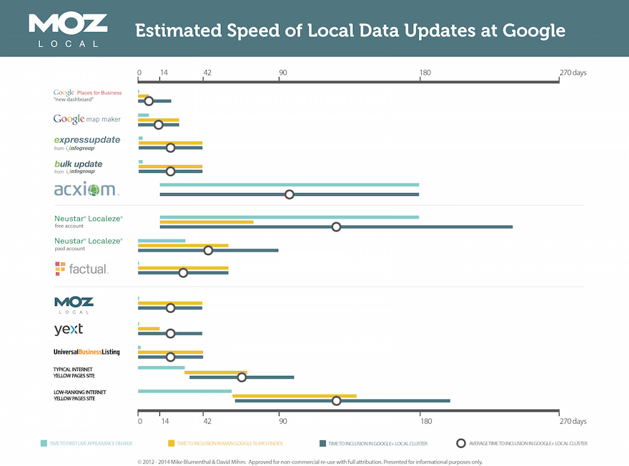](http://d2eeipcrcdle6.cloudfront.net/learn/listing_time_to_live.pdf)

1. **Local search engines**

Local search engines like Google and Bing crawl the web for citations that will validate or correct the business information in their own indexes. Getting listed on sites like Yelp, Foursquare, Hotfrog, and others can shore up search engines' confidence in the accuracy of your business name, location, and website. Most local businesses will need to engage in a concerted citation building campaign that ensures that they are listed in as many relevant, quality local business directories as possible.

1. **Local blogs**

Local blogs are a great place to get your business listed. These will obviously vary by particular geography, but if you simply perform a search on your favorite search engine for "[your city] blog" or "[your neighborhood] blog," you'll likely see good candidates.

The sites that show up for these kinds of searches are, by definition, very well-indexed by the search engines, and highly associated with a particular neighborhood, city, or region in local results. Businesses that are mentioned or linked to on these blogs are viewed as trusted, relevant results in the local search engines.

1. **Locally focused directories**

Like local blogs, local directories are well-indexed by the search engines and are highly associated with a particular city or region. Directories which are edited by a human are much better than those which are "free for all". Human-edited directories are less susceptible to spam, and are therefore more trusted by the local search engines. Two examples of terrific locally focused directories are Best of the Web's Regional Directory and Yahoo's Regional Directory. You can perform searches for things like "[your city] directory" or "[your state] directory" to find good prospects for these kinds of citations.

1. **Industry-focused directories or blogs**

If a website is focused on topics and keywords related to your products and services, it may be included among the sites that the local search engines count as citation sources—even if that website or directory is not focused on a particular region. For instance, the membership directory of your trade organization or a blog that is popular among readers in your industry will both probably be crawled by the local search engines for citations. Searches like "[your industry] directory" or even "[your keyword] directory" will give you some ideas of the kinds of sites on which to get listed.

---------------------------------------------------------------------------------------

# WHAT IS SEARCH ENGINE ALGORITHM?

Unique to every search engine, and just as important as keywords, search engine algorithms are the why and the how of search engine rankings. Basically, a search engine algorithm is a set of rules, or a unique formula, that the search engine uses to determine the significance of a web page, and each search engine has its own set of rules.

These rules determine whether a web page is real or just spam, whether it has any significant data that people would be interested in, and many other features to rank and list results for every search query that is begun, to make an organized and informational search engine results page.

The algorithms, as they are different for each search engine, are also closely guarded secrets, but there are certain things that all search engine algorithms have in common.

1. Relevancy – One of the first things a search engine algorithm checks for is the relevancy of the page. Whether it is just scanning for keywords, or looking at how these keywords are used, the algorithm will determine whether this web page has any relevancy at all for the particular keyword.

Where the keywords are located is also an important factor to the relevancy of a website. Web pages that have the keywords in the title, as well as within the headline or the first few lines of the text will rank better for that keyword than websites that do not have these features. The frequency of the keywords also is important to relevancy. If the keywords appear frequently, but are not the result of keyword stuffing, the website will rank better.

2. Individual Factors – A second part of search engine algorithms are the individual factors that make that particular search engine different from every other search engine out there. Each search engine has unique algorithms, and the individual factors of these algorithms are why a search query turns up different results on Google than MSN or Yahoo!.

One of the most common individual factors is the number of pages a search engine indexes. They may just have more pages indexed, or index them more frequently, but this can give different results for each search engine. Some search engines also penalize for spamming, while others do not.

3. Off-Page Factors – Another part of algorithms that is still individual to each search engine are off-page factors. Off-page factors are such things as click-through measurement and linking. The frequency of click-through rates and linking can be an indicator of how relevant a web page is to actual users and visitors, and this can cause an algorithm to rank the web page higher.

Off-page factors are harder for web masters to craft, but can have an enormous effect on page rank depending on the search engine algorithm.

Search engine algorithms are the mystery behind search engines, sometimes even amusingly called the search engine’s “Secret Sauce”. Beyond the basic functions of a search engine, the relevancy of a web page, the off-page factors, and the unique factors of each search engine help make the algorithms of each engine an important part of the search engine optimization design.

How Google is changing its search algorithm?

Website owners are very much aware of how essential mobile accessibility is nowadays. With the quantity of individuals browsing the web on their phone or tablet expanding each month, not having a mobile-friendly site is no more drawn out worthy.   
  
**How it works and how it’ll work**?  
  
A refresher on how Google Search functions: Google's bots creep the web tracking more than 60 trillion web pages and the links inside them. Google then classifies them into a monstrous index in view of several different factors. This index, alongside a series of algorithms, is the thing that empowers Google to return relevant search results — that rundown of blue links — when you enter a question into the search box.   
  
Rather than fundamental desktop sites, Google is moving to the mobile version of websites for search result rankings, turning its search indexing system significantly mobile-driven.   
  
To date, Google has just figured out how to slightly change and explore different avenues regarding the move; the entire move time frame may take some time before it could go into full impact.   
  
“Although our search index will continue to be a single index of websites and apps, our algorithms will eventually primarily use the mobile version of a site’s content to rank pages from that site, to understand structured data, and to show snippets from those pages in our results,” said Google product manager Doantam Phan.

How to Recover From Any Google Penalty?

For most online businesses, search engine traffic is very important, but achieving high rankings in Google is not as easy as it used to be. Therefore, many SEOs and marketers are pushing the link-building process to the limit. As a result, many websites are being penalized for violating Google’s guidelines.

According to Matt Cutts, over 400,000 manual actions are being initiated every month by Google. That’s not all. Numerous other websites are being penalized by algorithmic updates such as Penguin and Panda. What’s interesting is that only about 20,000 webmasters are submitting a reconsideration request every month. So, this means that only 5% of the websites that have been penalized are trying to recover their rankings.

Do you own a website that has received a manual or algorithmic penalty? Don’t throw in the towel just yet because I’m going to show you how to recover your lost rankings and traffic.

**Why You’ve Been Penalized**

If you suddenly see a traffic drop, you’ll have to find out what caused it. There are two main penalties you can get. The first one is a manual action from Google’s spam team, and the second one is an algorithmic penalty.

**1. Manual Action** – To find out if your website was penalized by a manual action, go to Google Webmaster Tools and check to see if you have any new notifications. Below you can see an example of an “unnatural links” message:

[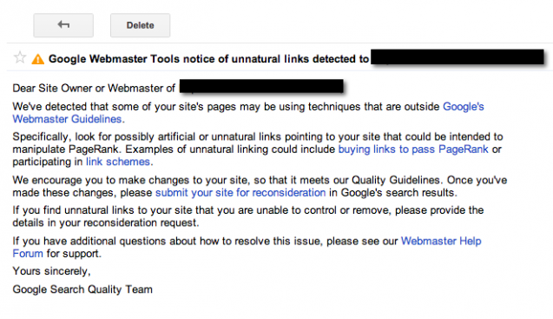](https://blog.kissmetrics.com/wp-content/uploads/2014/05/1-GWT-penalty.png)

If you have no warning messages on GWT, dig deeper to find the cause of your traffic drop.

**2. Algorithmic Penalty** – To identify what type of algorithmic penalty your website has, you will have to correlate the time period when you lost traffic with the date when a new algorithmic update occurred. For this, you can check Google Algorithm Change History.

To stay up to date with all of the latest changes to Google’s search algorithm, do the following:

* Follow Matt Cutts on Twitter. Here he announces all of the new changes.
* Follow [Google Webmaster on YouTube](https://www.youtube.com/user/GoogleWebmasterHelp) to get tips about SEO.
* Check MozCast or Algoroo often for new changes that are not officially recognized by Google.

The most popular algorithmic updates are Panda, which is focused on content quality, and Penguin, which is focused on backlinks and anchor text distribution.

**Backlinks That Are Bad for Your Website**

Low-quality links can get your website penalized. These types of backlinks can be a potential threat to your rankings:

* Websites that are penalized or banned from Google – If you have backlinks from websites that are violating Google’s guidelines, you will have to remove them. You can easily check if a website is de-indexed from Google by doing a simple search like: “site:mywebsite.com.”
* Websites with duplicate content – They usually are of low quality, and you should avoid having links from such websites.
* Websites unrelated to your niche – Google gives a lot of value to relevancy. Having links from sites that are completely unrelated to your website can raise a red flag. For instance, if you own an online baby store, it would make no sense to have links from a fishing website.
* Spammy comments and forum profiles – Everyone hates spammers, including Google. Comments or forum posts that are left only for the purpose of placing a link will get your website penalized.
* Websites with thin content – Backlinks from directories or social bookmarking websites are of low quality.
* Site-wide backlinks – Avoid having links from sidebars, footers, or widgets.
* Advertorials – Google is against sponsored content that is passing PageRank. If you want to promote your services on a blog, use a nofollow attribute for your links to keep your rankings safe.
* Hidden text – Don’t hide text or links from users using CSS.
* Links from adult or gambling websites.
* Other links and methods that are violations of Google’s guidelines: cloaking, sneaky redirects, doorway pages, hacking, link schemes, automatically generated content, and irrelevant content and keywords.

Over 95% of all Google penalties are related to your website’s backlink profile. If you have too many low-quality backlinks, you will end up losing your rankings in Google.

If you have a penalized website and you want to learn more about bad backlinks, it’s crucial to read Google’s Webmaster Guidelines.

**How to Recover Your Rankings**

Whether we are talking about a manual or algorithmic penalty, you will have to analyze your website’s backlinks and identify the ones that caused your rankings to drop.

Once you identify the links, try to remove them, and disavow the ones that you cannot delete. Without any further ado, let me show you how I do all of this:

**Find All of Your Backlinks**

To start, go to Google Webmaster Tools and download all of the backlinks recognized by Google.

In the left menu, click on “Search Traffic” and select “Links to Your Site”:

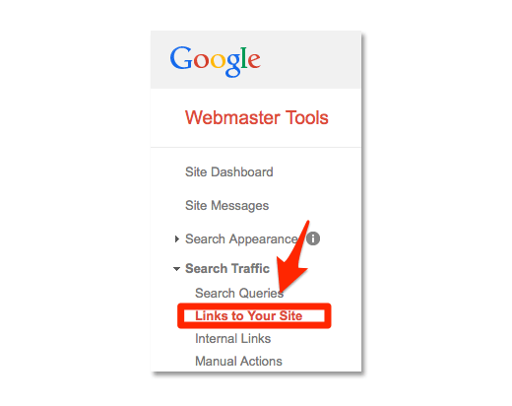

From the module “Who links the most,” click on “More” to see all of the backlinks. To export all of your backlinks, click on “Download latest links”:

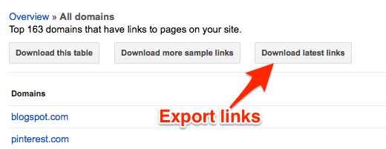

Now, you can import all of the backlinks from Google Webmaster to your favorite SEO tool, and get more insights and SEO metrics for your links. You can use any tool you like and are familiar with. However, **try to avoid using tools that promise to automatically identify low-quality backlinks, because you might end up disavowing some of your best backlinks**.

**Identify the Bad Backlinks**

My favorite tool is called Monitor Backlinks. I am going to show you how I use it to identify the bad backlinks on my websites. After connecting with my Google Analytics account and importing my links from Google Webmaster Tools, I can see all of the backlinks on my website.

The very first things to look for are the backlinks that are dofollow. These are the links that are passing PageRank, and Matt Cutts has clearly said that they ignore the backlinks with a nofollow attribute.

From the right side of Monitor Backlinks, click on the thumbs up icon to view all of your dofollow backlinks:

[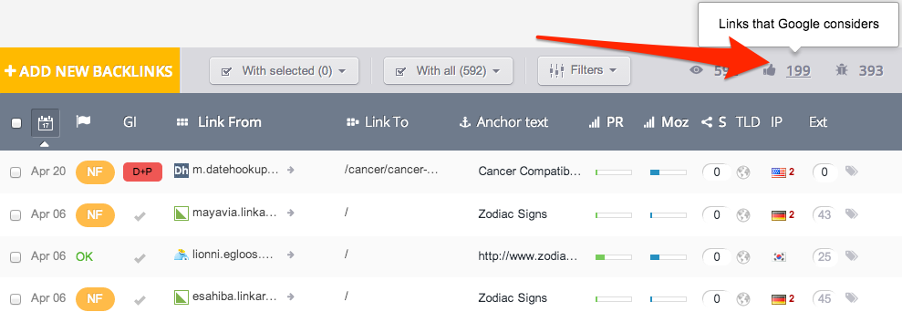](https://blog.kissmetrics.com/wp-content/uploads/2014/05/4-links-considered-by-Google.png)

I’ll concentrate on the 199 backlinks that are dofollow and influence my rankings in Google. To identify the low-quality ones, I first will look at the links that have over 100 external backlinks per page. For this, you have to click on “Filters” and select “External”:

[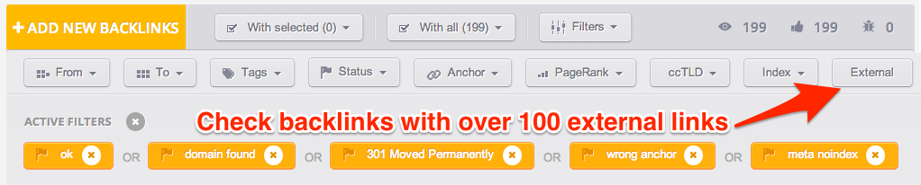](https://blog.kissmetrics.com/wp-content/uploads/2014/05/5-external.png)

In the last column, you can see the exact number of external links each page has:

[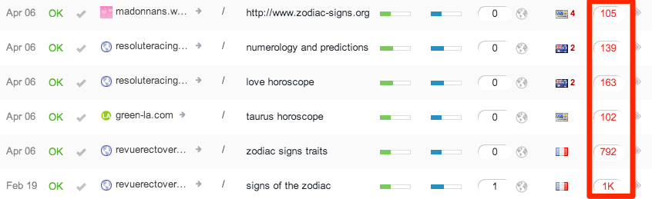](https://blog.kissmetrics.com/wp-content/uploads/2014/05/6-high-external.png)

Now, you have to manually verify each or these backlinks, and identify the bad ones. Most of the time, such backlinks are coming from blog comments. Let me show you some real examples of low-quality backlinks with a high number of external links.

One of the links pointing to my website looks like this:

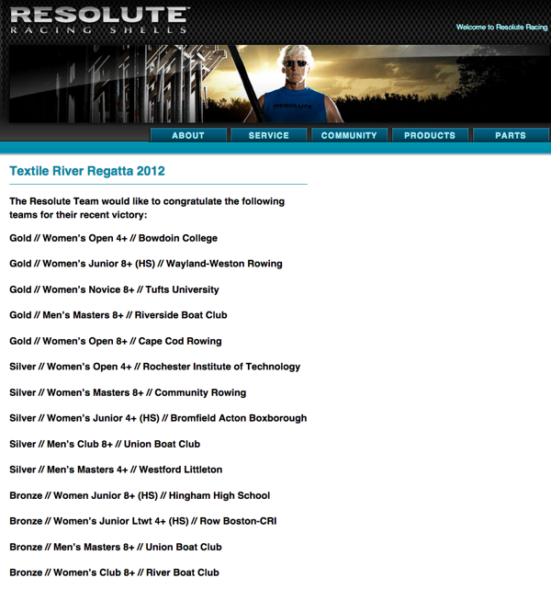

This is followed by a comments module with hundreds of spam links:

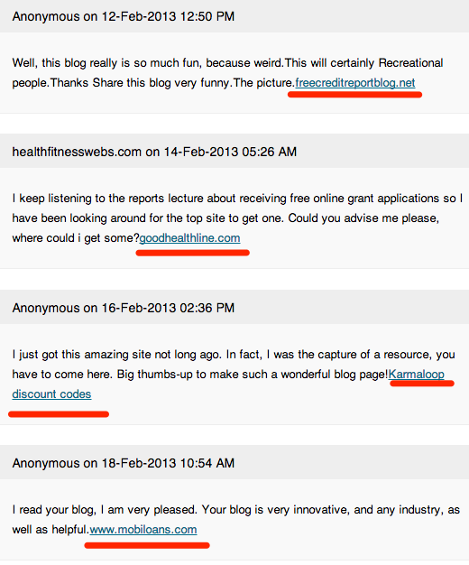

This website has all the ingredients of a low-quality website that I don’t want to be associated with because:

* It’s unrelated to my website.
* It has very thin content.
* It has hundreds of external backlinks coming from auto-approved blog comments.

Here’s another example of a website that has no value:

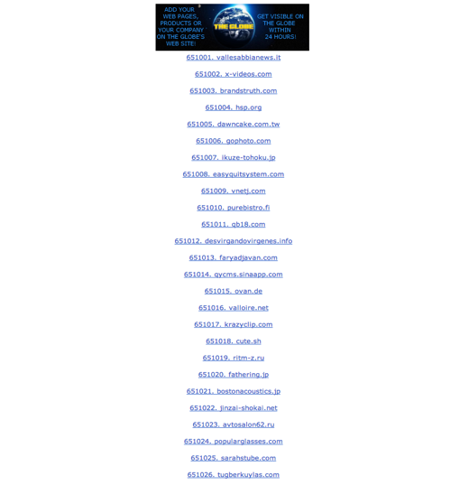

This website is just a list with thousands of dofollow backlinks. It provides no value to the user, and it makes no sense to have a link to my website here. I should try to remove or disavow this link.

So, this is what you can find when you sort your links by the number of external backlinks. To find other bad links, you can verify all of your backlinks that have a domain PageRank of zero. To see these links, from Monitor Backlinks, click on “Filters,” then select “PageRank,” and then select “Domain – 0”:

[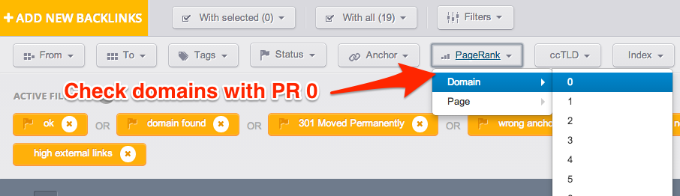](https://blog.kissmetrics.com/wp-content/uploads/2014/05/10-pagerank0.png)

Once again, verify these backlinks manually and decide which ones are not related to your website and might hurt your rankings.

After analyzing these websites, you can set a new filter, and check your backlinks by their website’s domain extension. Why? Because relevancy is the key. For instance, if you have a website written in German, most of your backlinks should come from websites with the extension .de. Think logically, why would a German website have backlinks from websites written in Korean, Chinese, or Russian? To view your backlinks by their domain extension, click on “Filters” and then on “ccTLD”:

[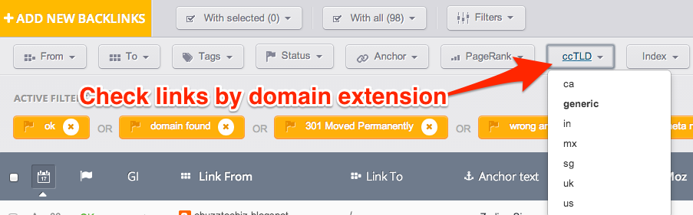](https://blog.kissmetrics.com/wp-content/uploads/2014/05/11-links.png)

If your website has suffered from a Google Penguin update, you will have to look at your anchor text distribution. This update penalizes websites that have over-optimized their money keywords. There is no secret percentage to keep your website safe, but try to make it as natural as possible.

If anyone is going to link to you, most of the time, they will use your website’s name or URL. So, if you have hundreds of backlinks using your money keywords as anchor texts, you can either contact the webmasters to request that they change your anchor text or remove your links.

**Request Removal of the Bad Links**

When you are certain that a link is hurting your Google rankings, try to remove it. Here’s how you can do this in four easy steps:

**1. Create an email with your request to remove a link.**

To increase your chances of having your link removed, all of the requests should follow these basic rules:

* Be polite and don’t threaten the webmaster.
* Use your company’s email address instead of a free email provider. For instance, you should use felix@mywebsite.com instead of felix@gmail.com. This is how you prove to the webmaster that you own the website.
* Don’t use silly words like “Dear webmaster” or “Dear business owner.” Find the website owner’s name, and personalize each request you send.
* Be as specific as possible. You are requesting someone’s time to help you with something. Make it easy for them to understand where your link is located.
* Don’t spam the site owner with emails. You might end up having your email reported as spam. One request is enough.

This is an example of how a correct request should look:

[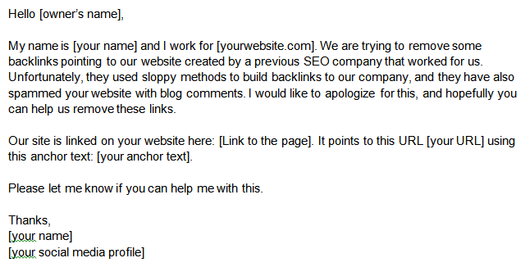](https://blog.kissmetrics.com/wp-content/uploads/2014/05/letter-to-site-owner.png)

**2. Keep track of your email requests.**

As I said above, all requests must be sent from your website’s email address. It’s important to keep track of your requests and see who has opened your emails. For this, you can use Signals by HubSpot. But before you do this, you must forward all of your company’s emails to Gmail. Here’s how to do this:

Go to your Cpanel or web hosting control panel, and from the “Mail” section, click on “Forwarders”:

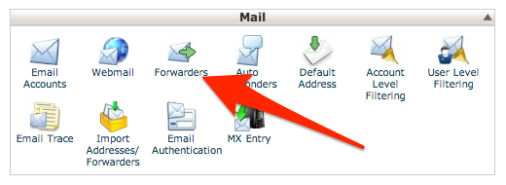

On the next page, click on “Add forwarder.” Select your company’s email address and your Gmail account where you want to forward all of your emails:

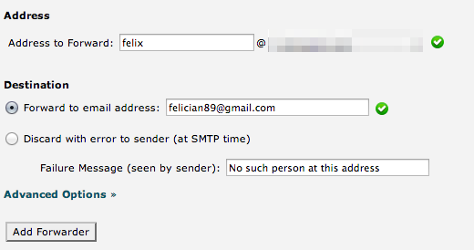

Now, all of the emails that will be sent to your company’s name also will be sent to your Gmail account. To send emails from Gmail using your website’s email address, go to Gmail Settings and click on “Accounts and Import.” From this page, click on “Add another email address you own”:

[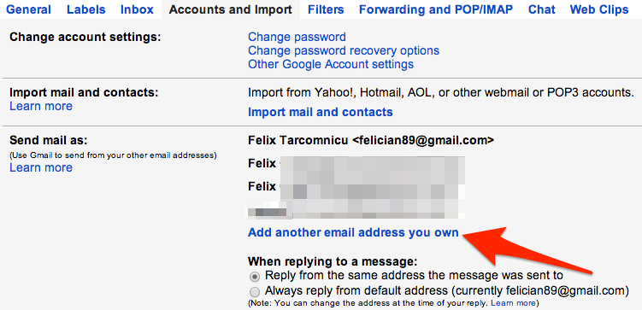](https://blog.kissmetrics.com/wp-content/uploads/2014/05/14-add-new-email.png)

You will be requested to enter your website’s email address and also your name. Click on “Next step,” and check the code you received via email. Enter the code, and click Finish. You will be able to send emails using your website’s address, right from Gmail.

The next step is to install the Signals Chrome extension. This plugin will give you a notification each time someone opens one of your emails. Here’s how to activate it and send an email.

From your “new message” box, at the top, select from which email address you want to send your email. At the bottom, click on the right button to activate Signals:

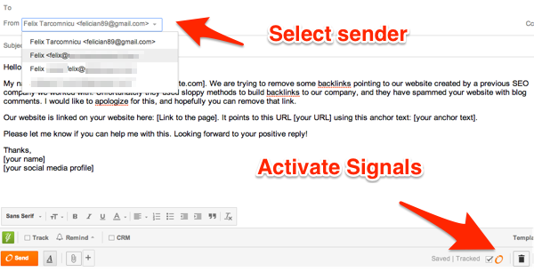

How will this help you with your link removal requests? You’ll know who read your email and who is ignoring your request. Allow one week for a reply.

**3. Find the webmaster’s contact details.**

Most websites have a “Contact us” or “About us” page where you can find the owner’s name and email address. However, there are cases when these pages are missing, and it’s more complicated to find the contact details.

If you encounter such problems, you can use [Whois.com](http://www.whois.com/whois/) to find their email address. Simply type the website whose contact you are trying to find, and check for: “Administrative Contact Email.”

**4. Send your personalized requests to remove the bad links on your website.** These are some possible scenarios:

* Your link will be removed.
* Your email will be ignored. In this case, you will have to disavow the entire domain. I’ll show you how in just a bit.
* The webmaster will request money to remove the link. In this case, you should not pay anything, and disavow the domain.

**Disavow the Remaining Bad Links**

It’s important to remove all of the backlinks you can before creating a disavow report. Then, this is how you can easily create a disavow report:

Going back to Monitor Backlinks, from the backlinks page, on each link’s row, you have a settings button on the right. Click on that button and add tags to all of the links you could not delete. You can use a simple tag like “disavow.”

To see a list with all of the backlinks you have tagged, go to Filters, click on “Tags” and select “Disavow”:

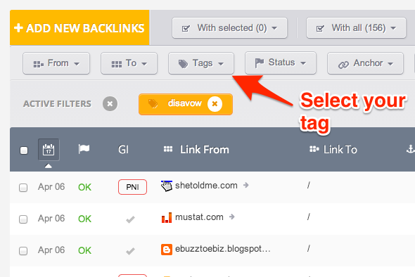

Now, you can easily create a disavow report that you can submit to [Disavow Links Tool](https://www.google.com/webmasters/tools/disavow-links-main). For this, click on “With all” and select “Export (Disavow Format)”:

[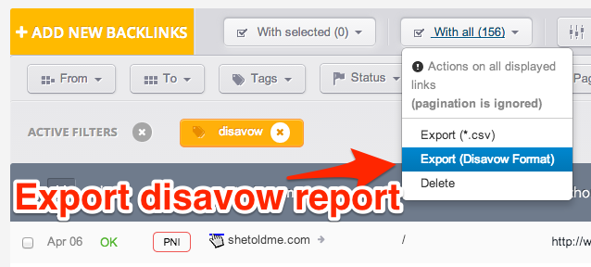](https://blog.kissmetrics.com/wp-content/uploads/2014/05/17-export.png)

When you are ready to submit the report, you will have to upload your file to Google Disavow:

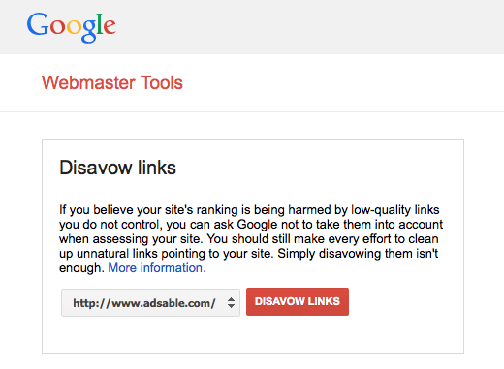

It usually takes 2-4 weeks for the report to be processed, and then you should start to see a difference in your rankings.

**Final Words**

Whether you have built some bad backlinks to your website or someone has used negative SEO against you, getting rid of a Google penalty is doable. Numerous websites have recovered from all types of penalties.

The key to removing any Google penalty is to understand what caused it. This is why it’s very important to read Google’s Webmaster Guidelines. Once you identify the reason for your penalty, you have to remove the backlinks that led to your rankings drop and disavow the ones you cannot remove. Download all of the backlinks from Google Webmaster Tools, and use your favorite SEO tool to get more insights about your links.

-----------------------------

# How to perform Website Analysis for SEO- SEO Audit Guide

Part 1 of Website Analysis for SEO- Checking a website’s overall performance in Google

As part of doing a website’s SEO Analysis, you need to check a website’s performance in Google. It shows your website’s position and ranking on Google, as well as the factors contributing to such rankings.

**1. Google Visibility:** Obviously the first and foremost chore is checking the site’s visibility on Google, the number of the site’s pages indexed on Google. There is a very easy command for this and it’s **site: example.com.**Note down the number of pages the site has in total and compare it with all the pages indexed on Google. Also check the site’s ranking for the related keywords on Google.

**2. URL Analysis:**A website’s URL must contain a small description about the webpage in four to five words. If the URL is not optimized, the search engine bots can have a hard time figuring out what your site is about and which category/area your site belongs to.

**3. Meta Description Tags:** Analyze the meta description tag for each page on the website. A meta description is shown as the rich snippet on Google upon the lists returned to a related search query done by the user. You need to check whether the meta description includes the right keywords as well as entices the visitors to click on to the site.

**4. Title tags and Headings:**Is the webpage title and headings containing all the **marketable keywords**? I say, marketable keywords, because there is no use targeting keywords that have a high search volume or a click through rate. They won’t or will generate very less enquiries. The use of marketable keywords is necessary considering that the ultimate goal of formulating an SEO campaign is to generate more business and expand one’s market. Record whether the <H1>, <H2>, <H3> and <H4> tags are optimized for the best marketable keywords.

**5. Checking global rankings of the website:** Alexa.com gives you the global ranking of your website in terms of users visiting your website. Though it’s not an accurate way of measuring traffic, it gives you an insight into the position of the website among all the other websites in the world. It also displays the country wise rankings for your website. It is a simple tool to know the bounce rate of your site and the average time visitor spends on your site.

The best feature is that the “Alexa Site Overview” shows the top 5 search keywords which are sending traffic to your site. This can be really useful to optimize your site’s content incorporating these keywords.

**6. Page Authority and Domain Authority:** This is important to find out the trust value of the website as far as Google is concerned. Page Authority is an indicator of how a webpage ranks in Google while Domain authority points out how your site domain ranks in Google.

**7. Check Spam Score:** Many websites have gotten links from low authority or spammy directories, contributing to bringing down their Page Authority, or increasing their spam score. Finding out spam score is necessary to eliminate all the bad links pointing at the website. The **[Moz Open Site Explorer tool](https://moz.com/researchtools/ose/)** works best to show these.

**8. Bounce Rate:** Bounce rate is the percentage of visitors clicking on the close or back button of their browser when they come across a website. The bounce rate is to be reported while doing a website analysis. It can be found out via [**Alexa.com**](http://alexa.com/siteinfo) or through the site’s Google Analytics profile, if you are granted the access. While reporting the bounce rate, you should also analyze and state what can be done to decrease- maybe increasing the page loading speed might help or maybe a rearrangement of content is required.

**9. Incoming links from other sites:** Analyzing the number of links coming to your website as well as the competitors’ websites is necessary to know the amount of work that’s to be done as part of the SEO campaign for the site.

* **Using Link checkers/tools online:** There are lots of backlink checker tools like Ahrefs tool, the Moz Open Site Explorer which shows the links pointing to your site.
* **Using SEO commands:** Alternately if you use the **link:command example.com**on Google, you will get a list of sites having links to the webpage concerned. But Google just shows a few links. So it’s really good to use Yahoo for this purpose as it lists out all possible links. The command has a minor difference and it goes like this **linkdomain:example.com**.
* **How to know if a website has got bad links?** The spam score in Moz Open Site explorer can indirectly state the number of spam links you have got. For example, if it is getting displayed in orange, you have 3 bad links. If you’ve got a red spam score, then it means you have got more than 6 bad links. In this case, the only option is to manually analyze each and every linking site, find all the sites with a bad spam score and use the Disavow tool to remove them.

**10. Reputation Analysis:** So you have got a certain number of links from different domains to your site. But what is the anchor text that’s having the hyperlink in them? In SEO, it’s very important you get links with the relevant anchor text and with this, the surrounding content quality also matters.

**How to find these anchor texts?** To find out the anchor text of every link coming to your site, you can use the [SEMRush](http://semrush.com/) Backlink Analysis tool. If you are signed in, you can see all the backlinks to your site, classified as links coming from domain and root domain and most significantly the anchor text which gave the link.

**11. Social Media Profile:** This states the company’s outreach on social media platforms. **The number of +1’s on Google+ profile, the amount of likes on the company’s Facebook page as well as the twitter followers all indicate a company’s social media presence** and as we all know, social signals matter a lot in improving a site’s rankings.

Part 2 of Website Analysis- The website age and its performance in the past

Even if knowing the age of website has no significance of its own, it can work wonders to make impressions on your employers. It can also help you know when the site was started and the keywords and headings used on the site’s content previously.

Suppose you get an enquiry wherein the owner of the website tells you that he was receiving a lot of enquiries/having higher conversion rate before, going through the previous version of the website can make you understand the keywords which led to conversion. After that you can formulate optimized content strategies for the website.

**How to check the age of a website?**If you have installed the [**SEOBook toolbar**](http://seobook.com/) on your Mozilla Firefox browser, click on the “**Archive.org site age**” button when you are on the site. Alternately, you can go to <http://web.archive.org/web>/*/example.com, from your browser and a data which looks like a calendar appears. If you click on the dates marked in blue, you can get a screenshot of the site as on the date. So, the catch is to go to the oldest date available by clicking on the year and then the first date marked in blue. There, you get the oldest, the first version of your website! Interesting, right?

Part 3 of Website Analysis- A complete internal analysis for the website

A complete internal analysis of the website is mandatory if the company is planning to go for an SEO campaign. A website’s internal analysis reveals the underlying errors in its design and structure. One of the best tool to analyze all the internal aspects of a website is the **[GTMetrix](https://gtmetrix.com/) tool**. Besides offering a detailed comprehensive overview of the website’s structure, it has a grading system that gives you scores on the various aspects of the website. It also gives you suggestions as to how you can optimize or fix certain issues like page speed.

**1.Number of Requests made:** A website is built up of a number of files. More the number of files, higher will be the number of requests made to the server by the browser program. When there are a large number of requests to be made, it affects the page loading speed and this can be a big turn off to the visitor trying to access your website. Note the number of requests to be made to the website’s server and make recommendations on how you can combine similar files and java scripts.

**The Waterfall:**You can view the waterfall diagram of your site on clicking the “waterfall” tab on the menu below the scores. This can also be viewed on another website analysis website which is the Pingdom Website Speed Test tool. The waterfall shows the number of requests made by a browser to the server and the time taken for each request in a cascading form. The length/height of the waterfall indicates the number of requests and the width denotes the time taken for the request to receive a response that’s to be downloaded on the browser.

**2. Page loading speed and time:** **GTMetrix** gives a clean summary of your website’s loading speed in Google and Yahoo browsers in the form of **PageSpeed** and **Yellow** scores respectively. Below you can see all the reasons and options listed below neatly. You can click on each of the options and work on the suggestions given.

**3. Leverage Browser Caching:** To leverage your browser’s caching means that you can control and specify the time period in which the browsers should store and keep the images, CSS and Javascripts locally. It’s done to reduce loading time in the users’ browsers.

Leverage Browser caching gives the user many advantages like saving data because already a certain amount of the website data is stored in the browser’s cache the first time he visits the page. For the website owner, the advantage leverage browser caching gives is that it doesn’t send the user away from visiting his site as the page loads with great speed and less time.

How leverage browser caching is done?

Go to Google and search for “**leverage browser cache htaccess code**“. You will find many pages which have the code. It should look like something below. Copy the code and **paste it to the file having the .htacess code** of your website. You can ask the site’s developer to do the same for you.

**5. G Zip Compression:**The G Zip compression code helps you transfer files easily. Just like you compress files into a ZIP for easy transfer on your computer, websites can also use the G Zip compression code for doing the task of transferring the files from the server to the user’s browser easily. The advantage of this code is that compresses the many files on the server into a ZIP file and then after the ZIP file has been transferred to the user’s browser, the Zip file is extracted and uncondensed and displayed on the browser in the original form. All these happens at a speedy rate and the user doesn’t get to know them.

**How to enable G Zip Compression?**Google “**G Zip compression htaccess code**“. Out of any of the webpages mentioning the code, copy the code and paste it to the **file having the .htacess code** of your website. You can ask the site’s developer to do the same for you.

**6.Keep Alive:**Just like the G Zip and leverage browser caching codes, the Keep Alive code, if added in the .htacess file for your website, it helps in achieving faster page loading speed. The Keep Alive code is used to allow a persistent connection between the server and web browser. Usually, every time a new request is made for each file on the server, a new TCP connection has to be established. With Keep Alive, just one TCP connection is required to send requests for all the files altogether.

**How to enable Keep Alive?** Google “**Keep Alive htaccess code**“. Copy the code from any of the webpages having the code and **paste it to the file containing the .htaccess code** of the website. Again, if you are not familiar doing this for your website, seek help from the developer who has developed the website. It is rather better not trying to break your website for this.

**7. Serve Scaled Images:** If you have a low score against this point, you need to resize all the images on the website and place them in the appropriate sections of your website.

1. **Optimize Image:** Having a defined image size that’s optimized both in terms of resolution and is very important for a website, especially when it comes to page loading speed. The “Optimize Image” option in GTMetrix.com not only tells you which images you need to fix on the site, but also provides you with the optimized image samples which you can download and save for use in you site.

**9. Defer Parsing of JavaScript:** Parsing (analyzing and breaking the code into parts and reading their applicability) of JavaScript is done when the browser loads a webpage. If your site has too many JavaScript lines, then it can impact the page loading speed by slowing it done. So the best solution is to defer parsing of JavaScript for the website by adding the “defer” attribute in the JavaScript code. Another option is to load all the java scripts at the bottom of the HTML page.

**10. Combine images using CSS Sprite:** If your website has got a lot of images to handle, it can slow down the page loading speed. Combining all the images of the site in a CSS Sprite can reduce page loading time as well as enable data savings for the user. If you have a low score against this option, considering writing a good CSS Sprite for the website concerned. You can seek the aid of the website’s developer for this.

**11. Minify JavaScript and CSS:** This score indicates unnecessary characters in the JavaScript and CSS of the website, which can slow down page loading speed. If your score for this option is low, they also give recommendations on the unnecessary characters that are to be removed.

**12. Check for Broken links:**Broken links or links to a page that do not exist/ has been removed can reduce crawlability of the webpage. If your site has broken links or links to other sites having broken links, Google bots will hesitate to crawl across your webpage.

**13. Creating a customized 404 Page:**If a person comes against a **404 Page Not Found error** when surfing your website, he usually just clicks on the close/back button of his browser. It’s unsure as to whether he will come back to your site or not and chances are he will not visit your website forever! So creating a custom 404 page is mandatory if you want to keep your user on the website itself.

**Certain tips to be noted while creating the custom 404 Page are:**

* Maintain the same navigation and menus as the rest of the site.
* Inform the visitor that the Page they are looking for is not found.
* Include suggestions for browsing any other pages of the website.
* A search tab can also be included.

**13. Content Delivery Network (CDN):**CDNs or Content Delivery Network is a worldwide distribution network of proxy servers. The way a CDN works is simple. For example, if you have a website hosted in New York, people in New York and nearby states can load the site faster than the people far away, say India.

CDNs eliminate this difference by storing the website’s data files in its servers which are located in different countries and these are called POP servers (point of presence). So when a person is loading the site from US or India or the UAE, he/she can load the site in more or less the same time because they don’t need to travel all the way to the website’s origin server. Rather they can go back and forth from their browsers to the POP server. CDNs can store content, videos and images.

**CDN benefits for your website:** Besides playing a huge role in optimizing page speed, CDNs ensure safety as your site as it stores all the website files in its temporary cache which users can access, even if there is an Internet malfunction. It also prevents the site from crashing as the CDNs divide the page load time among the different geographically located servers.

**14. XML Sitemap:**Having an XML site map for the website enables better crawling by the Google bots. Check if the website has a sitemap and if it doesn’t, make recommendations for the same in the report. One can generate a sitemap from many of the XML sitemap generators available online.

**15. Mobile optimization:**Being mobile optimized has never been more important before ever after Google made it compulsory through the officially announced Mobilegeddon update on May 12, 2016. Websites which are not mobile optimized won’t show up in mobile search results.

* =>Check if the website is able to be viewed easily on mobile devices without zoom.
* =>Also check the server’s responding time for the website- it tells you about the page loading speed on mobile devices.

Part 4 of Website Analysis- Presenting the Website Analysis/ SEO Audit Report

The last and most important step is making a report on the website’s SEO Analysis. A well-presented SEO Report is key to getting hired or convincing your boss that you are one smart SEO Analyst!

Make sure you support all the facts and findings in your report with appropriate screenshots. Also make recommendations or suggestions as to what you will be doing to improve the site’s performance as well as its rankings. So here I give you brief list of contents that form part of a brilliantly prepared SEO Website Analysis Report:

**1. Your company profile:** Name of your company (or your name), title of the report as well as the date on which you created the report.

**2. The profile of the company you are reporting for:** Name of the company, URL of the company’s website, Webpage title.

**3. Page Authority and Domain Authority**

**4. Google Visibility:** Number of pages indexed on Google.

**5. Alexa Rankings**

**6. Bounce Rates**

**7. Daily Page Views**

**8. Average time spent on site**

**9. Links Analysis:**Number of backlinks to the website, the number of domains and root domains

**10. Reputation Analysis:** The anchor text of the backlinks coming into the website.

**11. Internal Analysis:** PageSpeed score, YSlow score, Page Load Time, Total Page Size, Requests, Broken Links if any

**12. Page Speed Improvement recommendations:** Leverage browser caching, G Zip compression, CDNs, scaling and optimizing images, custom 404 not found error page, defer parsing of JavaScript, whichever is applicable

**13. SEO Recommendations:** Optimizing the URL, title tags, headings and meta tags of the website; adding Alt tags for images on the company’s website, XML sitemap generation for easy crawl-ability by Google bots, mobile optimization of the website, creating a company page on the social media sites if not done yet.

An SEO audit report comprising all these ingredients is sure to impress the person reading it if it’s presented in a simple but catchy design. Don’t forget to add screenshots wherever required. A picture speaks 1000 times better.

SEO Tools for conducting a Website Analysis/ SEO Audit Tools

**1. SEO commands:** To show number of pages indexed on Google- **site:example.com**; to show all the sites linking to the company’s website- For Google- **link:example.com**, On Yahoo:**linkdomain:example.com**

**2. For showing Page Authority and Domain Authority:** Moz Open Site Explorer, Smallseotools Page Authority Checker, SmallSeoTools Domain Authority checker

**3. Backlinks Analysis:** SEMRush, Moz Open Site Explorer, Ahrefs backlink checker, Nibbler analysis, Woorank

**4. Reputation Analysis:** SEMRush, Google Webmaster Tools (Available only if you have access to company’s google profile: Dashboard>Search Traffic>Links to your site)

**5. Site Age check:**The SEOBook toolbar extension for Firefox browsers (downloadable after registering with the site), Internet Archive website

**6. Alexa Ranking:**Alexa Site overview for your website

**7. Bounce Rates, Page Views and average time spent:** Alexa Site Overview, Google Analytics (available only if you have access to company’s google profile)

**8. Mobile optimization check:**Google Page Speed Insights, Varvy Mobile SEO tool

**9. Internal analysis of website (page speed, loading time):**GTMetrix.com, Google PageSpeed Insights

I hope my post has helped you with conducting an effective website analysis as an SEO professional.

----------------------------------------------------



## What Is Google Hummingbird?

“Hummingbird” is the name of the new search platform that Google is using as of September 2013, the name comes from being “precise and fast” and is designed to better focus on the meaning behind the words.

Hummingbird is paying more attention to each word in a query, ensuring that the whole query — the whole sentence or conversation or meaning — is taken into account, rather than particular words. The goal is that pages matching the meaning do better, rather than pages matching just a few words.

Google Hummingbird is designed to apply the meaning technology to billions of pages from across the web, in addition to Knowledge Graph facts, which may bring back better results.

Why is it called Hummingbird?

Google told us the name come from being “precise and fast.”

How does Hummingbird work?

Well in short it's faster and more precise than previous versions of Google.

One of the deepest changes that makes Hummingbird so different than past versions of the Google algorithm is that it now focuses more on “conversational search". Google has said that less people are searching seriously with short keyword terms and focusing more on the longer tail keyword searches asking for multiple data points simultaneously.

This means Google is ultimately looking less at what each keyword in your query means and more at what your entire query means.

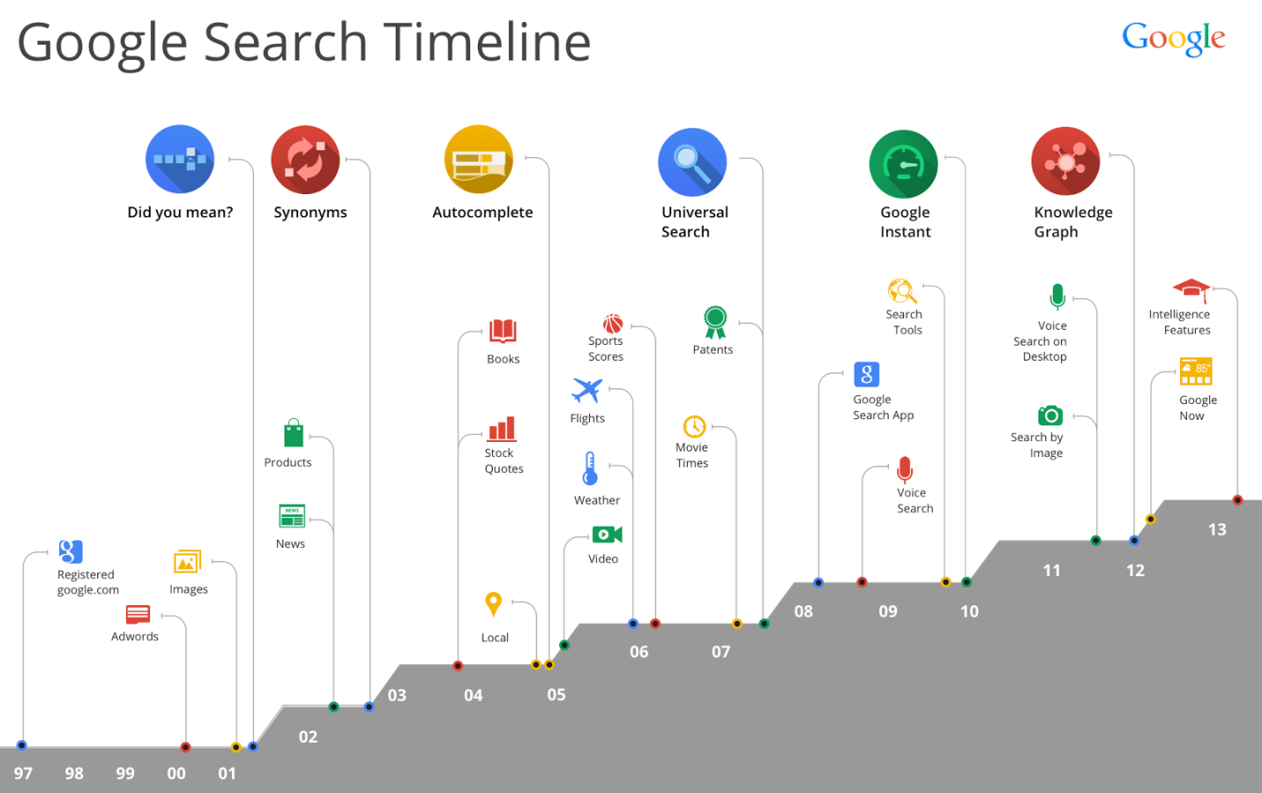

Google is paying more attention at what an entire query means, focus more on providing usable information to your visitors. This means:

* Detailed blog posts that answer specific questions
* How-to's for your industry and product category
* Utilizing schema.org and rich text markup for common data types
* Publish top secret tidbits on your blog that you'd rather save for paying customers
* Don't think so much about Google - build relationships with people on the social networks in an effort to connect genuinely with the people on the other end

Ultimately, it's probably not Google that pays you. You just need PEOPLE to find you. There are so many other ways to get eyeballs than through Google so focus on those areas first and Google will be sure to follow.

**What to do to be Hummingbird-friendly?**

1. When creating/optimizing a site, you should do it with a clear audience in your mind.
2. When performing on-page optimization for your site, you should follow at least these SEO best practices.
   * Using a clear and not overly complex information architecture
   * Avoiding canonicalization issues
   * Avoiding thin-content issues
   * Creating a semantic content model
   * Topically optimizing the content of the site on a page-by-page basis, using natural and semantically rich language and with a landing page-centric strategy in mind;
   * Creating useful content using several formats, that you yourself would like to share with your friends and link to;
   * Implementing Schema.org, Open Graph and semantic mark-ups.
3. Here are following link-building objectives:
   * Better brand visibility
   * Gaining referral traffic
   * Enhancing the sense of thought leadership of your brand
   * Topically related sites and/or topically related sections of a more generalist site (i.e.: News site)
4. As an SEO, is social media offering these advantages?
   * Wider brand visibility
   * Social echo
   * Increased mentions/links in the form of derivatives, co-occurrences, and co-citation in others' web sites
   * Organic traffic and brand ambassadors' growth.

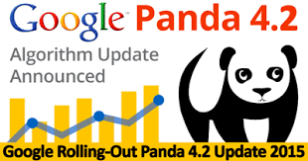

Google Panda

Google Panda is a change to Google's search results ranking algorithm that was first released in February 2011. The change aimed to lower the rank of "low-quality sites" or "thin sites", in particular "content farms", and return higher-quality sites near the top of the search results.

Google Panda takes the quality of a site’s content into account when ranking sites in the search results. For sites that have lower quality content, they would likely find themselves negatively impacted by Panda. As a result, this causes higher quality content to surface higher in the search results, meaning higher quality content is often rewarded with higher rankings, while low-quality content drops.

When Panda originally launched, many saw it as a way for Google to target content farms specifically, which were becoming a major problem in the search results with their extremely low-quality content that tended to rank due to sheer volume.

1. User Generated Content

It is important to note that Panda does not target user-generated content specifically, something that many webmasters are surprised to learn. But while Panda can target user-generated content, it tends to impact those sites that are producing very low-quality content – such as spammy guest posts or forums filled with spam.

Do not remove your user-generated content, whether it is forums, blog comments or article contributions, simply because you heard it is “bad” or marketed as a “Panda proof” solution. Look at it from a quality perspective instead.

2. Word Count

Word count is another aspect of Panda that is often misunderstood by SEOs. Many sites make the mistake that they refuse to publish any content unless it is above a certain word count, with 250 words and 350 words often cited. Instead, Google recommends you think about how many words the content needs to be successful for the user.

For example, there are many pages out there with very little main content, yet Google thinks the page is quality enough that it has earned the featured snippet for the query. In one case, the main content was a mere 63 words, and many would have been hard pressed to write about the topic in a non-spammy way that was 350+ words in length. So you only need enough words to answer the query.

3. Content Matches the Query

Ensuring your content matches the query is also important. If you see Google is sending traffic to your page for specific queries, ensure that your page is answering the question searchers are looking for when they land there. If it is not, it is often as simple as adding an extra paragraph or two to ensure that this is happening.

As a bonus, these are the types of pages – ones that answer a question or implied question – that Google is not only looking to rank well but is also awarding the featured snippet for the query to.

4. Technical SEO

Technical SEO also does not play any role in Panda. Panda looks just at the content, not things like whether you are using H1 tags or how quickly your page loads for users. That said, technical SEO can be a very important part of SEO and ranking in general, so it should not be ignored. But it does not have any direct impact on Panda specifically.

5. Determining Quality

If you are struggling to determine whether a particular piece of content is considered quality or not, there is one surefire way to confirm. Look in Search Analytics or your site’s analytics program such as Google Analytics and look at the individual page. If Google is ranking a page and sending it traffic, then clearly it is viewing it as quality enough to show high enough in the search results that people are landing there from those Google’s search results.

However, if a page is not getting traffic from Google, it does not automatically mean it is bad, but the content is worth looking at closer. Is it simply newer and has not received enough ranking signals to rank yet? Do you see areas of improvement you can make by adding a paragraph or two, or changing the title to match the content better? Or is it truly a garbage piece of content that could be dragging the site down the Panda hole?

### Panda Prevention

How to prevent Google Panda from negatively impacting your site is pretty simple. Create high-quality, unique content that answers the question searchers are asking.

Reading content out loud is a great way to tell if content is high-quality or not. When content is read aloud, suddenly things like over usage of repetitive keywords, grammatical errors, and other signals that the content is less than quality will stand out. Read it out yourself and edit as you go, or ask someone else to read it so you can flag what should be changed.

Google Penguin Update:

Google launched the Penguin Update in April 2012 to better catch sites deemed to be spamming its search results, in particular those doing so by buying links or obtaining them through link networks designed primarily to boost Google rankings.

What Is The Google Penguin Update 4.0?

Penguin updates, the first of which was introduced in 2012, have always drawn the attention of webmasters. In the past, websites which were penalized by Penguin for link spam could sometimes take a long time to recover. There were some domains which were able to change their link structure and quickly get back to normal, but there were just as many who were made to wait until the latest Penguin update – meaning, in some cases, that their punishment lasted more than 3 years…

What is Penguin 4.0?

The new version makes such delayed reactions a thing of the past. Penguin 4.0 is now, according to Google, part of the search engine’s core algorithm. This means that Penguin data, which the Google Bot identifies for certain links when crawling a website, is now updated in real time. Google describes “spam signals” which the crawler picks up – besides links these can also relate to keyword stuffing or cloaking. This means that Google now collates signals from other update paradigms, such as Panda.

**Increased flexibility and real-time impact**

With Penguin 4.0, Google seems to be saying a final goodbye to its practice of announcing major updates. Now that all of the most important components Google uses to evaluate websites have been incorporated into its core algorithm, they are all calculated in real time. With Hummingbird and Rank Brain, the algorithm was already able to reflect a real-time understanding of user intention in the search results. Panda followed suit and now Penguin has also become part of Google’s core algorithm, which is based on data-driven machine learning. This development is taking place in line with one of the most important areas of Google’s research. In its quest for perfection in identifying the most relevant search results, Google continues to make advancements in the field of Artificial Intelligence (AI).

**URL-based effects replace domain-wide penalties**

Another significant development is that Penguin 4.0 is now URL-based, whilst previous iterations targeted domains as single entities. Those websites which have tidied up since previous iterations have now been released from the Penguin’s grip and been given a boost by this latest update. However, some websites, even those which have not improved the structure of their backlinks, have also seen an increase in their domain’s visibility. This is a result of Penguin 4.0 now only penalizing the ranking of individual URLs and not of the whole domain. Therefore, there are now fewer clear-cut losers, as these websites are no longer subject to a domain-wide filter.

How Will Penguin 4.0 Affect My Website?

The effects of a Penguin update are usually felt immediately in the SEO community: “black hat” SEO is penalized, while websites who have had their penalties lifted begin to rise in the ranks again. But the latest Penguin update is a bit of a strange animal — if you’ll pardon the pun — because most SEO specialists and webmasters didn’t feel its effects until a few days after Google began rolling it out.

According to Moz’s co-founder Rand Fishkin, SEOs began to feel a SERP flux approximately three to five days after the update. He polled his followers and found that 24-28% of them were affected by the update, with some feeling the effects later than others. Most of the websites affected — including Moz itself — enjoyed a slight boost in rankings and only a small number of sites experienced penalties.

The takeaway from this is that **the latest Penguin update won’t hurt websites that don’t spam**. In fact, the update is likely to **improve the rank of websites who improve their links and focus on quality content.**

How to See If You Were Affected by Penguin 4.0

To see if Penguin’s latest update affected your SERPs (positively or negatively) you’ll need an anti-Penguin tool. I used my tool — SEO PowerSuite’s Rank Tracker — to measure organic traffic against Penguin updates:

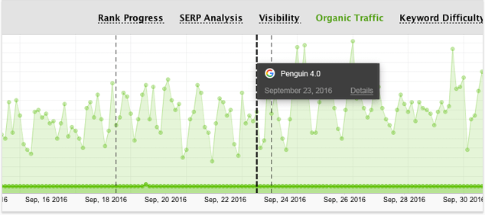

Hopefully, you’ll see the same healthy spike in traffic that I did following Penguin’s latest update.

🡪If for some reason you instead see decreased traffic, you’ve probably had some pages penalized. You may be suffering from some of the common Penguin hazards, such as:

Disreputable links from low quality (“spammy”) websites

Links from PBNs or other websites created for link building

Too many links from off-topic sources

Link schemes or paid links

Keyword over-optimization

Deceptive on-page SEO such as automatic redirects or hidden text

Thin or duplicate content

All of these issues could result in a Penguin penalty. If you’ve fallen afoul of an ill-advised link-building campaign or if you’ve accidentally posted some duplicate content since the last Penguin update, your website may have taken a hit.

How to Resolve Penguin Penalties

Thankfully, as I stated above, the beauty of Penguin 4.0 is that if you have received a penalty after the recent update, you won’t have to wait forever to see that penalty lifted. First things first, however, because your penalty won’t be lifted so long as issues remain. Here’s what you should do:

1. Remove Harmful Links:

Whenever possible, petition webmasters to remove spammy links from the offending sites. If they refuse, or if you can’t contact these webmasters, disavow these links using Google Disavow tool.

2. Steer Clear of Common Hazards:

This Penguin update hasn’t drastically changed what Penguin penalizes so much as what and how it deals with web spam. To that end use your preferred penalty risk assessment software to get a list of all of your website’s backlinks and then check them for any potential risks. Riskier sites should be removed or disavowed, as specified above.

3. Focus on Quality Content

The best way to earn links is to beef up your content with regular, high-quality offerings. Plan out your content in advance so that you have a content calendar for publishing blog posts, ebooks, and other assets. Focus your content on important topics that will earn you attention and help you rank for your targeted keywords.

4. Diversify Your Link Building

Finally, when you have your quality content locked and loaded, you just need to spread the word. Reach out to any industry authorities you reference in your content and see if you can win links from multiple high-profile experts who will help spread the word organically. This shouldn’t be too hard if your content satisfies a need you see in your audience.

Google EMD Update:

The EMD Update — for “Exact Match Domain” — is a filter Google launched in September 2012 to prevent poor quality sites from ranking well simply because they had words that match search terms in their domain names. When a fresh EMD Update happens, sites that have improved their content may regain good rankings.

What exactly is exact match domains?

We all know having Keyword in our domain name gives us extra SEO advantage and that’s why people prefer to use Keywords when buying domains. Now, having a domain name like makemoneyonline.com, toplaptops.com, will help you to rank faster and higher. Whereas using a domain name like tech geek, laptop guy are considered as partial match domain names.

Over the time, many Webmasters used to buy exact match domain names and rank higher in search even with low-quality content. This new algorithm update is aimed to target those Websites with low quality who are ranking higher in searches because of keyword advantage in the domain name.

One thing is clear that Google is following a pattern to penalize obvious SEO spamming. Earlier, Google algorithm took down private blog networks, which used to game the system with backlinks, and now Google taking down exact match domain SEOs.  Now, penalizing a site by name is right or wrong is a point of debate, as instead of penalizing they could simply reward other high-quality sites or work more on adding ranking signal based on content and other data.

How to recover from Exact match domain (EMD) Penalty?

As mentioned above, instead of targeting exact keyword matching domain name, go for partial match domain names. Add Prefix or suffix in your domain names and you can use service like Bustaname to get more domain name ideas.

For existing webmasters, who got penalized by this new algorithm change your read to recovery is going to be time-consuming as if your penalty is more on domain level and it’s different from Panda and Penguin, so you need to work more on content and branding your domain. [Domain authority](https://moz.com/learn/seo/domain-authority) is one thing which will create a major difference here.

If you have low-quality content, you can hire writers from sites like Blogging.org and get your content re-written again with more quality. Here you can read about 12 ways to judge high-quality content.

Another pattern which I have noticed among exact match domain ranking is, they let all their pages indexed in Google. Which includes [tags](https://www.shoutmeloud.com/how-to-organize-wordpress-tags.html), categories, and Archives pages also. It’s better to let Google index only quality and useful pages from your domain. Add noindex to WordPress categories and tags pages, and here you can learn more about what Google meant by [low-quality content](https://www.shoutmeloud.com/how-to-find-low-quality-content-fix-create-quality-site.html).

Social signals are one big SEO factor. You should work on integrating [social bookmarking and sharing icons](https://www.shoutmeloud.com/social-bookmarking-icons-how-much-is-enough.html) around your blog post. Also set up your blog [social media presence](https://www.shoutmeloud.com/social-media-marketing-blogging.html) footprint by [creating Google Plus page](https://www.shoutmeloud.com/how-to-create-google-pages-for-your-blog.html), Twitter page, and [Facebook fan page](https://www.shoutmeloud.com/how-to-create-a-facebook-fan-page-for-your-blog.html).

----------------------------------------------------------------------------------------------

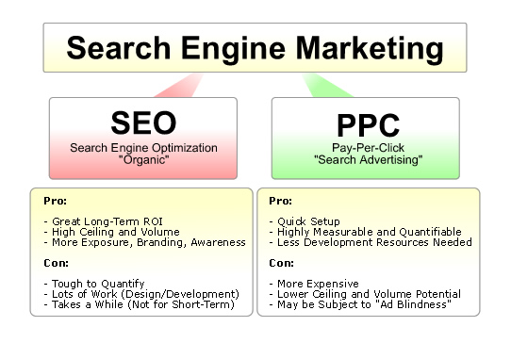

SEARCH ENGINE MARKETING (SEM)

Search engine marketing (SEM) is a form of Internet marketing that involves the promotion of websites by increasing their visibility in search engine results pages (SERPs) primarily through paid advertising.

If you’ve seen ads appear at the top or right of search engines, then you already know what SEM is. When your ads display in these optimal, highly visible positions, your business can have an edge over your competition. Plus, most searchers only click on the first few results, which gives these premium ad spots a visual advantage to catch the attention of your future customers.

Here's how it works:

1. **People search online for a product or service**  
   They enter search terms (called keywords) into search engines like Bing.
2. **These searchers then find your ad**  
   if the keywords in your ad match a search, your ad appears next to or above search results on Bing.
3. **Customers reach out to you**  
   you can configure your ad so that people have the option to call you, visit your website, or go right to your door.

Related SEM Synonyms & Acronyms:

“Search Engine Marketing” was once was used as an umbrella term to encompass both SEO (search engine optimization) and paid search activities. Over time, the industry has adopted the [SEM acronym to refer solely to paid search](http://searchengineland.com/does-sem-seo-cpc-still-add-up-37297).

We generally use **SEM** and/or “**Paid Search**” to refer to paid listings, with the longer term of [search marketing](http://searchengineland.com/guide/what-is-sem) used to encompass both SEO and SEM. Below are some of the most common terms also used to refer to SEM activities:

* Paid search ads

The world of Paid Ads online can be a slightly confusing one, full of acronyms and jargon. Often multiple labels can be applied to a single ad. The two simplest ways to categorize Paid Ads are to split them into Search Ads and Display Ads.

* **Search Ads**– These are designed to appear when the consumer is already looking for an answer or product. The most common form is a Google Ad, these are the paid-for results that show above organic results when you use Google to search for something.
* **Display Ads**– These are the ads that appear at other times. For instance the kind of ads that play before watching a Youtube video or the banners that appear alongside the original content on a website.
* Paid search advertising:

**Paid search** marketing means you advertise within the sponsored listings of a search engine or a partner site by paying either each time your ad is clicked (pay-per-click - PPC) or less commonly, when your ad is displayed (cost-per-impression - CPM).

* PPC (pay-per-click) :

PPC (pay-per-call) – some ads, particularly those served to mobile search users, may be charged by the number of clicks that resulted in a direct call from a smartphone.

* CPC (cost-per-click) :

Pay-**per**-**click** (PPC), also known as **cost per click** (**CPC**), is an internet advertising model used to direct traffic to websites, in which an advertiser pays a publisher (typically a website owner or a network of websites) when the ad is clicked.

The average amount that you've been charged for a click on your ad. Average CPC is calculated by dividing the total cost of your clicks by the total number of clicks. For example, if your ad receives two clicks, one costing $0.20 and one costing $0.40, your average CPC for those clicks is $0.30.

* CPM (cost-per-thousand impressions)

Most search ads are sold on a CPC / PPC basis, but some advertising options may also be sold on a CPM basis.

The formula for CPM goes this way:

Cost to an Advertiser = CPM x (Impressions / 1000)

CPM = Cost to an Advertiser x 1000 / Impressions.

Cost to an Advertiser: CPC x number of clicks.

CPC = Cost to an advertiser / number of clicks.

CTR = (number of clicks / number of impressions) x 100.

The terms pay-per-click (PPC) and cost-per-click (CPC) are sometimes used interchangeably, sometimes as distinct terms. When used as distinct terms, **PPC** indicates *payment* based on click-throughs, while **CPC** indicates *measurement* of cost on a per-click basis for contracts not based on click-throughs.

For example, consider a campaign where payment is based on impressions, not clicks. Impressions are sold for $10 CPM with a click-through rate (CTR) of 2%.

1000 impressions x 2% CTR = 20 click-throughs

$10 CPM / 20 click-throughs = $.50 per click

Social Media Marketing:

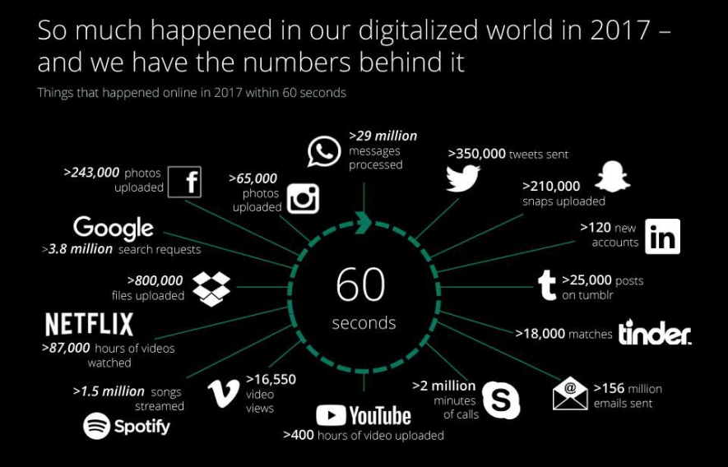

Social media marketing refers to the process of gaining traffic or attention through social media sites. Social media itself is a catch-all term for sites that may provide radically different social actions. For instance, Twitter is a social site designed to let people share short messages or “updates” with others.

The goal of SMM is to produce content that users will share with their social network to help a company increase brand exposure and broaden customer reach.

How Are Search & Social Media Marketing Related?

Why would a search marketer — or a site about search engines — care about social media? The two are very closely related.

Social media often feeds into the discovery of new content such as news stories, and “discovery” is a search activity. Social media can also help build links that in turn support into [SEO](http://searchengineland.com/guide/what-is-seo) efforts. Many people also perform searches at social media sites to find social media content. Social connections may also impact the relevancy of some search results, either within a social media network or at a ‘mainstream’ search engine.

Facebook Marketing:

Facebook represents a huge potential market for your social media efforts, but it is becoming increasingly difficult to stand out from the crowd. The following statistics highlight some relevant Facebook facts and can ultimately help you to navigate it better, increasing your return on investment (ROI) and leading to greater marketing success.  According to SEC filing, for the first time, Facebook’s U.S. ad revenue will be larger than the biggest traditional media companies trailing only behind Google.

1. Worldwide, there are over 1.79 billion monthly active Facebook users (Facebook MAUs) which is a 16 percent increase year over year. (Source: Facebook as of 11/02/16) What this means for you: In case you had any lingering doubts, statistically, Facebook is too big to ignore.
2. 4.5 billion likes generated daily as of May 2013 which is a 67 percent increase from August 2012 (Source: Facebook)
3. 1.18 billion people log onto Facebook daily active users (Facebook DAU) for September 2016, which represents a 17% increase year over year (Source: Facebook as 11/02/16) The Implication: A huge and vastly growing number of Facebook users are active and consistent in their visits to the site, making them a promising audience for your marketing efforts.
4. There are 1.66 billion mobile active users (Mobile Facebook MAU) for September 2016 (Source: Facebook as of 11/02/16) an increase of 20 percent year-over-year.  There are 1.03 billion Mobile Daily Active Users (Facebook DAU) for June 2016 which is an increase of 22% year-over-year.

## What is Facebook marketing?

## C:\Users\Aman\Desktop\FaceBook.png

Let’s clear this up right up front. Facebook marketing is not the same thing as Facebook advertising. Yes, your Facebook marketing strategy can include advertising (more on that below), but since Facebook is, after all, a *social* network, your marketing should also include efforts to build lasting relationships and ongoing engagement through valuable content that’s not about making the sale.

**Facebook’s three key pillars of value for marketers are:**

* Targeted Reach
* Deep Engagement
* Proven Results

Facebook’s ability to reach the right people at the right time is unparalleled. We know that you, as a marketer, care about people and this is at the heart of everything that Facebook offers.

This is how powerful this reach is across the globe:

* On average, nearly 1.9 billion people log into Facebook every month.1
* There are over 1 billion people on mobile daily.
* On average, more than 1 billion people use Facebook every day.

There are 3 tools to include in your Facebook marketing strategy:

With that in mind, let’s look at the three key Facebook marketing tools you can use to connect with Facebook users, and how each fits into your Facebook marketing plan.

1. Pages

Think of your Facebook Page as the equivalent of a Facebook profile for your business. It’s where you post content, engage with followers, and generally participate as a brand in the Facebook experience. It doesn’t cost anything to set up a Facebook Page or post content, which is great if you’re working with a limited budget.

But keep in mind that the Facebook algorithm prioritizes content from users’ friends and family, so you can’t assume that all—or even a majority—of your followers will see your posts organically (that’s where Facebook Ads come in).

That said, setting up your Facebook Page is the first step to creating your business presence on Facebook. You’ll need a Page before you can start working with Facebook Ads. For some examples of brands doing Facebook Pages right, check out our post showcasing lessons from six must-follow brands.

Just how big can a Facebook Page following get? Coca-Cola has one of the highest brand follower counts, currently sitting at more than 99 million.

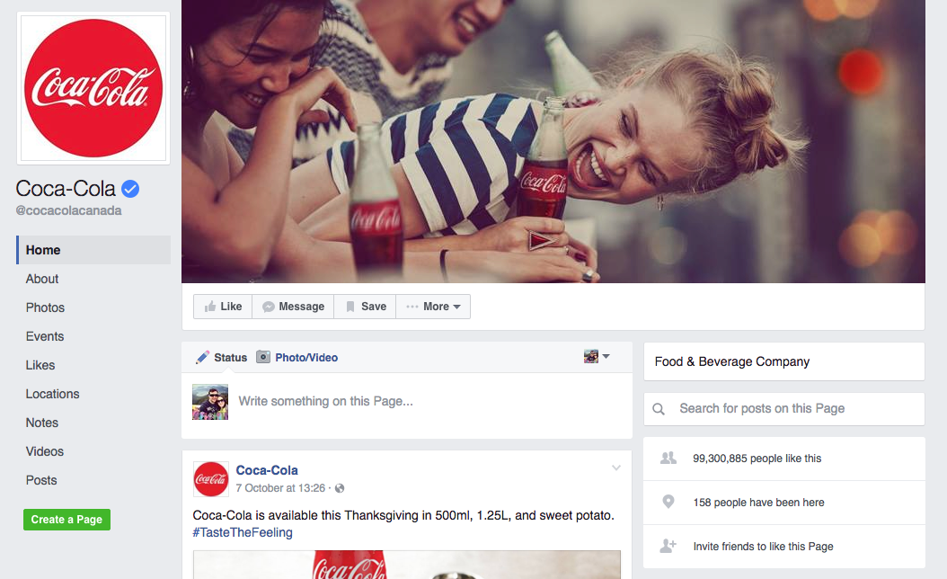

### Groups:

Think of Facebook Groups as the online equivalent of the office water cooler or your favorite coffee shop. They provide a place for people to get together to share information and ideas with like-minded users in an online community environment.

Creating your own Facebook Group can be an effective way to gather your fans in one place and encourage them to interact with one another, building an active community of people talking about your business. It’s also a key way to gather customer intelligence: what are people really saying about you? It’s like a focus group with unlimited members, and you can dive right in to facilitate conversation or ask questions.

It’s also a prime way to source brand evangelists and showcase your expertise. You can even position a Facebook Group as an added benefit for existing customers—after all, it’s a chance for them to interact directly with you.

Entrepreneurs with a compelling message, personality, or brand story can make especially good use of Facebook Groups. For example, Josh and Jill Stanton of Screw the Nine to Five have more than 25,000 members in their Screw the Nine to Five Community Facebook Group.

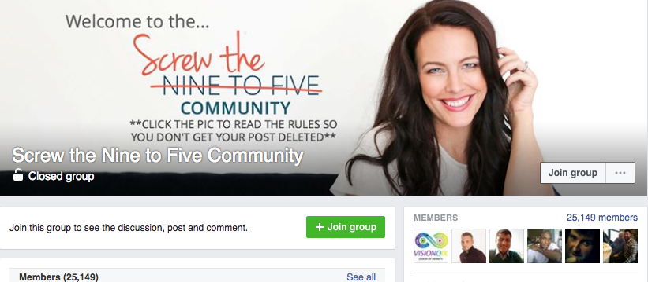

Sometimes fans will create their own Facebook Group with a focus on your brand. It’s a good idea to join these groups to make sure that the conversation is positive and factual, but in general this is a great thing, since it shows your brand has a dedicated fan base that’s really into what you do!

### 3. Ads:

Much like an ad on any other channel—traditional or digital—a Facebook Ad is basically content that you pay to share with a specific, targeted audience: it’s all about getting your brand in front of the right eyeballs and achieving your conversion goals.

For example, Dos Equis ran a series of Facebook Ads to highlight its “Dos de Mayo” promotion (the brand’s answer to the Cinco de Mayo holiday). The beer company’s ads were displayed only to males aged 21 to 34 and to an audience identified as beer buyers. The campaign resulted in a three times return on the ad spend.

## Facebook marketing best practices

Now that you understand the components of your Facebook marketing toolbox, it’s time to dig into some Facebook marketing best practices that can help you maximize the return on your Facebook marketing investment.

### Know your audience

It’s impossible to target a message effectively if you don’t know whom you’re speaking to. When you’re first getting started with your Facebook marketing plan, you may not have much information to go on in terms of who is most likely to connect with your business on Facebook. The overall picture of Facebook demographics and your own brand intelligence about your customer profile can be the first building blocks in developing a sense of who your Facebook audience will be.

From there, you can use Facebook Audience Insights to drill down into the nitty-gritty details about potential customers on Facebook, giving you insights into the aggregate information about any group of users, including age, gender, education, relationship status, location, language, Facebook usage, and even past purchase activity. (For more details, check out our full tutorial on Facebook Analytics and Insights.)

This is extremely valuable information when you’re determining what kind of Facebook content will be most effective for your brand.

### Don’t focus on selling

Remember when Facebook changed its algorithm back at the start of 2015? That was partly in response to brand content on the social network leaning far too heavily into driving sales.

Facebook wants its users’ news feeds to be filled with content they want to Like and share, rather than sales pitches. As a brand marketer, you should want that, too—since all those Likes and shares help extend your reach and put your brand in front of new eyeballs, without any direct effort from you or your team.

### Post your best content

On that note, your Facebook content should feature the very best of what your team is creating so that your followers are motivated to engage with it and share.

Have you tweeted content that’s getting a great response? Share it on Facebook, too. Have a page on your blog that’s always getting new comments? That’s another Facebook post contender.

Once you’ve started sharing content, you can adjust your strategy based on how your audience responds. You can track audience engagement with content on your Facebook Page and Facebook ads through Page Insights or Business Manager.

### Don’t forget to respond

Nobody likes talking into a void—including your Facebook followers. If Facebook users who try to interact with your brand are met with radio silence, you’re hardly playing fair at the “social” part of the social networking game, and followers will quickly catch on and head for more interactive Pages.

Your mantra here is reply, reply, reply. That’s really all there is to it.

### Make the most of pinned posts:

You know you have it—that one piece of content that soars above the rest, that really captures your brand and shows potential followers exactly why they should Like your Page. Well, pin it.

**To pin a post to the top of your Page's Timeline:**

1. Go to the post on your Page's Timeline.
2. Click in the top-right corner.
3. Select Pin to Top.

A pinned post sits at the top of your Facebook Page and isn’t bumped down when you post new content. You can also use this space to share important news, showcase an amazing video, and raise awareness about a current campaign, or anything else that will get potential followers excited about engaging with your brand on Facebook. You can tell a post is pinned when you see a little blue thumbtack icon on the top left of the post.

### Post at optimal times:

You may have noticed that there’s a lot of content on Facebook. Your post has the best chance of making it to the top of the pile if you post when your audience is most active. This will take some trial and error to pin down for your specific business (using engagement data gleaned from Page Insights), but research generally shows that the best time to post is Thursday or Friday from 1 to 3 p.m., so that’s a good place to start.

-----------

## What is Facebook advertising?

Facebook advertising allows businesses to promote custom ads or content targeting a specific audience, with costs varying based on the reach and engagement the ad receives. Facebook ads can appear in your target audience’s News Feed or right column of Facebook.



When you advertise on Facebook, you’ll gain insight about your current and potential customers. The data you collect through Facebook ads allows you to improve your ad targeting for a more efficient and effective advertising experience.

Key factors of Facebook advertising

1. Find people easily:

You can choose your audience based on demographics, Behaviors or contact information.

2. Get attention:

Facebook's advert formats are eye-catching, flexible and work on every device and connection speed.

3. See the result:

Facebook's advert reporting tools shows you how your adverts have impacted your business in visuals, easy to read reports.

Facebook advertising best practices

Before you begin, remember these three Facebook advertising best practices:

1. **Always determine your objectives before you start.**It’s important to know the purpose of your Facebook Ad before you decide on a budget for advertisements. Understand whether the aim is to increase for brand awareness, conversions, video views, etc. Each action made by your audience on your Facebook ad costs money, so make sure you solidify your objectives before making those investments.
2. **Be specific on your audience targeting.** Facebook houses millions, if not billions, of data points. Take the time to narrow your audience targeting to ensure your ad will appear where the people you want to see it will be.
3. **Rotate your ads regularly.**To avoid ad fatigue, rotate your Facebook ads regularly. ‘Ad fatigue’ is when people see your ad too many times, so they get bored and stop clicking. Unfortunately, when your clickthrough rate starts to drop, Facebook penalizes you, driving up your cost per click (CPC)—which makes likes, comments, and clickthroughs more expensive. This affects both acquisition and engagement campaigns.

**How to advertise on Facebook in 7 simple steps**

With these seven steps, you’ll be able to define your objective, target an audience, set a budget, and place your ad.

**Step 1: Create a Facebook business page**

When creating a Facebook Page, an important step is determining the category of the Page. Choose an appropriate category that best describes the nature of your business and will help people find your Page. The category name is displayed on your Page, so it’s one of the first things a user sees when they visit your brand on Facebook.

1. Go to facebook.com/pages/create
2. Then choose a Page category
3. Click Get Started and follow the on-screen instructions

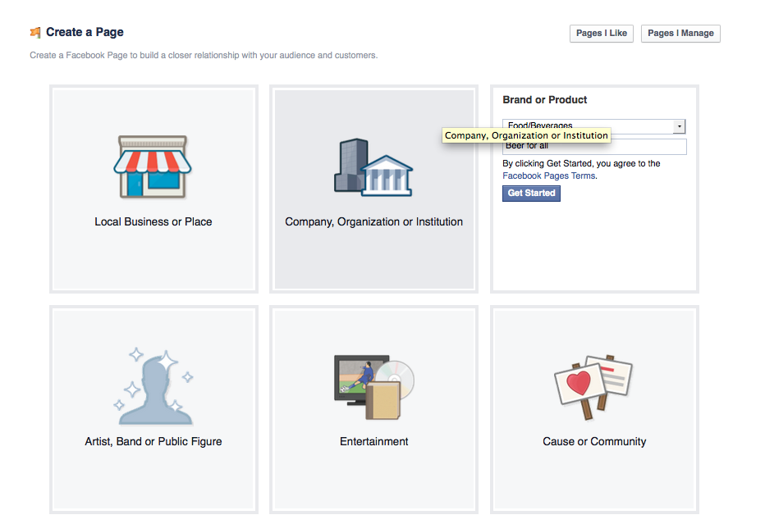

Keep these best practices in mind when creating a Facebook Page:

* Fill out your page info in full detail
* Include a relevant Facebook profile and cover photo
* Have a Facebook Page strategy

Step 2: Create goals for your Facebook ads

When creating a strategy for your Facebook Ads, make sure your goals are S.M.A.R.T. goals—specific, measurable, attainable, relevant, and time-bound. Creating S.M.A.R.T. goals for your Facebook Ads will help you achieve a better return on investment.

For example, if you’re running a conference, your goal can be: acquire 100 registrants in two months. This goal will now guide your Facebook Ad strategy and help you choose the right type of ad.

Step 3: Choose an objective for your campaign

Now that you have created your Facebook Page and have goals for your ads, you can now go into the Facebook Ads manager and choose an objective for your ad.

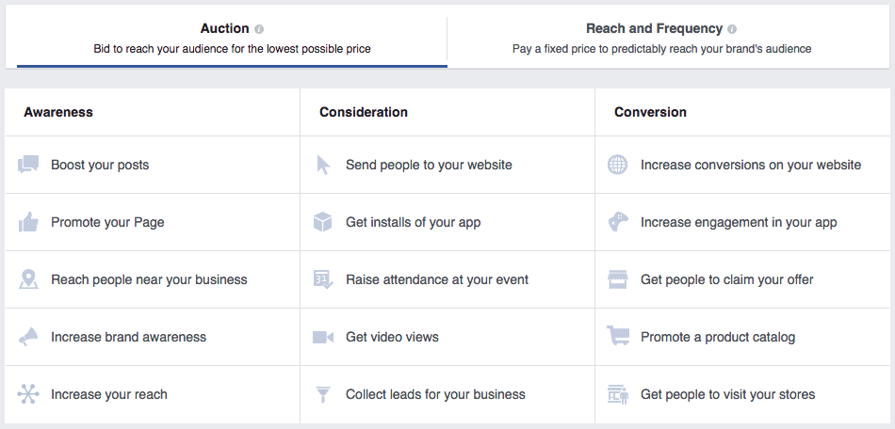

If your goal is to acquire registrants for an upcoming event, the Facebook Ad objective you would choose is to “Raise attendance at your event.” Or if you want to drive people to your blog, then you would choose the objective, “Send people to your website.”

Step 4: Choose your target audience and ad spend

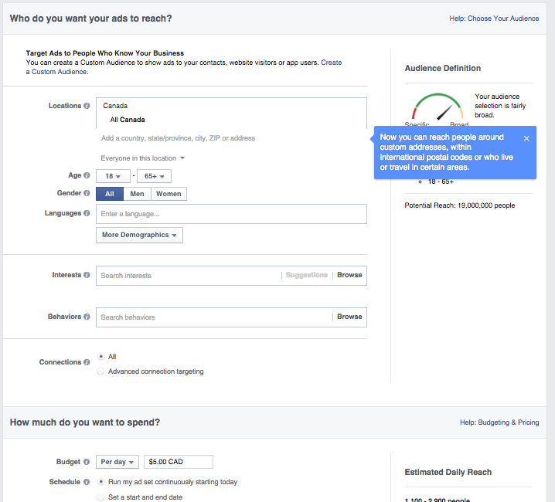

1. **Customize your target audience**

This step is crucial in setting your Facebook ad up for success. You can target ads based on location, age, gender, language, interests, and behavior.

You can further customize by creating custom audiences to reach people who already know your business, or to remove them from your ad’s target audience so you can reach new people on Facebook. These custom audiences can be created through a customer list, website traffic, or app activity.

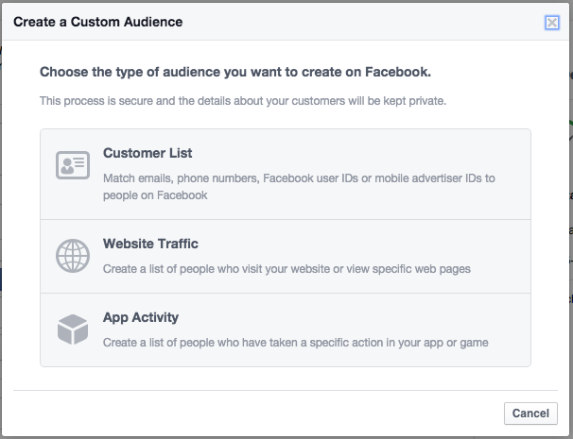

1. **Choose your budget**

After you’re done choosing your target audience, you can then choose how much you want to spend on your ad. The ad budget you set is the maximum amount you want to spend. If you choose to have a daily budget, the amount you enter will be the maximum amount you’ll spend each day. If you do a lifetime budget, the amount you enter is the maximum you’ll spend during the lifetime of your ad.

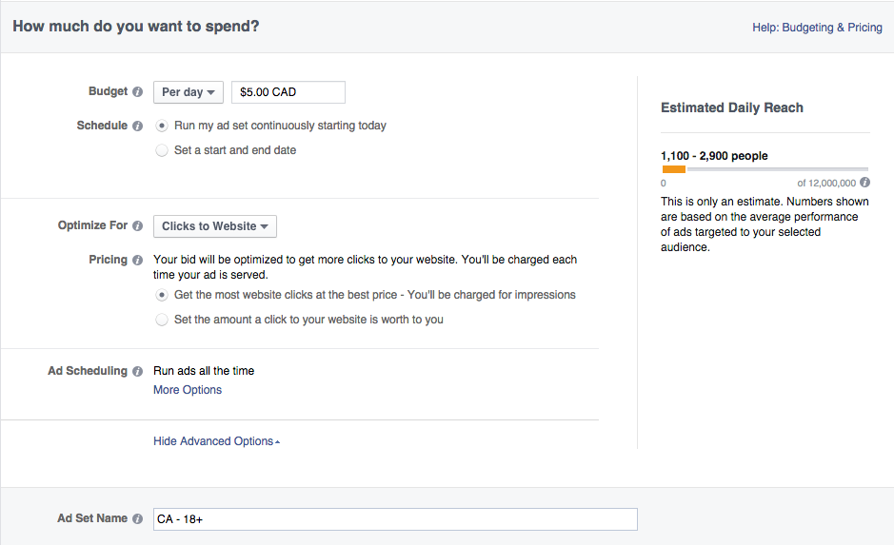

1. **Choose your objective**

First, choose to bid for an objective: clicks or impressions. This will determine how you will pay and who your ad will be served to. For example: if you optimize for the Page like objective, you’ll be charged when your ad is shown to people who might be more inclined to like your Page.

Once you’ve placed a bid for your objective, choose when you want your ad to run under ad scheduling. If you choose the lifetime budget route, you choose specific hours and days of the week when you want your ad to run.

Choosing to run your ad on a schedule is the most efficient way to spend your ad budget wisely; this means that you are only serving your ad when your target audience is most likely on Facebook. For example, if you chose to target a specific region, you want to make sure you’re scheduling your ad when they are awake, this will allow you to make sure your ad will be seen by the people you want to target.

Step 5: Choose how you want your ad to look

The actual creation of the ad is the fun part of advertising on Facebook. Choose your images, headline, body text, as well as placement of the actual ad. You can have up to five images and the headline text can only be 25 characters.

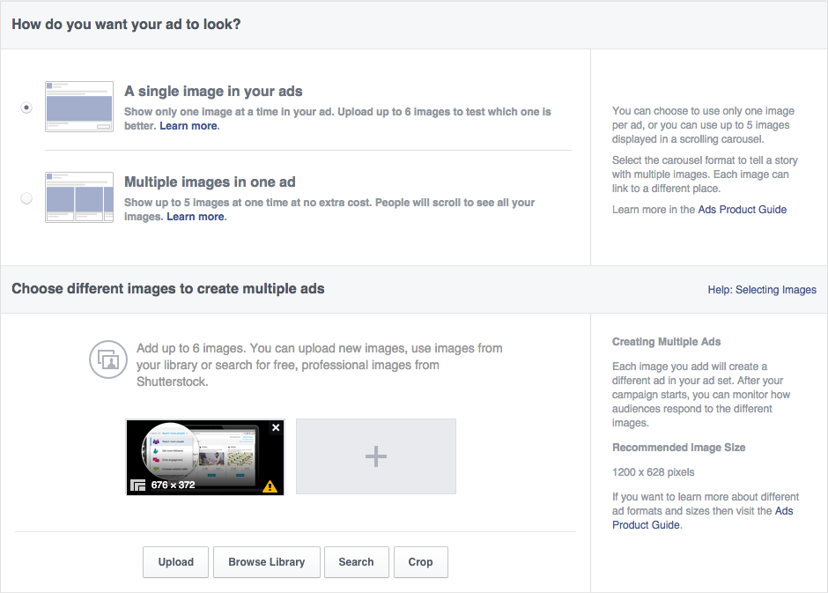

Keep in mind that because your headline is so short, your copy has to be intriguing enough for people to want to click on it. Along with the headline, there is also text that will accompany the post. This can only be 90 characters long, which means your copy needs to be clear and concise (think of it as a really good Tweet!).

Lastly, you need to choose the placement of your Facebook Ad. Choose whether you want it on people’s desktop News Feed, mobile News Feed, right column, or audience network.

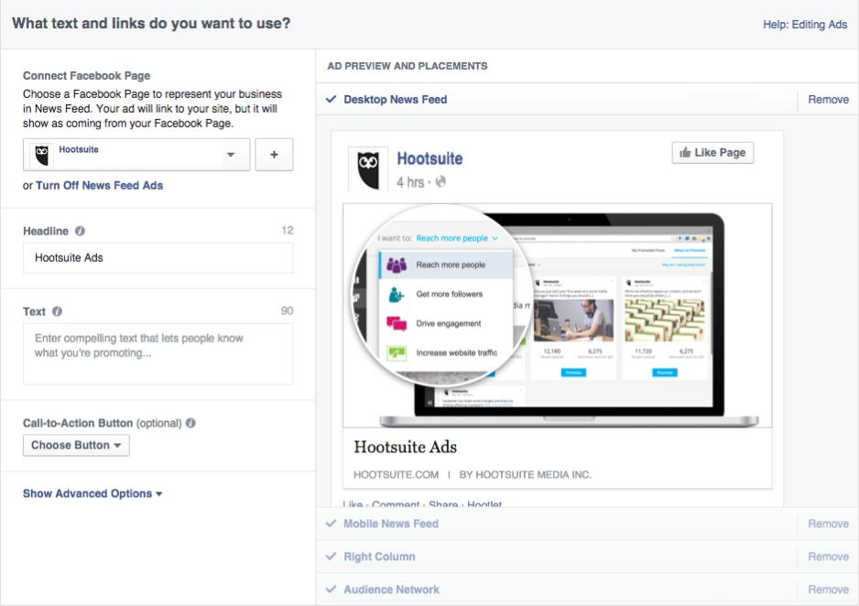

Step 6: Place your order

Once you’re ready for your ad to be reviewed, click on the green button that says Place Order, located on the bottom right-hand corner. You’ll receive an email from Facebook once your ad has been reviewed and approved.

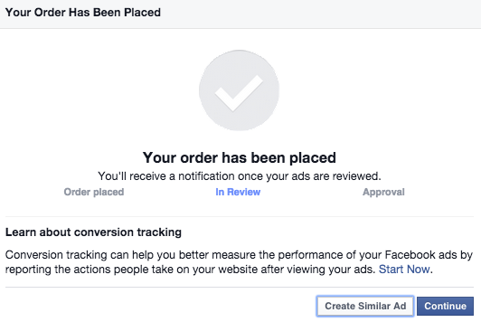

Step 7: Create a Facebook ads report

Now that you have created your Facebook Ads, it’s important that you report on the successes (and failures) of your endeavors.

1. Go to Ads Manager and click Reports in the navigation. You’ll automatically see data from the default report called General Metrics over the last 30 days for your active campaigns.

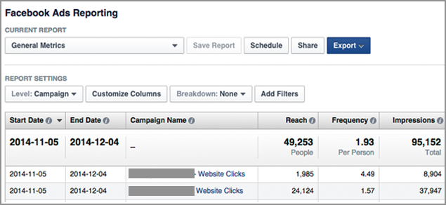

1. Customize the metrics you see in your report and then click the blue Export button on the top-right column to download your report.

How to Use LinkedIn as a Marketing Tool



After you learn the secret to social media marketing success, it’s time to get to work. For business-to-business social networking, LinkedIn is where the action is!

LinkedIn is the most ‘professional’ of the major social networking Websites, used by over 450 million business professionals worldwide. Since it is largely focused on B2B connections, LinkedIn should be a big part of your social media marketing strategy.

Most people only use LinkedIn as an online resume. To take LinkedIn to the next level and use it as a marketing tool, put the following recommendations into action.

BEEF UP YOUR LINKEDIN PROFILE

Think of your LinkedIn profile as an interactive resume – on steroids. In addition, to information about your work experience and education, LinkedIn allows you to enhance your profile with the following Web 2.0 capabilities to showcase your expertise:

* **Status Updates:**One of the best ways to keep your connections informed about your happenings is by posting ‘status updates.’ Status updates are brief statements that you feel your connections will find useful. In addition, they can include links to related content on your Website or third-party Websites. To appear active in the LinkedIn community, post useful and actionable status updates on a regular basis.
* **Posts**:  LinkedIn allows you to easily publish articles (or posts) to your profile. This is a great way to establish yourself as a though leader getting exposure to your LinkedIn community.
* **Videos and Presentations:** If you post PowerPoint presentations to SlideShare or videos to YouTube, you can display these valuable content items in your LinkedIn profile.
* **Recommendations and Endorsements:** LinkedIn makes it easy for you to request recommendations and endorsements from your connections. A collection of glowing recommendations that underscore your expertise and experience will significantly enhance your profile.
* **Publications:** If you wrote and published traditional books or e-books, you can highlight these publications with active links so connections can view and purchase them.
* **Projects:** If you have successful projects you want to highlight, post your projects including a description, link and the team members you worked with.

TAKE ADVANTAGE OF LINKEDIN COMMUNITY FEATURES

In addition to your profile, LinkedIn provides a number of community features that allow you to communicate and collaborate with other LinkedIn users, including:

* **Groups:** LinkedIn Groups help you stay informed and keep in touch with people that share your interests. You can create your own LinkedIn groups or join any number of groups that focus on your area of interest or expertise. Participating in LinkedIn Groups by adding value to the discussion is a great way to expand your circle of influence.
* **Company Pages:** Company Pages are a powerful research tool that you can use to find companies to do business with or research competitors. In addition, you can create a Page for your company to showcase your expertise. You can publish your company’s description, headquarters address and Website address. To further your company page’s value, you can post targeted jobs, recruitment videos, information about products and services and company images.

LEVERAGE LINKEDIN AS A BUSINESS-BUILDING TOOL

LinkedIn can be a valuable business tool to help you grow your business and catapult your career. The following strategies will help you use this resource to produce results:

* **Brand Your LinkedIn Address:** When you create a LinkedIn profile, it will create a LinkedIn Web address that will appear like a collection of odd letters and addresses. LinkedIn will let you customize this address to create a branded LinkedIn address with your name.
* **Become a Recognized Expert:** By actively participating in LinkedIn group discussions and publishing thoughtful posts on a regular basis, you have an opportunity to establish yourself as an expert and thought leader.
* **‘Warm Call’ Sales Prospects:** If you’re in sales, you can use LinkedIn as a ‘warm calling’ tool. If there is a prospect you want to reach, you can easily find them on LinkedIn and see how you are connected to them. If you have an active list of LinkedIn connections, you are most likely only two or three connections away from the prospect. Use LinkedIn’s introduction features to ask one of your connections for an introduction.
* **Find Rock Star Employees:** Successful business people are always looking to find valuable employees that will ensure their future success. LinkedIn provides you with an easy place to find them. You’ll have access to a pool of talented individuals within your LinkedIn groups. You can also post a job directly on LinkedIn to attract a talented set of candidates.
* **Keep Your Connections Current:** Whenever you meet someone, connect with them on LinkedIn. It’s a great way to expand your influence and keep connections up to speed on your accomplishments.

-------------------------

Twitter Marketing

## Twitter.com

* Launched: March 2006
* Public: NYSE stock symbol – TWTR

On average, Twitter sees 500 million tweets per day. Out of all of the interactions people have with these tweets, 92% of them involve clicking links.

Why Twitter?

When devising a social media strategy, you have your choice of social networks to choose from. As our post [“The Top Social Media Sites That Matter for Marketers”](https://blog.hootsuite.com/top-social-media-sites-matter-to-marketers/) explains, “While it may seem like there’s a hot new social media network being launched every day, the truth is that there are currently a core group of platforms that are key to consider for your social media strategy.” With [over 310 million monthly users](https://blog.hootsuite.com/social-media-statistics-for-social-media-managers/), Twitter is undoubtedly one of these platforms.

Along with this reason for adding your organization’s content to Twitter’s mix, our post [“125+ Essential Social Media Statistics Every Marketer Should Know in 2016”](https://blog.hootsuite.com/social-media-statistics-for-social-media-managers/) shares the following statistics that show why Twitter is a fundamental part of your social strategy:

* Of the 310 million users, [83 percent are active on mobile](https://about.twitter.com/company)
* Every second, [6,000 Tweets are sent](http://www.internetlivestats.com/twitter-statistics/)
* More than [130,000 active advertisers](http://venturebeat.com/2016/02/10/twitter-brings-in-710m-in-revenue-as-mobile-advertising-falls-to-86/) market on Twitter
* Twitter users are three times as likely as Facebook users to follow a brand, with [49 percent of monthly Twitter users following brands](http://www.convinceandconvert.com/social-media-strategy/7-surprising-statistics-about-twitter-in-america/) or companies.
* Twitter is a place to interact with brands: [42 percent of users learn about products and services via Twitter,](http://www.convinceandconvert.com/social-media-strategy/7-surprising-statistics-about-twitter-in-america/)41 percent of users provide opinions about products or services on Twitter, and 19 percent of users seek customer support on Twitter.

Twitter marketing strategy

Now that you know the stats behind the social network, it’s time to think strategy.

Set goals

As with any personal and professional endeavor, it’s a great idea to set goals. What are you hoping to achieve with every 140 characters? Who are you trying to reach? What does Twitter success look like to you and your brand? These are all questions you should think about before you dive into the Twittersphere.

You might have your own surefire way of creating and reaching your goals, but if not, the [S.M.A.R.T framework](https://blog.hootsuite.com/smart-social-media-goals/) is one that we highly recommend. This acronym suggests making goals that are specific, measurable, attainable, relevant, and timely. Examples of each of these as they could apply to Twitter are as follows:

**Specific:** “I will create a campaign of hashtag contests on Twitter to increase brand awareness.”

**Measurable**:  “I aim to increase my reach by 100 followers a week and answer all queries over Twitter within 24 hours.”

**Attainable**: “I want to grow my Twitter followers by 35 a week for the next quarter.”

**Relevant**: “I will use Twitter to position my brand in a relatable way that grows my online community.

**Timely**: “I will average 10 interactions per day by Q3.”

With these goals in mind, you’re able to focus your Twitter marketing efforts much more clearly and take the next steps to achieve them.

Listen and engage

As a social media or content marketer, you know the importance of social listening. You need to know what your Twitter community is talking about, whether it’s directly mentioning your brand or not. What are the topics they’re interested in? What kinds of content are they responding to? Who are they engaging with? These are all important factors to consider when participating in social media listening.

Our [social media glossary](https://blog.hootsuite.com/the-2015-social-media-glossary-207-essential-definitions/) defines social listening as “The process of finding and assessing what is being said about a company, topic, brand, or person on social media channels” and Twitter is a top platform for this. To use social listening in your [Twitter marketing plan](https://blog.hootsuite.com/social-listening-business/), be sure you’re monitoring:

* Your own brand’s name (including misspellings!)
* Your competitors (again, including misspellings)
* Industry buzzwords
* Brand slogans
* Your CEO or public representative’s names (and misspellings)
* Campaign names or keywords

To maximize your social listening efforts on Twitter, there are some helpful tools:

**Twitter Advanced Search**—narrow down your searches, search by negative or positive sentiment, explore relevant hashtags, and much more. For a guide on using Twitter’s Advanced Search, see our post [“How to Use Twitter’s Advanced Search for Lead Generation.”](https://blog.hootsuite.com/how-to-use-twitter-advanced-search-for-lead-generation/)

* **Social Mention—**monitors over 100 sources and “allows you to easily [track and measure what people are saying about you](http://www.socialmention.com/about/), your company, a new product, or any topic across the web’s social media landscape in real-time.”
* **Hootsuite—**use Hootsuite to set up streams that allow you to not only monitor conversations and keywords, but respond or assign the response to someone else on your team. For more information on using Hootsuite for your social listening, our [“Introduction to Social Listening](https://blog.hootsuite.com/social-listening-hsu-videos-2/)” guide is extremely helpful.
* **TweetReach—**offers basic listening tools, and helps you monitor Tweets about your brand, and industry conversations.
* **ViralHeat—**allows you to listen to conversations around your brand across social networks and then “identify trends to drive insights around your social media performance.”

Measure results

Measuring your Twitter marketing results allows you to evaluate your success, see what kind of content your community engages with, and shows you what areas you could probably stop spending resources on.

Twitter has its own native analytics tool, appropriately named [Twitter Analytics](https://business.twitter.com/en/analytics.html). As explained on the home page, “Twitter’s analytics help you understand how the content you share on Twitter grows your business.” With Twitter Analytics, you can see an overview of how your Tweets are performing, who is engaging and when, influencers in your network, and metrics for individual Tweets. You can also track your followers’ activity over time, their interests, demographics, and much more. If you’re running a Twitter Ads campaign, your analytics are also found through Twitter Analytics.

[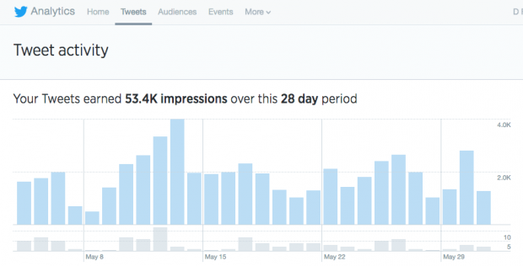](https://blog.hootsuite.com/wp-content/uploads/2016/06/Twitter-Marketing-Analytics.png)

Hootsuite’s analytics tools are also a great option for your Twitter measurement efforts. With Hootsuite, you can:

* **Create social reports—**quickly and easily build intuitive reports and keep your team up-to-date with automatic report sharing.
* **Tag and track messages—**Tag messages tied to specific campaigns or events to easily analyze their content, volume, and sentiment.
* **Measure internal metrics—**Track performance at the individual and team level—including messages sent, and resolution times.

Measuring your analytics is a major part of any Twitter marketing campaign, and the following tips can help you see success in these results.

Twitter marketing tips

Best times to post:

Working hard on a piece of Twitter content, only to have it receive zero engagement is not a fun feeling. While my number one piece of advice would be to make sure you’re focusing on quality over quantity when planning your Tweets, knowing when to post doesn’t hurt.

With the lifespan of a Tweet—24 minutes—being much shorter than that of a Facebook or Instagram post, it’s even more important that you find the timing sweet spot for your brand. If you don’t know where to start with finding this, the following are times that other sources have found the most success with:

* The Huffington Post: “For maximum retweets, post at **5 p.m., 12 p.m., and 6 p.m**. Additionally, 12 p.m. and 6 p.m. also deliver higher click-through rates. The best days to Tweet for **business-to-business** organizations is Monday through Friday, for **business-to-consumer** it’s the weekends and Wednesdays.”
* Hubspot: Between **12 p.m. and 3 p.m. from Monday to Friday**, and between **5 p.m. and 6 p.m. on Wednesdays**.
* Kissmetrics: **Weekdays at 5 p.m.**, where the highest percentage of Retweets occur.

Now that you have a general idea of what times might work best for your Twitter marketing strategy, you can make your life a lot easier through scheduling Tweets at these times.

Use hashtags

For Twitter marketing success, it’s a good idea to ensure that your content is being seen by as many audience members as possible. Hashtags make this possible. Hashtags work as a classification system, enabling your Tweets to be grouped with other relevant Twitter content. This means that not only will those looking for that specific hashtag find your content easily, but you’ll be able to find influencers and others in your industry without much effort.

The following best practices for your Twitter marketing hashtag use.

Do’s:

* Do be specific when using hashtags
* Do cater hashtags to the social network you’re using
* Do come up with relevant, unbranded hashtags

Don’ts:

* Don’t go too long or too clever
* Don’t have more hashtags than words.
* Don’t hashtag everything

A hashtag can make or break a Tweet

Include multimedia

If you never include multimedia in your Tweets, you’re missing out on huge opportunities for Twitter marketing success. Multimedia will take your Tweets to the next level by making them more engaging.

Some of the kinds of multimedia you can include on Twitter are:

* GIFS—with users sharing over 100 million GIFS on Twitter last year, they’re a great option for adding some relevant fun to your Tweets. With Twitter’s integrated GIF search introduced this past February, it’s easier than ever to add a touch of animated joy to your Twitter content.
* Video—video is king in 2016, and your Twitter content is no different. Tweet out videos either your organization has created, or retweet relevant video content your audience would find valuable.
* Photos—this seems like common sense, but with so many other image-sharing sites Twitter sometimes gets put on the back burner as far as image sharing goes. Include relevant images to catch the eye of your community and encourage engagement.
* Polls—Twitter Polls offer you a direct way of interacting with your followers and finding out what they’re thinking. Use Twitter Polls for customer service feedback, quick product or service opinions, and direct social listening opportunities.

Host a Twitter chat

You can boost your visibility and make meaningful connections through your Twitter marketing efforts with engaging approaches such as a Twitter chat. If you don’t know what a Twitter chat is, our post “Everything You Need to Know to Set up Your First Twitter Chat” explains: “Using a shared hashtag, users meet at a predetermined time to discuss issues of community relevance. These chats generate tons of conversation, and build deep connections between the people partaking and brands who host.”

--------------

YouTube Marketing

For internet marketers, YouTube Marketing is an exciting new strategy to take advantage of the web's massive shift toward video. That's why it's so important to learn and test some strategies right now. It will give you a huge leg up on the competition moving forward.

How to create a new channel

With a Google Account, you can watch and like videos and subscribe to channels. However, without a YouTube channel, you have no public presence on YouTube. Even if you have a Google Account, you need to create a YouTube channel to upload videos, comment, or make playlists. You can use a computer or the YouTube mobile site to create a new channel.

Create a personal channel

Follow these instructions to create a channel that only you can manage using your Google Account.

1. Sign in to YouTube on a computer or using the mobile site.
2. Try any action that requires a channel, such as uploading a video, posting a comment, or creating a playlist.
3. If you don't yet have a channel, you'll see a prompt to create a channel.
4. Check the details (with your [Google Account name and photo](https://aboutme.google.com/)) and confirm to create your new channel.

Create a channel with a business or other name

Follow these instructions to create a channel that can have multiple managers or owners.

You can use a Brand Account to create a channel that has a different name but that's still managed from your Google Account. Learn more [about Brand Accounts](https://support.google.com/accounts/answer/7001996).

1. Sign in to YouTube on a computer or using the mobile site.
2. Go to [your channel list](http://www.youtube.com/channel_switcher).
3. Choose to create a new channel or use an existing Brand Account:
   * Create a new channel by clicking Create a new channel.
   * Create a YouTube channel for a Brand Account that you already manage by choosing the Brand Account from the list. If this Brand Account already has a channel, you can't create a new one—you'll just be switched over to that channel if you select the Brand Account from the list.
4. Fill out the details to name your new channel and verify your account. Then, click “Done”. This creates a new Brand Account.
5. To add a channel manager, follow the instructions to [change channel owners and managers](https://support.google.com/youtube/answer/4628007).

What is Twitter Marketing?

There are currently 60 hours of video uploaded to YouTube every minute of every day – one hour of video content every second. Which only validates the fact that video marketing is the latest trend – the numbers said it all.

In fact, Cisco is scrambling to re-engineer its routers to deal with what they call the “video onslaught”. They have even predicted that by 2015 at least 90% of all internet traffic will be video. More than half of all web traffic after 5PM is ALREADY video traffic — YouTube, Netflix, and other companies serving as prime video platform.

Video is where the web is going. The move toward video has reached critical mass, a tipping point where the momentum will swing and things will all start to speed up.

For internet marketers, YouTube Marketing is an exciting new strategy to take advantage of the web’s massive shift toward video. That’s why it’s so important to learn and test some strategies right now. It will give you a huge leg up on the competition moving forward.

Think about it: As others struggle to establish their company on YouTube, you’ll have an established presence with a top ranked video. Believe us, it’s very hard to knock a popular YouTube video out of the number one spot. You’ll benefit from a massive and almost instantaneous rise in your Google ranking. And it goes without saying that a front page Google rank is as good as gold.

Did you know that the top listing in Google’s organic search results gets an average of 46% of the clicks? The second gets around 25%. The third gets 13%… That means all the rest of the results on page one (paid and organic) fight over the remaining 16%. The paid results only get about 5% of the traffic — it’s a horrible affliction referred to as “ad blindness.”

### The Best Marketing Practices on Youtube

##### Channels vs. Pages:

It’s important that you reset the way you look at YouTube channels versus YouTube pages as you begin to think about YouTube strategically. You need to think of YouTube as a kind of second website. Your channel is the homepage that anchors your YouTube website. Your videos are the webpages.

Every video you have on your channel strengthens the website, because every video points back to your channel page. The more authoritative your channel/homepage becomes, the easier it becomes for your site to rank.

Here’s a key thing to remember, the rules of good web design apply in YouTube the same way they apply elsewhere.

To build authority, you need to keep your videos relevant to the theme of your channel. Whether your niche is model trains or growing azaleas, you should create a specific channel for each major topic.

In other words: There’s no benefit to throwing a ton of unrelated videos on one channel. That would simply dilute your channel’s  
authority.

##### Video Creation:

This is usually the first big challenge that comes up when a first-timer wants to launch a YouTube Channel.

Most people are a bit camera-shy and don’t feel comfortable having their face plastered all over YouTube. Well, here’s the good news – you don’t have to become a YouTube celebrity. In fact, it might actually be better if you don’t appear in your YouTube videos.

But before you even begin the creation process, you have a very important decision to make: What purpose should your video serve?

Here’s a list of goals you might want your video to achieve:

* **To build your website’s readership** – Your video is a great opportunity to encourage viewers to check out your “real” website. This move can often lead to an opt-in or even a sale down the road.
* **To capture a lead** – You can also ask for an opt-in directly in the video. Simply draw attention to a link listed below your video, and explain what visitors will get once they’ve opted in.

In addition, it’s really important that you track all of the leads you get from YouTube – because they’re educated about your product. And an informed lead is worth roughly 10 times the value of an uneducated lead.

* **To build your website’s brand** – While most brands do this almost exclusive, it’s really hard to tell if you’re accomplishing anything, because it’s not measureable in any way.
* **To make a direct sale** – There’s absolutely no reason you shouldn’t present a CALL-TO-ACTION in your video and provide a link that goes directly to an order form. We’re actually shocked to see how few people actually do this!

To sell an affiliate product – Here are the three best affiliate marketing strategies used on YouTube.

**1. Open box buy** – In these videos, affiliates will simply open a product in a YouTube video, showing viewers exactly what is inside the packaging. Then, they’ll provide their affiliate link to that product on Amazon or elsewhere.  
  
**2. Reviews** – YouTube reviews are another great way to relieve buying anxiety and provide an affiliate link.

**3. Training videos** – Lastly, many affiliates make money by simply training viewers how to use a complicated product, and then sending those educated leads to their affiliate link.

##### Video Sequence

Timing is everything, and sequencing is the key to making sure your timing is perfect. While we’re on the subject of timing, the ideal length of your YouTube video is right around 3 minutes.

If yours is an in-depth training video, you may have to go considerably longer. Still, we recommend that you keep it under 10 minutes if at all possible.

Also, don’t forget to include a call-to-action every 3 minutes!

Here’s a 7-step sequence you can use in your video marketing strategy:

1. **Intro and branding** – In the first step of this sequence, you’ll want to inform viewers about who you are and where else they can connect with your brand – e.g. Facebook or Twitter.
2. **Tell them what’s in it for them** – Immediately after your brief intro, you need to explain 2 things: WHY they should watch AND how long the video is going to run (most people don’t like open-ended commitments).
3. **Give them the value** – The third step is where you actually deliver whatever information you promised in your title. YouTube videos are great places to explain concepts.

So if your video is titled, “What Is Facebook Timeline?” this is the part where you’d explain all the key INS and outs of Facebook’s latest overhaul.

**Recap with a conclusion** – Referring back to our old marketing proverb, this is the part where you, tell them what you told them. You may say something like, “Today we learned what Facebook Timeline is and how it works.”  
  
**5. Advise them** – Offer some advice based on the information you just gave the viewer. It may be a recommendation, encouragement, or even a warning; you just need to impart some form of helpful advice.  
  
**6. Call to Action (CTA)** – You didn’t produce this video just because you had some extra time to kill, did you? Of course not. That’s why you need to memorize this mantra: READ, LEAD, or BUY.

ALL of your videos should have a CTA that asks viewers to become a reader, subscribe to your list, or buy something. It’s amazing to see how many YouTube marketers miss out on this step completely!

7. Drag at the end – Once you’ve delivered the CTA, leave a little dead time for emphasis, maybe a minute or two. It may just be silence with an arrow pointing down to the link you’re promoting.

You don’t want the video to simply end, because Google will immediate suggest other videos inside the player – and your link will disappear.

### YouTube is the New Twitter

And finally, this is one very important YouTube concept you need to know: YouTube is no longer just a video search site – it has aspirations to become a top-tier social networking site as well.

That means, the more friends, likes, viewers, and engagement your videos get, the better they will rank.

If you’re looking to maximize your YouTube channel’s social engagement, internet video marketers have given positive feedback about Tube Toolbox. This service is notable for being highly effective and for playing by the rules of YouTube’s terms of service.

##### Here is the conclusion

YouTube is one of the largest, most visited websites in the world. Fortunately, and it’s also one of the easiest places to get massive amounts of traffic with minimal effort. By utilizing these best practices, you can now create engaging videos, dominate SEO, and send your videos surging up the search rankings on both YouTube and Google.

It’s an amazingly powerful strategy and it will help you position yourself for growth as the “video onslaught” powers on across the web. The best part – the real cherry on top – is how unbelievably fast this strategy can improve your search rankings. So get started today and see how you can rank up page 1 of Google.

-------------------------

Pinterest Marketing

 Pinterest is an image-based social media platform. It has 5 million users. It allows you to market your business using visuals that can take your customer to various links i.e. your website. I think we can all agree that visuals like photographs, diagrams, infographic, and videos are eye-catching and easily absorbed by most customers. Pinterest allows sharing of images and boards.

Boards are the online equivalent of a visual board where you would stick images on to create a collage. Pinterest is better and less messy to use.

While Facebook may have more users than Pinterest, the 150 million monthly active users on Pinterest don’t add up to something marketers should ignore.  In fact, this means that Pinterest has increased its monthly active user base by 50% since 2015, which means that it has enormous potential as a marketing platform.

The key difference:

Pinterest displays content differently than any other social media site, and it does so in four ways. Users can view your pins:

* On their home feed, if they follow you or the pins are deemed to be particularly relevant to their interests.
* By searching for a keyword relevant to your pin.
* In relevant categories (like “Food and Drink” and “Health and Fitness”).
* On your actual profile, under themed/categorized boards.

This means that relevant, interested users can find your content organically, whether they’re following you (or even know anything about you) or not.

Finally, the biggest and best reason businesses should be on Pinterest:

Research has shown that large amounts of Pinterest users actually use the platform to research purchasing decisions before buying, and with many buying something they’ve found on the site.

Pinterest for Business vs. Personal Account – What’s the Difference?

While business accounts have some added perks, companies also need to abide to some additional rules. The differences between personal and business Pinterest accounts are reflected in:

* Different terms of service that encourage companies not to promote spam, run sweepstakes or contests.
* Educational marketing materials such as the Pinstitute – a series of interactive workshops that brings together businesses and pinners, as well as webinars and resources for small businesses.
* Pinterest Analytics, a tool that helps businesses keep track of the strategies that work.
* Rich Pins that are loaded with more information than the regular ones, including real-time price and stock updates, interactive maps and even direct links to the brand’s website.
* Different Settings that enable brands to use the business name instead of the First and Last Name format.

#1 – Creating an Account

When you go to create an account, you’ll see the option at the bottom of the sign in box to “**Continue as a Business**.” If you miss it, you can still convert your account to a business later, but it’s easier to do it now.

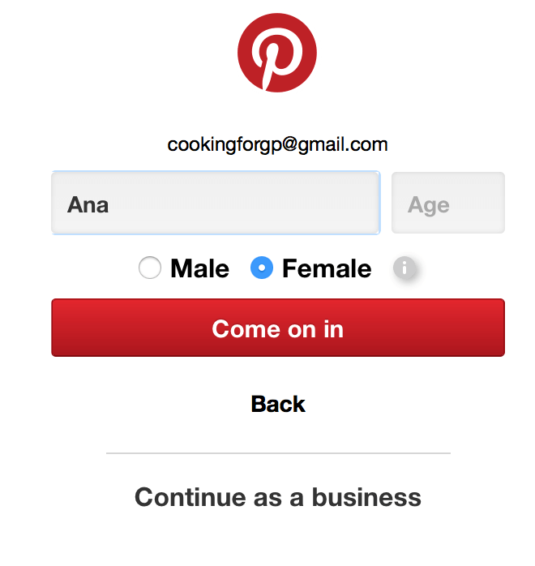

When you create your account as a business, you’ll be asked to fill out the additional fields supplying the information of your business’s name, what type of business you are, and your website (though this is optional).

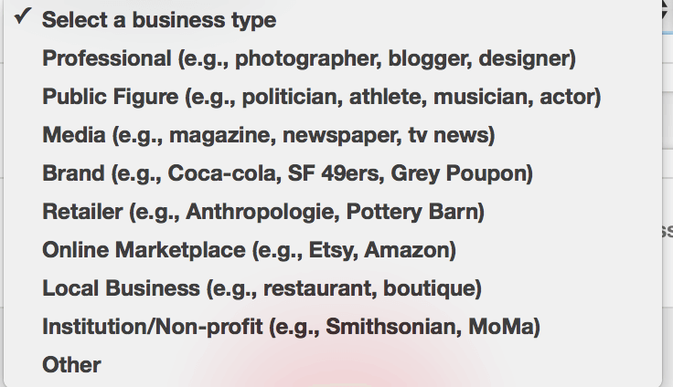

Once you’re done, hit create account.

You’ll then be asked to **follow 5 topics that interest you**. This doesn’t really matter, since you’ll be using this to promote your content instead of following others, but it never hurts to select topics that are relevant to your business.

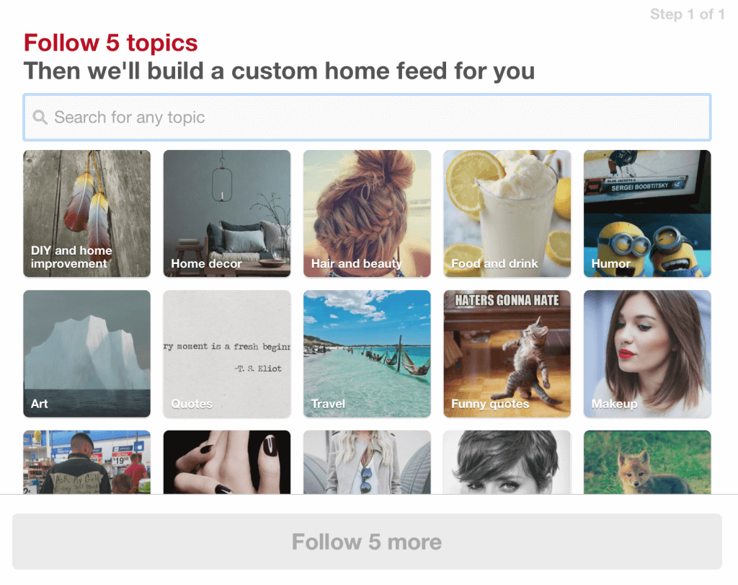

Once your account is created, your home page will look like the screenshot below. This is just what you see, not what anyone following you will see. Click on the red thumb tack in the top right-hand corner to get to your profile.

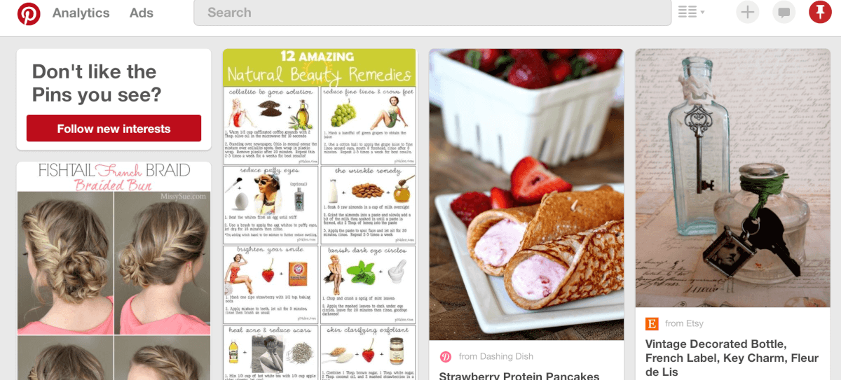

#2 – Setting Up Your Profile

Your profile starts out looking like this—blank and ready to be filled in. To do so, first click the “**Edit Profile**” button.

Some businesses make the mistake of not filling out all the information here, and that’s a mistake.

**Give as much information as you can**—users will see this, and the more info, the better. **Choose an image** that best represents your brand; for many, this is**a logo**. Make sure to **add your website** so users can visit you through it. Locations matter if you’re a local or brick-and-mortar location, and always, *always* try to **use keywords in your “about me.”**

#3 – Setting Up Boards

You can create a board from your profile page. You’ll be asked to name it, describe it, what category it falls under, if it’s secret, and if you want to invite collaborators.

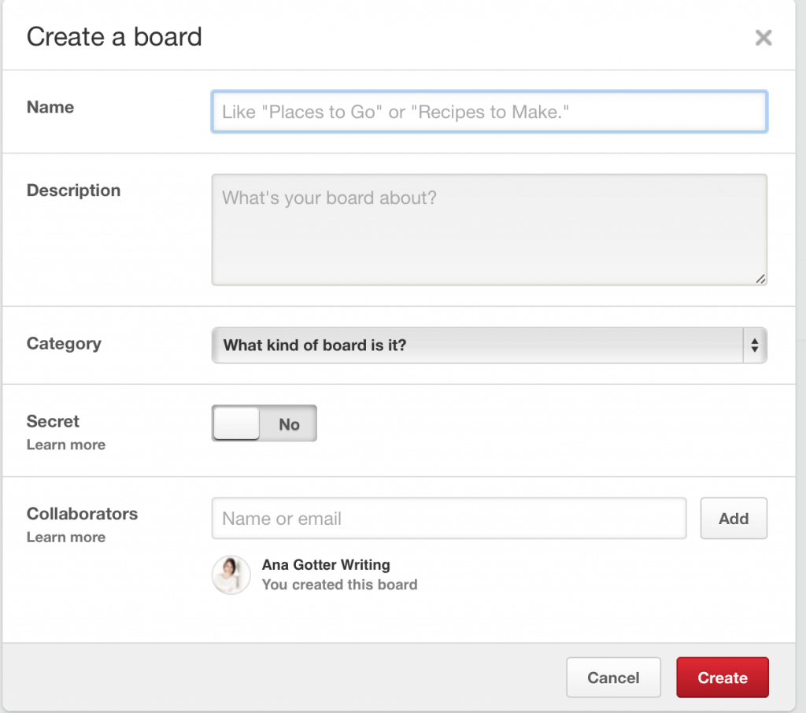

**When you name your board, keep keywords in mind, and make sure it’s a relevant title.** If you’re creating a board with candy recipes, for example, you could name it “Sweet Treats,” but this could also include cakes, cookies, and pies; adding “candy” in the title as a keyword could help your search results and help you connect with more relevant users.

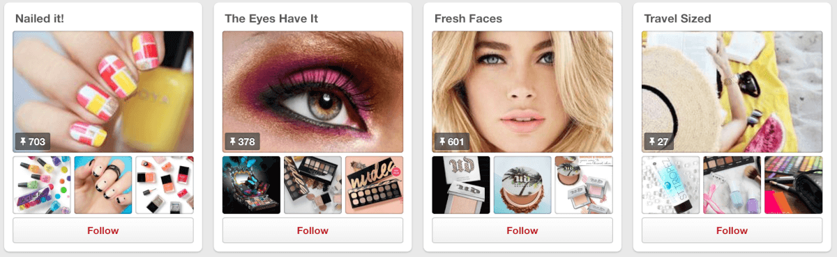

**The description matters just as much as the title**; again, keywords matter, and describe it accurately.

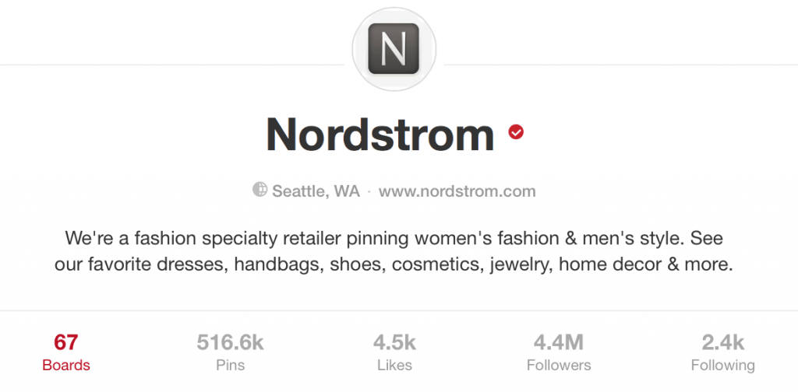

If you invite collaborators, keep in mind that they can pin to and edit the board.

**Once you add pins to the board, you can choose which image you want to represent the board**. You’ll go to “edit board,” and then choose to change your cover image.



You can scroll through the images selected and choose your new cover image.

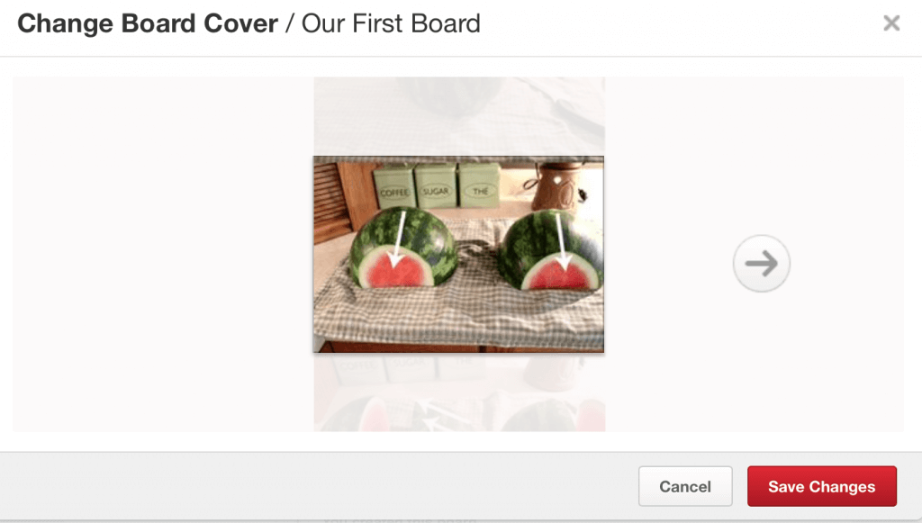

 4 – Viewing Analytics

Pinterest has their own analytics program, available only for business accounts. You can view the analytics by clicking on the tab on the navigation bar in the top left hand corner of the page.

This account is new, so it doesn’t have any analytics information yet, but **Pinterest’s analytics can tell you how many views and how much engagement your pins and boards are getting, along with information about your followers or those who viewed your pins**.

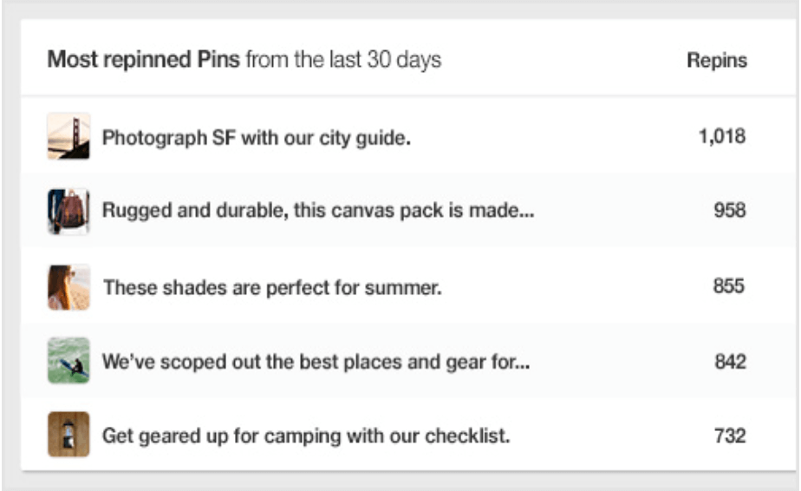

How to Get Pins Noticed

While setting up your profile in a way that’s optimized for success is important, your actual pins will be what matters most. **Your pins need to be visually striking** so they stand out against the others, whether that’s in a page of other search results or under a general category.

**There are several ways you can get your pins noticed and increase their visibility,**in addition to choosing the right keywords to describe them. These include choosing the **right image size** and following **best image practices**.

Best Image Size

Choosing the right image size on Pinterest can help your pin stand out from the rest, regardless of where users are viewing it.

Image on Pinterest will be scaled to fit the platform, with the width being scaled to 236 pixels.

By Pinterest’s own recommendations, the best aspect ratios for Pins fall between a 2:3 and 1:3.5 (width to height). The minimum recommended width is 600 pixels. **Having Pins that are taller than they are wide can help your pins have enough space to stand out,** but pins that seem to go on forever and are too long don’t get nearly as much engagement.

Best Image Practices

To help get your pins noticed, there are several best image practices you can use to increase views, repins, and engagement. These include:

* **Tasteful branding.** This comes from Pinterest’s own recommendations; according to Pinterest, including “tasteful branding” in the image can help increase repins and engagement, which can lead to purchases. Whether this is featuring the packaging of your product in the image or just a small logo or watermark, they recommend adding it in where possible.

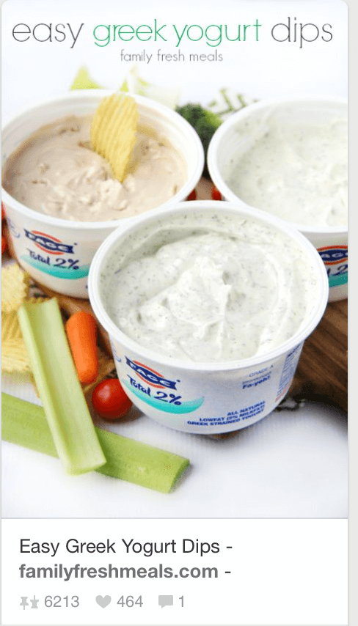

**Add lifestyle images.**While images of your products alone can be effective, adding in lifestyle images where users are [actively using your product](https://adespresso.com/academy/blog/37-instagram-ads-examples/) can help it get the attention of users. Avoid overly user-generated images, but having high quality images of someone using your product in its best use case can be effective.



**Text overlays.** This isn’t Facebook; there’s no [20% rule](https://adespresso.com/academy/blog/breaking-news-facebook-changes-20-text-rule/). Adding text overlay to your image can help get your point and your ideas across quickly.



**List images.** Lists and listicles are big in content marketing right now; Pinterest is no different. Having an image that demonstrates the list your pin will take you to can be a great way to stand out and increase engagement.



Pinterest Promoted Pins

Promoted Pins rolled out for everyone last year, and businesses in all industries are using the platform.

Since it’s rolled out, it has **provided businesses and brands of all sizes a major platform to connect with new and interested users**.

Promoted Pins: How It Works

**Pinterest’s Promoted Pins is their paid ad platform.** It works on a bidding system like the other social media ad platforms we’re familiar with.

You pay to have your pin placed in front of your target audience. Your pins will show up in relevant category feeds and relevant searches, aided by the keywords that you choose.

**You must have a business Pinterest account in order to access and run your own promoted pins campaigns.**

How to Create Promoted Pins

To access the promoted pins platform, **click on the Ads clickable tab and drop down menu**, which can be located in the left hand corner.

This will take you to the **dashboard**, where you can see the total number of impressions, engagement, conversions, and ad spend on all your campaigns in the prior week. This information can be broken down by engagement campaigns and traffic campaigns.

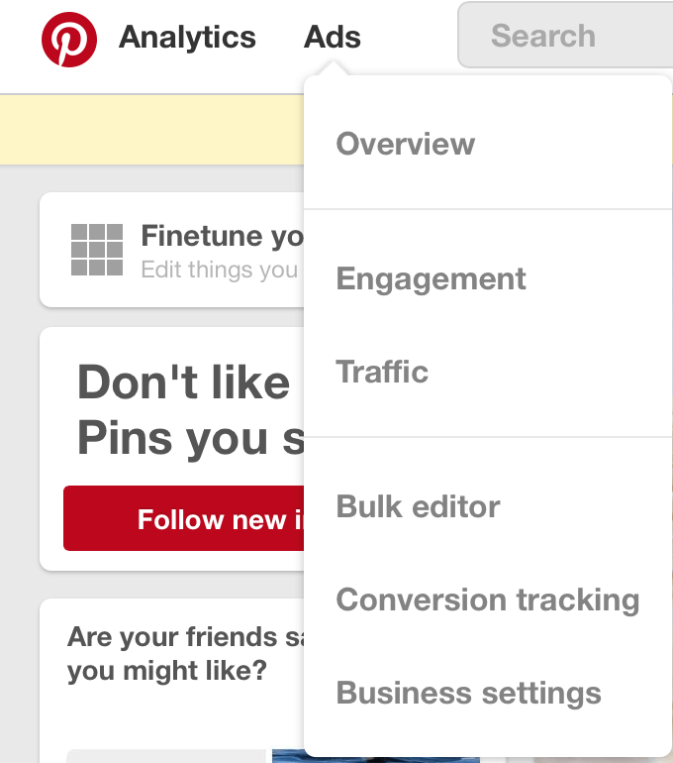

To get started creating a promoted pin, click on the + in the top right hand corner of Pinterest’s navigation bar, and select “Create an Ad.”

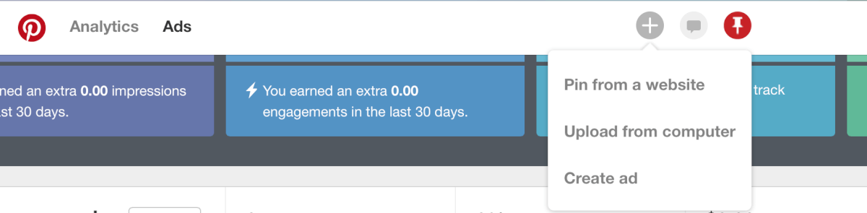

You’ll first be asked to decide whether you want to boost engagement with your pins, which will focus on- and charge by- close up views, repins, and clicks, or send traffic to your site, which will charge by clicks.

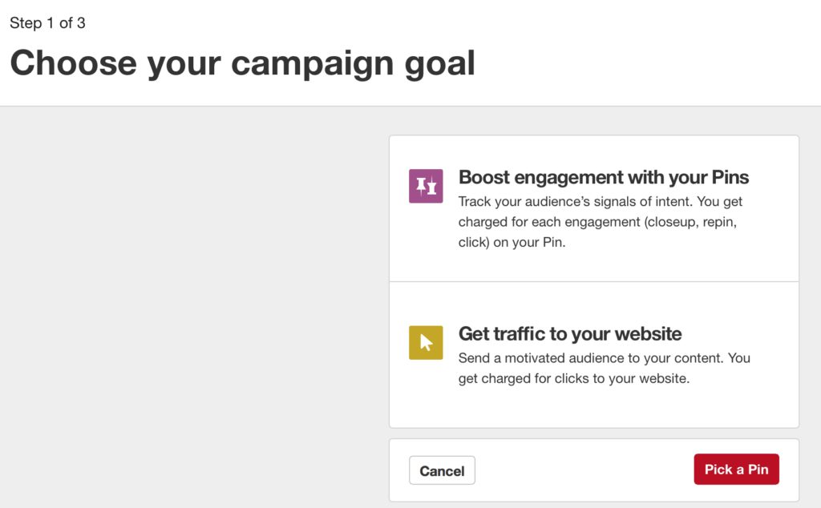

Once you choose your campaign goal, you’ll add in information about your campaign name, your daily budget, and the start and end date for your campaign.

The end date is optional, but I highly recommend it—keeping your pins updated and varied is as important here as it is on any other platform.

When you’ve filled out all of the information, click “Pick a Pin”

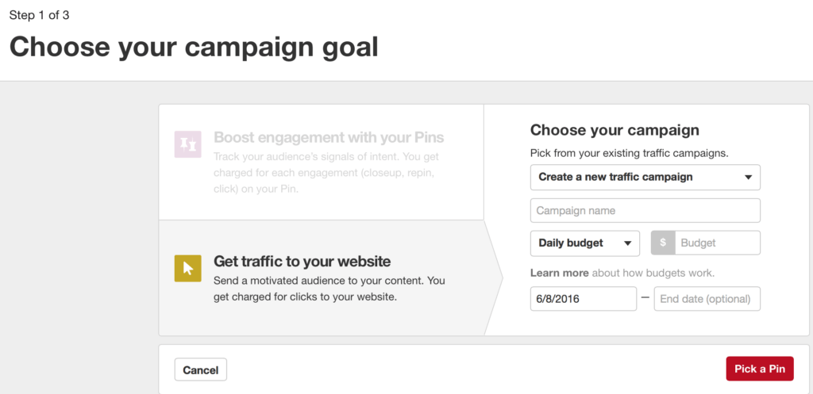

On the next screen, you’ll be asked toselect the pin you want to promote.

When choosing a pin, you can search for a pin by the keyword or URL, or scroll through your pins. You can see the number of repins each has as you scroll through them. Pinterest also gives you the option of viewing your most clicked and most repined pins in the past 30 days.

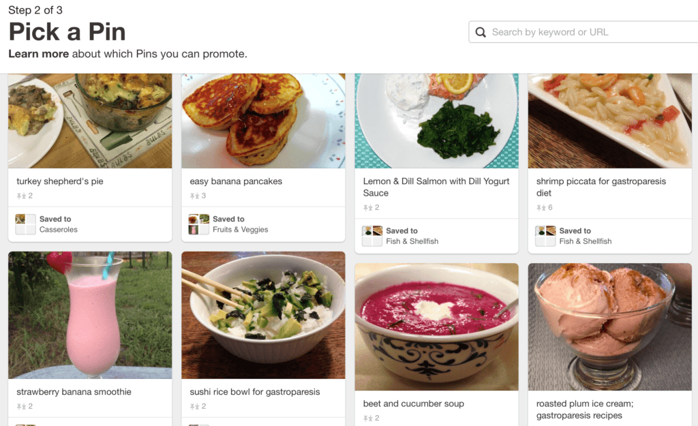

On the next screen, you’ll give your promoted pin it’s name, which will be the visible title of the pin that users will see. You can also set a destination URL.

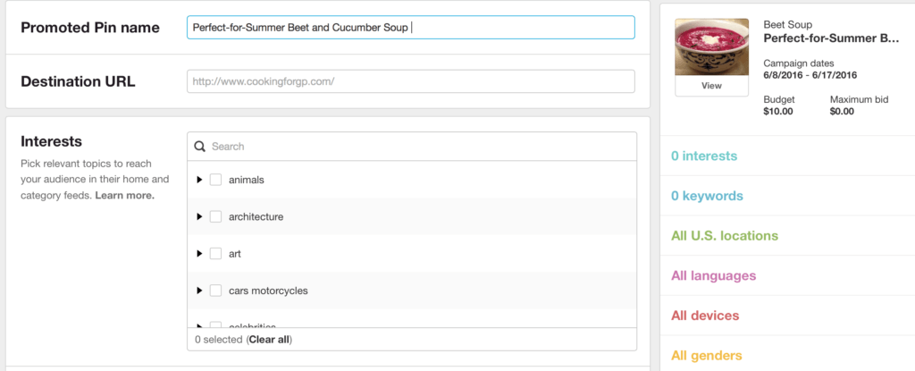

Promoted Pins Targeting

Below this, you’ll be able to select differentinterests, which are used as a sort of targeting criteria. These interests will help reach a relevant audience in their browsing and home feeds. They will also sort your post into the correct categories.

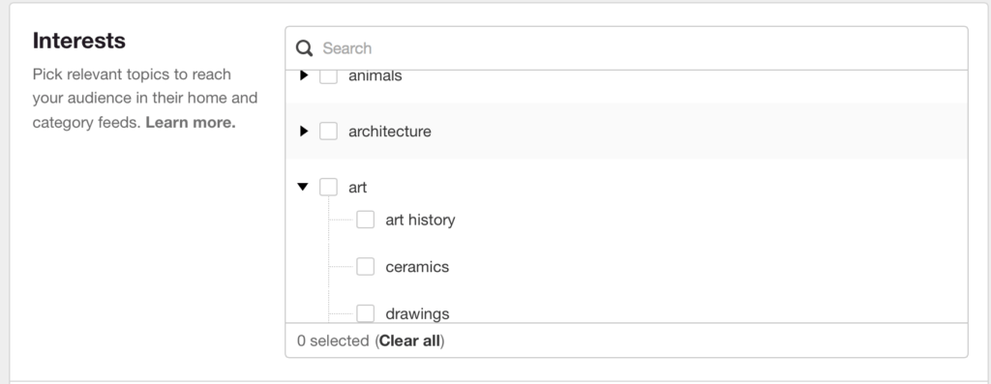

When you scroll down, you’ll be asked to choose keywords. I believe that this is the most important section in the entire ad creation process.

The keywords you choose will determine what searches your pin shows up in**.**You want to connect with users who are actively searching for content like yours. Pinterest automatically suggests searches based on their information about your pin, and they’ll provide a list of keywords for every search that you make.

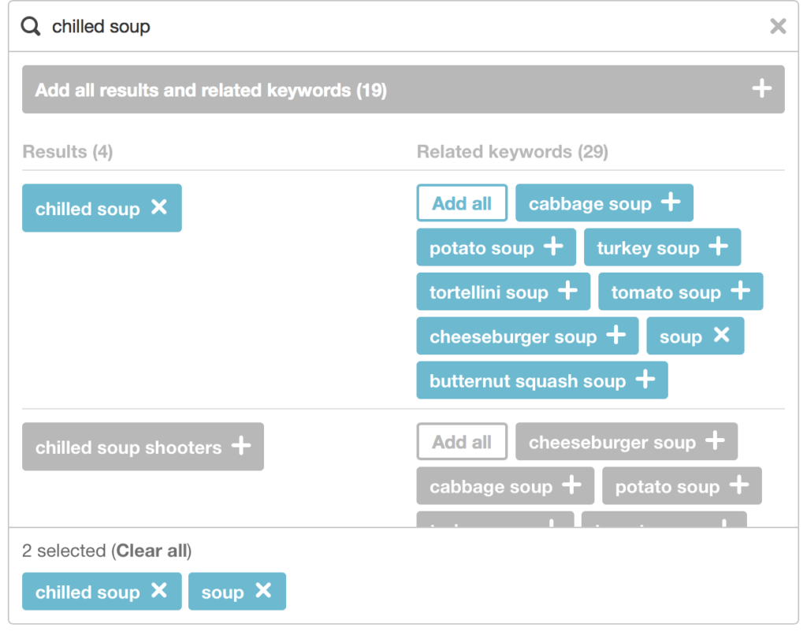

Click on different keywords to add them to your campaign. Pinterest recommends using 20-30 keywords per promoted pin.

When it comes to the keywords you choose,think outside the box to help your pin show up in more searches. For example, instead of just having keywords like “beet soup” and “beets,” you can add “chilled soup,” “summer recipes,” and “liquid diet.”  This gives you more diversity, expanding visibility.

When you scroll to the next section, you have the ability to have your pins only shown to those:

* in certain locations
* who speak certain languages
* use specific devices
* are a certain gender

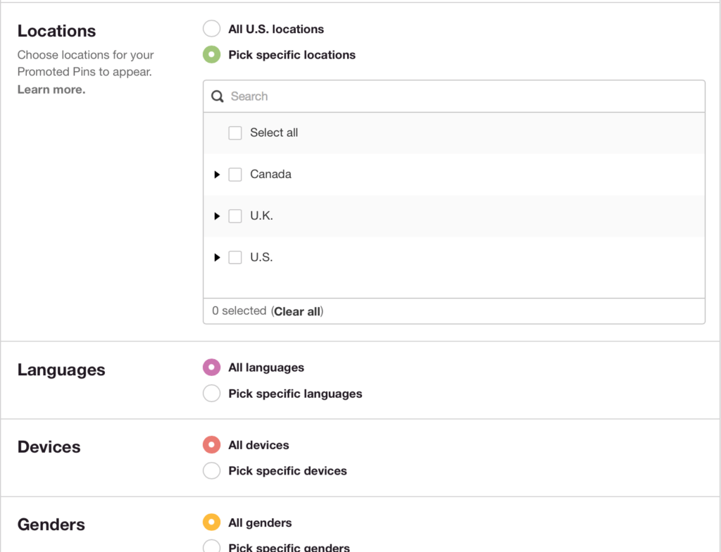

Finalizing Your Campaign

Next, you’ll be able to set your Maximum CPC bid**.** This is the most you’re willing to pay for a single click to your website (or, in the case of an engagement objective, for a single measure of engagement).

This must be at least $0.10**.** Pinterest will let you know if your bid is too high or low compared to what others are bidding.

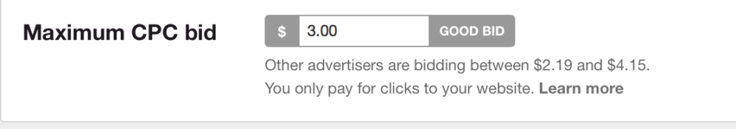

Once you submit your campaign, it will need to approve. You can view your campaigns’ approval status under the Engagement campaigns or Traffic campaigns tabs.

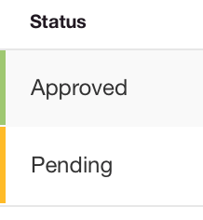

Promoted Pins Analytics

Both as your campaigns progress and once they’re over, it’s important to monitor them through the promoted pins analytics.

You can find **information** about how your campaigns are performing **on the home page of the ads platform**, or find detailed information on each campaign by clicking on them.

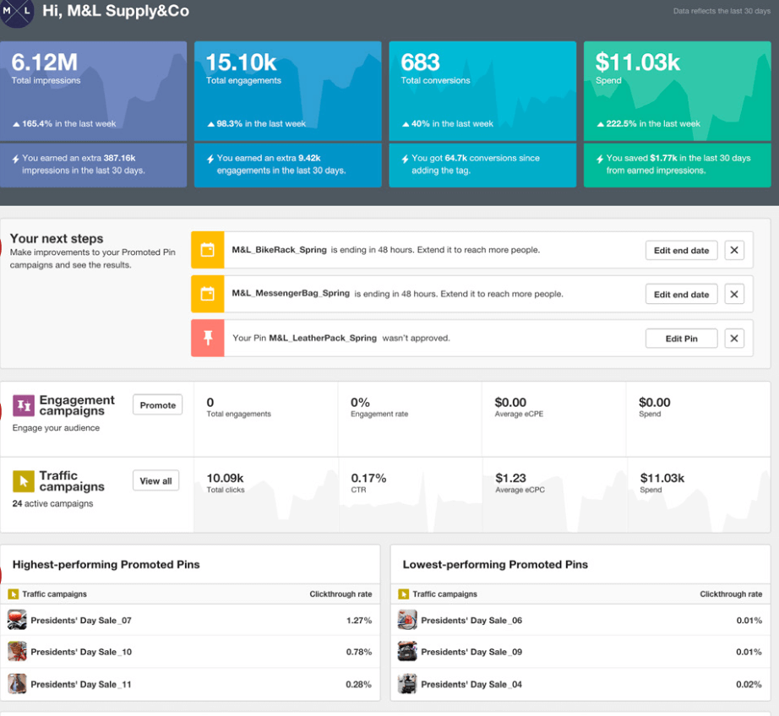

Pinterest’s reporting shows you your total impressions, total engagement, total conversions, and your total spend over the past thirty days both for your campaigns as a whole and by engagement goals.

You can also see you’re highest and lowest performing promoted pins.

-----------------------------------------------------------------------------------------------

The Inbound Marketing

Inbound marketing is about using marketing to bring potential customers to you, rather than having your marketing efforts fight for their attention. Sharing is caring and inbound marketing is about creating and sharing content with the world. By creating content specifically designed to appeal to your dream customers, inbound attracts qualified prospects to your business and keeps them coming back for more.

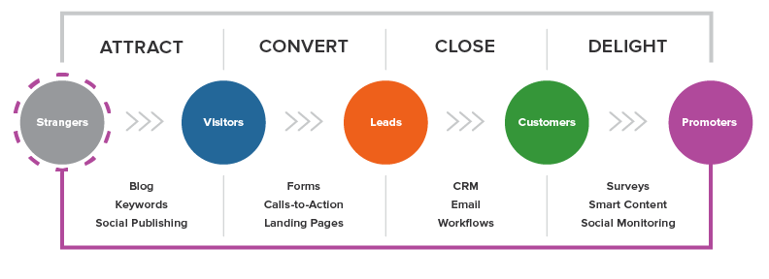

### Major Themes of Inbound Marketing:

#### 1. Content Creation + Distribution

Create targeted content that answers prospects' and customers' basic questions and needs, then share that content far and wide.

2.Lifecycle Marketing

Promoters don’t just materialize out of thin air: they start off as strangers, visitors, contacts, and customers. Specific marketing actions and tools help to transform those strangers into promoters.

3**.**Personalization

Tailor your content to the wants and needs of the people who are viewing it. As you learn more about your leads over time, you can better personalize your messages to their specific needs.

4.Multi-Channel

Inbound marketing is multi-channel by nature because it approaches people where they are, in the channel where they want to interact with you.

5. Integration

Content creation, publishing and analytics tools all work together like a well-oiled machine - allowing you to focus on publishing the right content in the right place at the right time.

The Four Inbound Marketing Actions

1. Attract

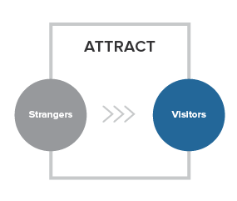

We don’t want just any traffic to our site, we want the right traffic. We want the people who are most likely to become leads, and, ultimately, happy customers. Who are the “right” people? Our ideal customers, also known as our buyer personas. Buyer personas are holistic ideals of what your customers are really like, inside and out. Personas encompass the goals, challenges, pain points, common objections to products and services, as well as personal and demographic information shared among all members of that particular customer type. Your personas are the people around whom your whole business is built.

Some of the most important tools to attract the right users to your site are:

**Blogging.**Inbound marketing starts with blogging. A blog is the single best way to attract new visitors to your website. In order to get found by the right prospective customers, you must create educational content that speaks to them and answers their questions.

**SEO.**Your customers begin their buying process online, usually by using a search engine to find something they have questions about. So, you need to make sure you’re appearing prominently when and where they search. To do that, you need to carefully, analytically pick keywords, optimize your pages, create content, and build links around the terms your ideal buyers are searching for.

**Pages.**Your website pages are your digital storefront. So put your best face forward! Optimize your website to appeal to your ideal buyers and transform your website into a beacon of helpful content to entice the right strangers to visit your pages.

**Social Publishing.**Successful inbound strategies are all about remarkable content - and social publishing allows you to share that valuable information on the social web, engage with your prospects, and put a human face on your brand. Interact on the networks where your ideal buyers spend their time.

2. Convert

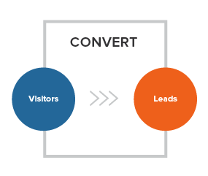

Once you’ve attracted website visitors, the next step is to convert those visitors into leads by gathering their contact information. At the very least, you’ll need their email addresses. Contact information is the most valuable currency there is to the online marketer. So in order for your visitors to offer up that currency willingly, you need to offer them something in return! That “payment” comes in the form of content, like eBooks, whitepapers, or tip sheets - whatever information would be interesting and valuable to each of your personas.

Some of the most important tools in converting visitors to leads include:

**Forms.**In order for visitors to become leads, they must fill out a form and submit their information. Optimize your form to make this step of the conversion process as easy as possible.

**Calls-to-Action.**Calls-to-action are buttons or links that encourage your visitors to take action, like “Download a Whitepaper” or “Attend a Webinar.” If you don’t have enough calls-to-action or your calls-to-action aren’t enticing enough, you won’t generate leads.

**Landing Pages.**When a website visitor clicks on a call-to-action, they should then be sent to a landing page. A landing page is where the offer in the call-to-action is fulfilled, and where the prospect submits information that your sales team can use to begin a conversation with them. When website visitors fill out a form on a landing page for the first time, that visitor becomes a contact.

**Contacts.**Keep track of the leads you're converting in a centralized marketing database. Having all your data in one place helps you make sense out of every interaction you’ve had with your contacts - be it through email, a landing page, social media, or otherwise - and how to optimize your future interactions to more effectively attract, convert, close, and delight your buyer personas.

3. Close

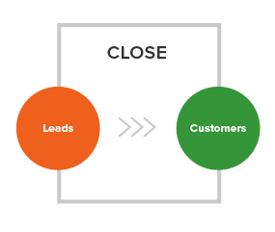

You’re on the right track. You’ve attracted the right visitors and converted the right leads, but now you need to transform those leads into customers. How can you most effectively accomplish this feat? Certain marketing tools can be used at this stage to make sure you’re closing the right leads at the right times.

Closing tools include:

**CRM.**Keep track of the details about all the contacts, companies, and deals in your pipeline, and easily get in touch with the right prospects at the right time. Customer Relationship Management (CRM) systems facilitate sales by making sure you have the right information at your fingertips to better engage with prospects across every channel.

**Closed-loop Reporting.**How do you know which marketing efforts are bringing in the best leads? Is your sales team effectively closing those best leads into customers? Integration with your CRM system allows you to analyze just how well your marketing and sales teams are playing together.

**Email.**What do you do if a visitor clicks on your call-to-action, fills out a landing page, or downloads your whitepaper, but still isn’t ready to become a customer? A series of emails focused on useful, relevant content can build trust with a prospect and help them become more ready to buy.

**Marketing Automation.**This process involves creating email marketing and lead nurturing tailored to the needs and lifecycle stage of each lead. For example, if a visitor downloaded a whitepaper on a certain topic from you in the past, you might want to send that lead a series of related emails. But if they follow you on Twitter and visited certain pages on your website, you might want to change the messaging to reflect those different interests.

4. Delight

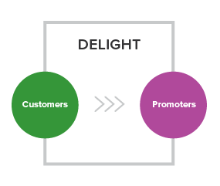

The Inbound way is all about providing remarkable content to our users, whether they be visitors, leads, or existing customers. Just because someone has already written you a check doesn’t mean you can forget about them! Inbound companies continue to engage with, delight, and (hopefully) upsell their current customer base into happy promoters of the organizations and products they love.

Tools used to delight customers include:

**Surveys.**The best way to figure out what your users want is by asking them. Use feedback and surveys to ensure you’re providing customers with what they’re looking for.

**Smart Calls-to-Action.**These present different users with offers that change based on buyer persona and lifecycle stage.

**Smart Text.**Provide your existing customers with remarkable content tailored to their interests and challenges. Help them achieve their own goals, as well as introduce new products and features that might be of interest to them.

**Social Monitoring.**Keep track of the social conversations that matter to you most. Listen out for your customers’ questions, comments, likes, and dislikes – and reach out to them with relevant content.